UNITED STATES

SECURITIES AND EXCHANGE COMMISSION

Washington, D.C. 20549

SCHEDULE 14A

Proxy Statement Pursuant to Section 14(a) of

the Securities Exchange Act of 1934 (Amendment No. )

Filed by the Registrant ☒

Filed by a Party other than the Registrant ☐

Check the appropriate box:

- Preliminary Proxy Statement

- Confidential, for Use of the Commission Only (as permitted by Rule 14a-6(e)(2))

- Definitive Proxy Statement

- Definitive Additional Materials

- Soliciting Material under §240.14a-12

VAIL RESORTS, INC.

(Name of Registrant as Specified In Its Charter)

(Name of Person(s) Filing Proxy Statement, if other than the Registrant)

Payment of Filing Fee (Check the appropriate box):

- No fee required.

- Fee paid previously with preliminary materials.

- Fee computed on table in exhibit required by Item 25(b) per Exchange Act Rules 14a-6(i)(1) and 0-11


On October 30, 2026, Vail Resorts, Inc. (“Vail Resorts”) launched a website, Vote.VailResorts.com, relating to its 2026 annual meeting of stockholders.

A copy of the materials on the website is provided below.
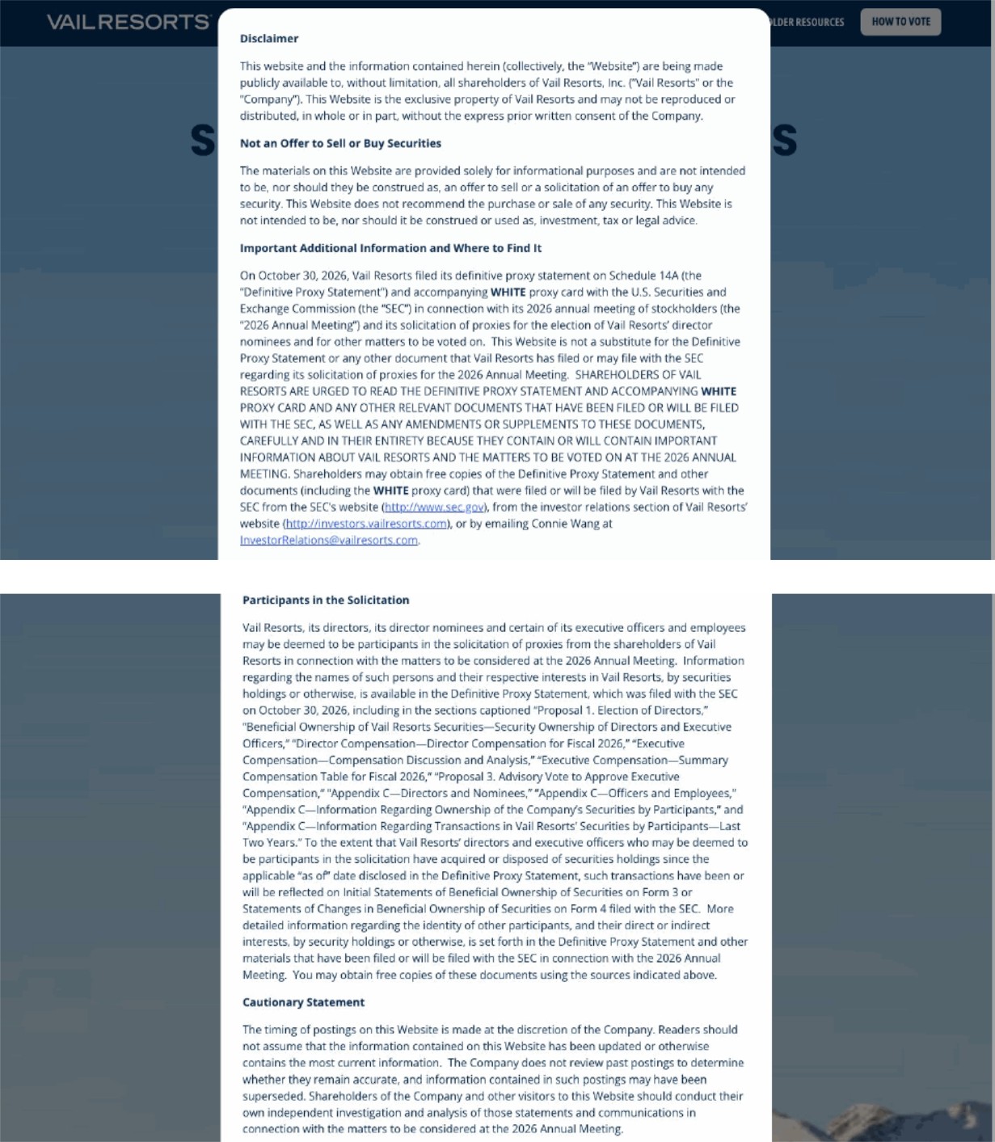

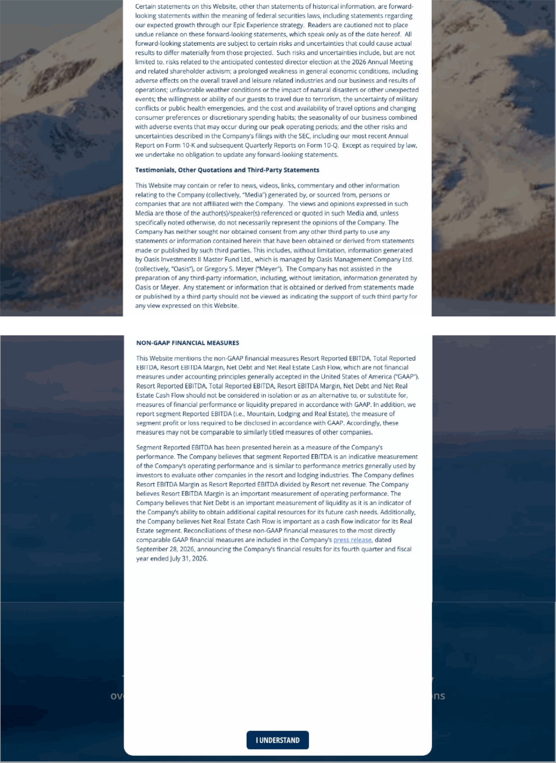

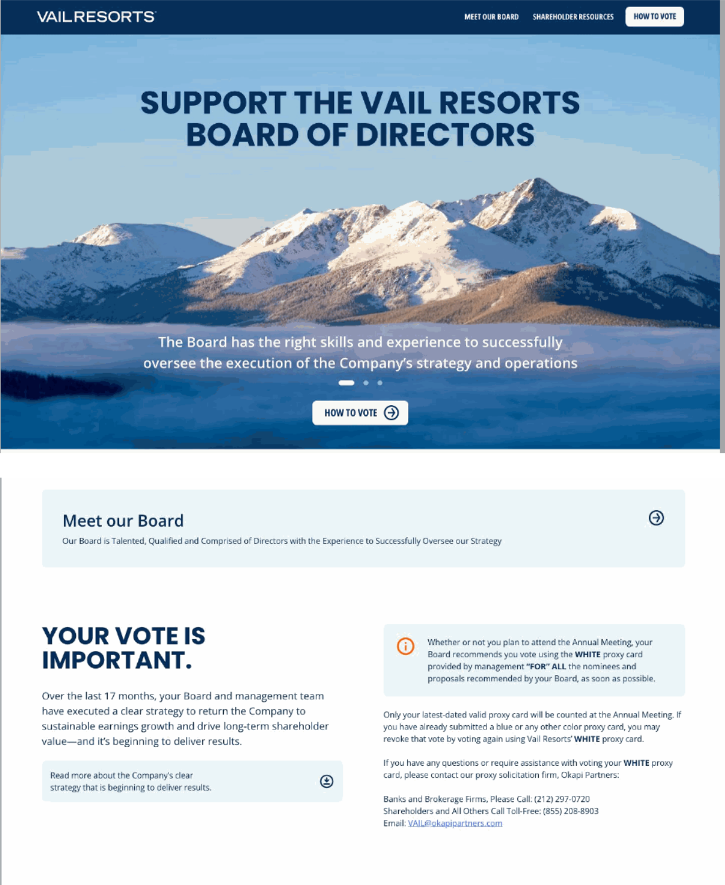

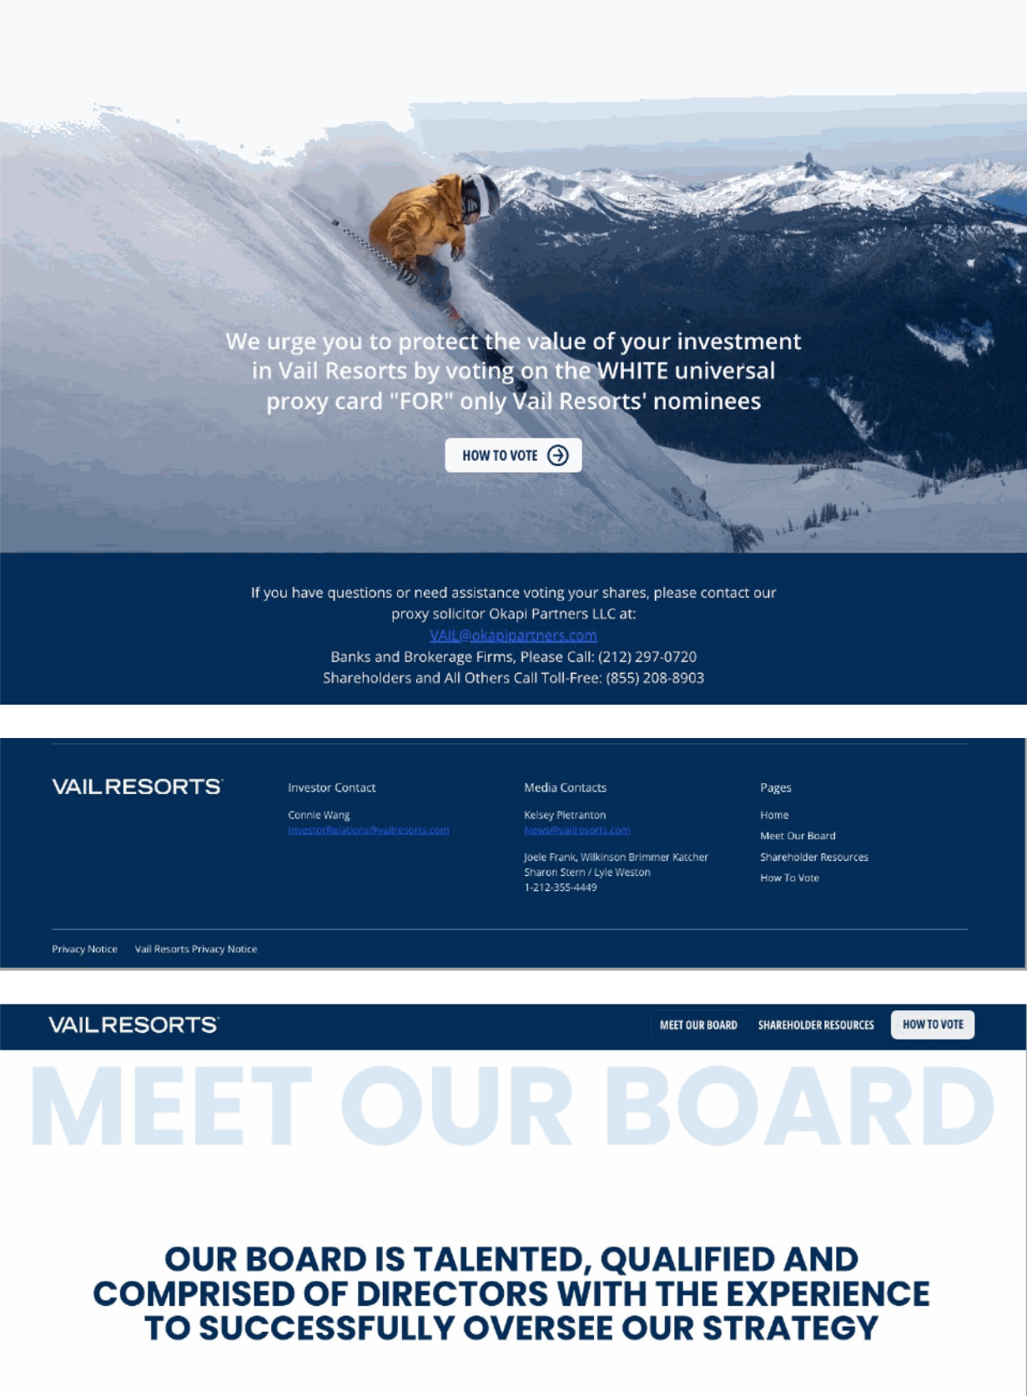



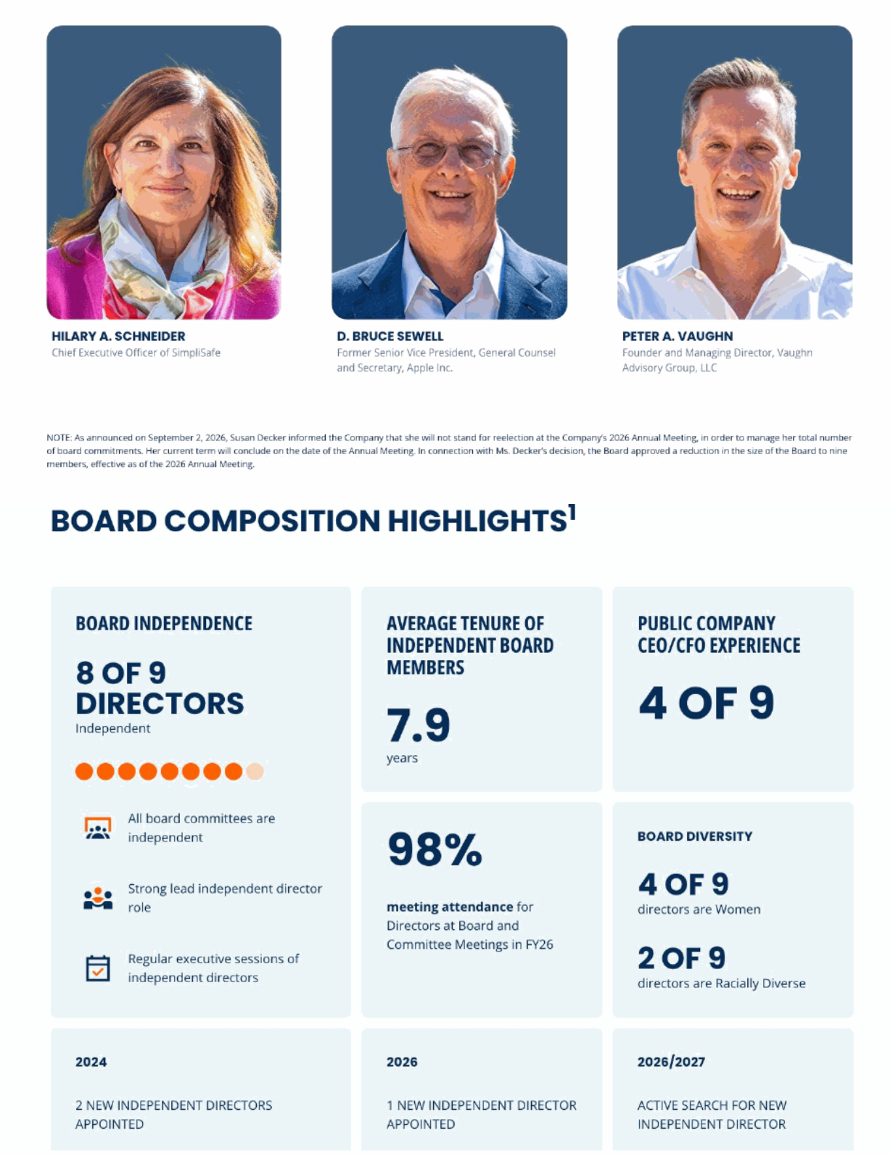

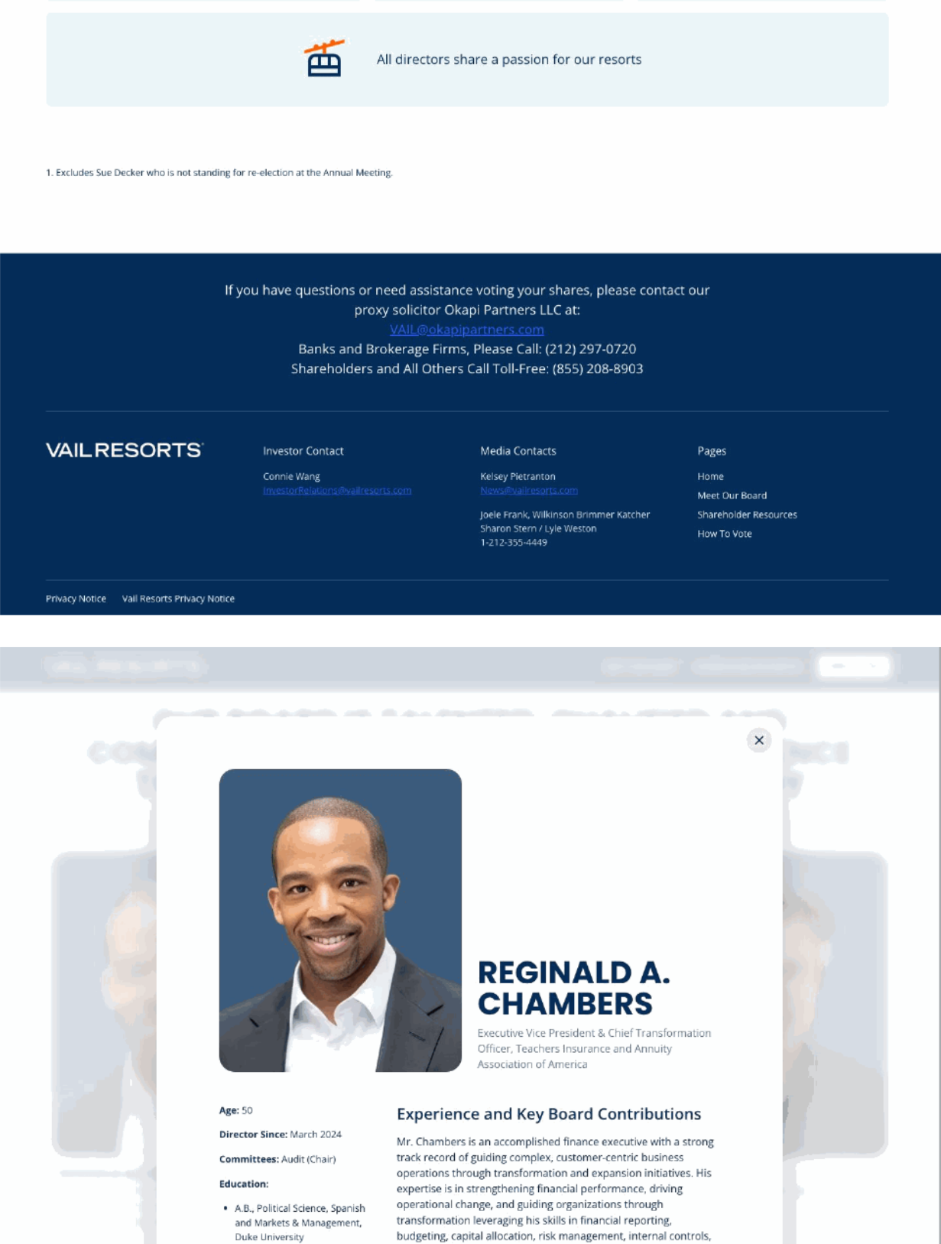

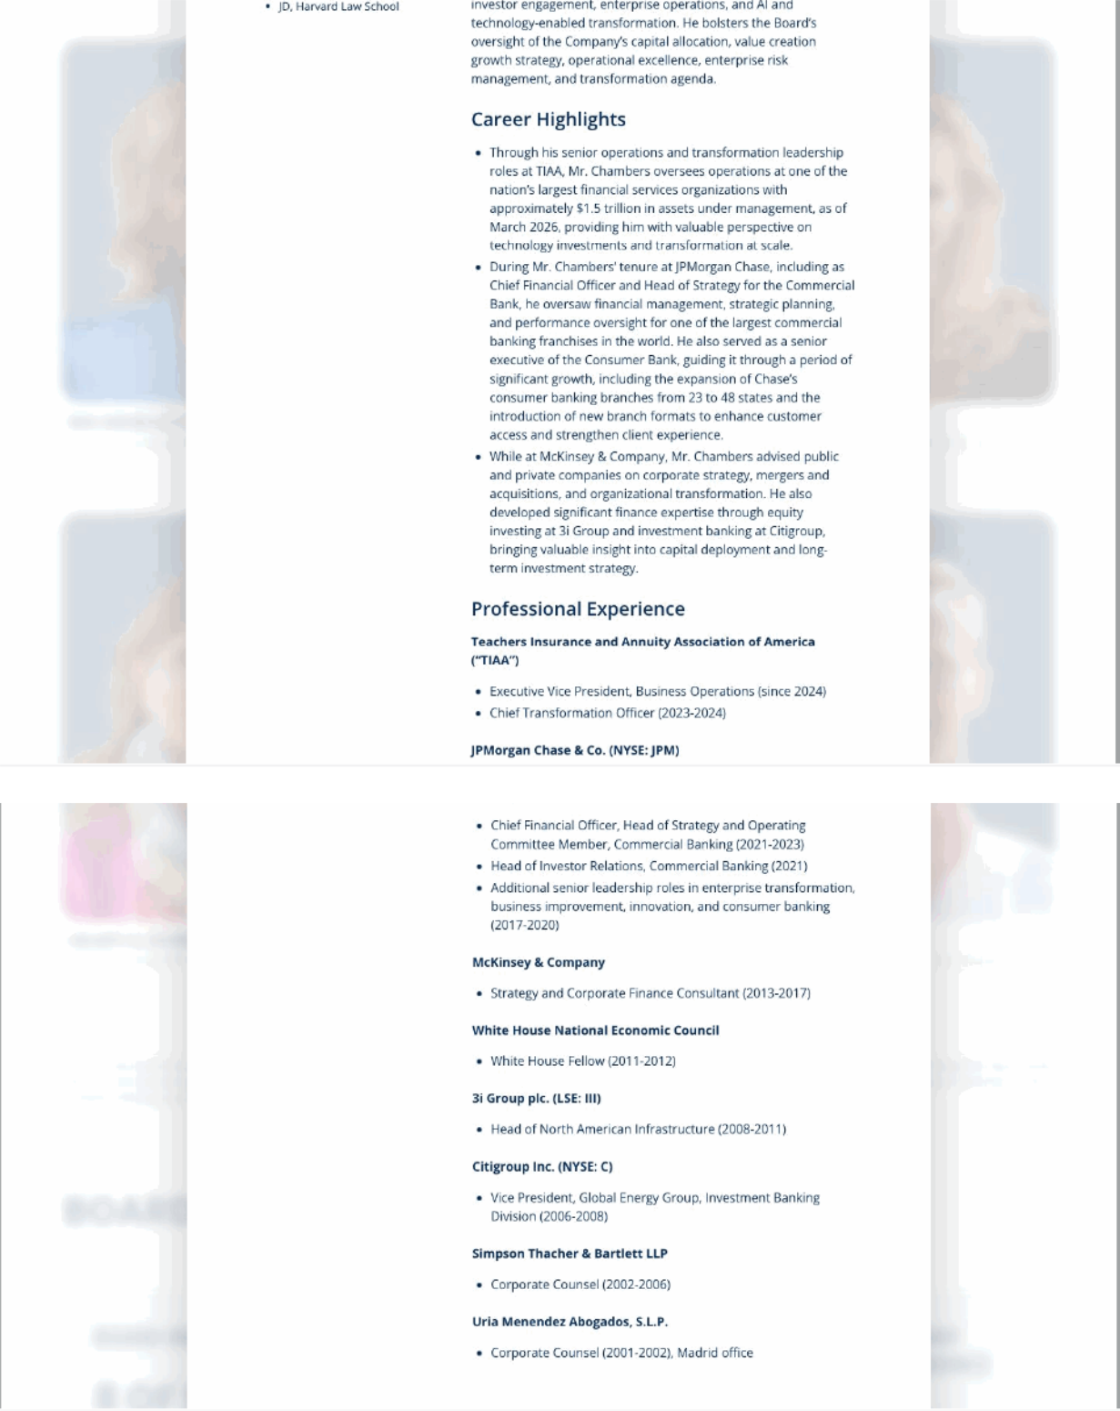

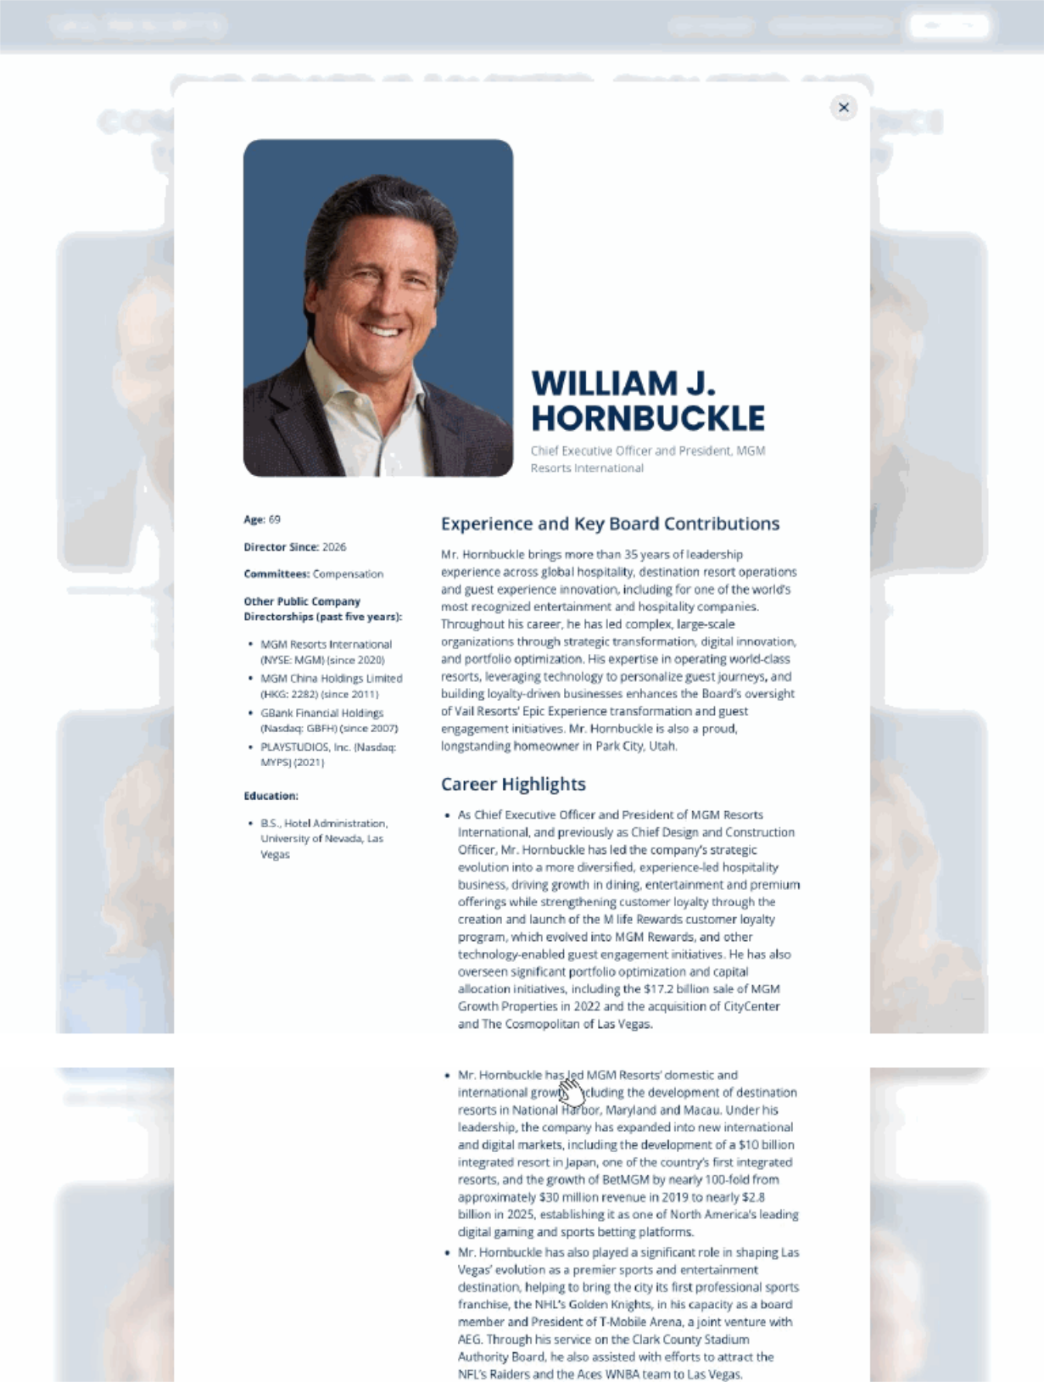

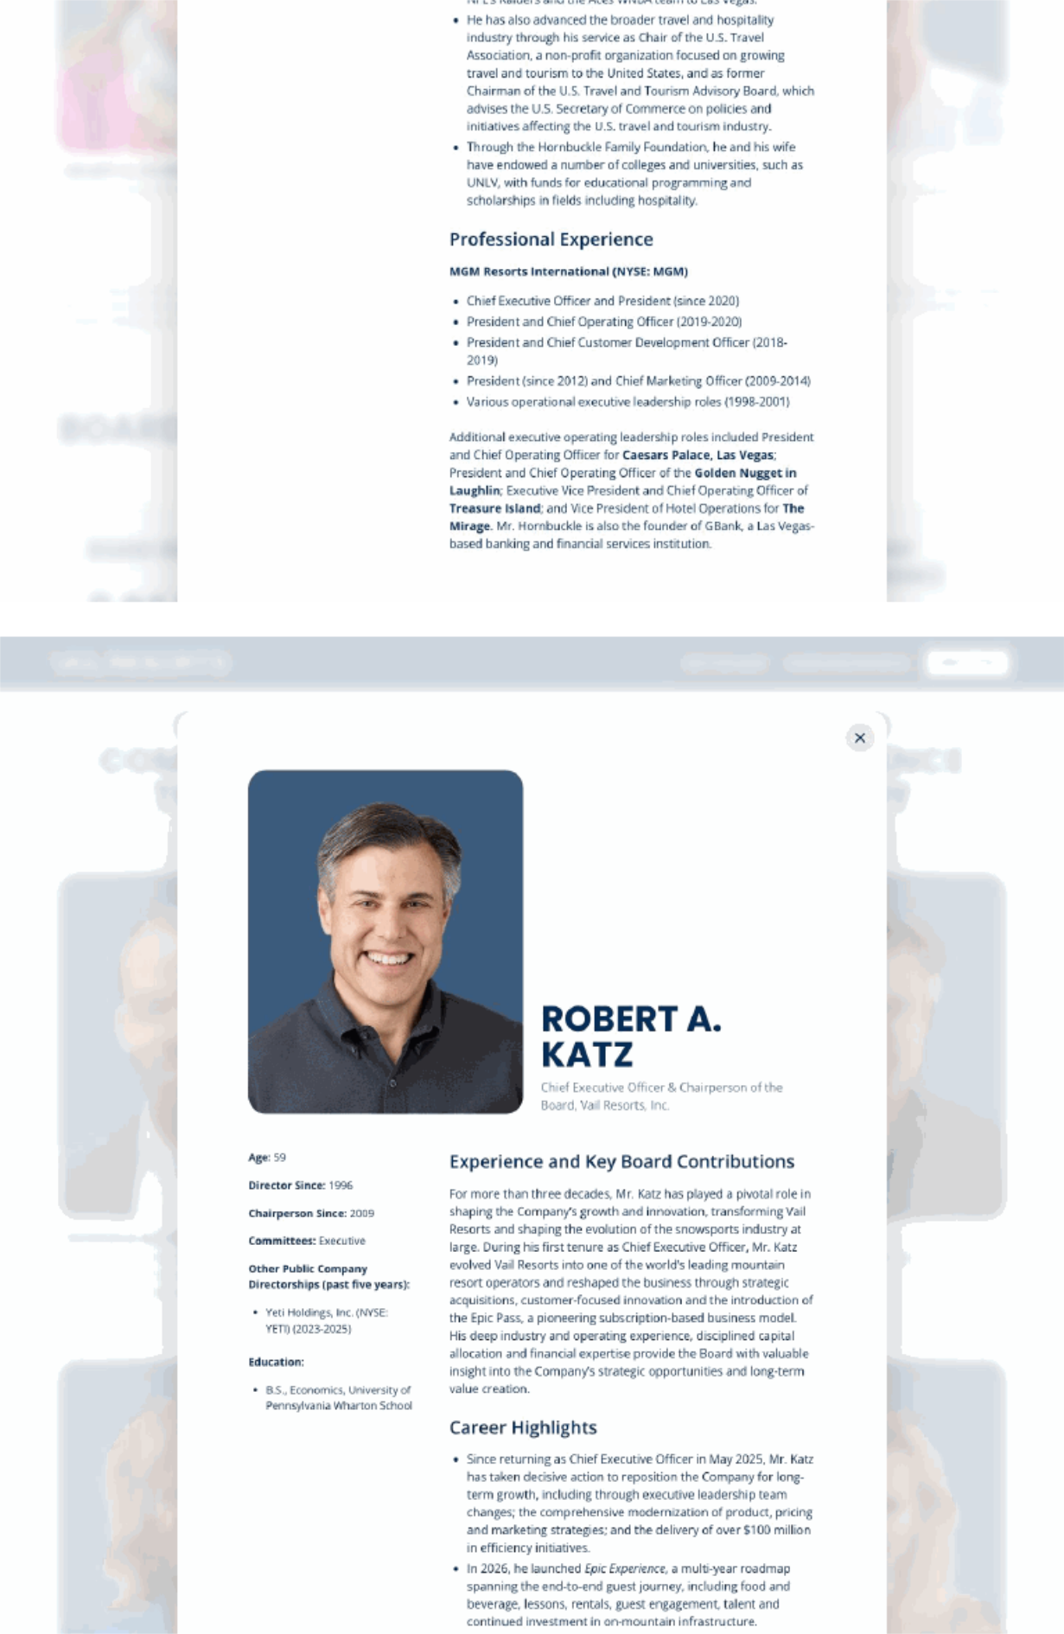



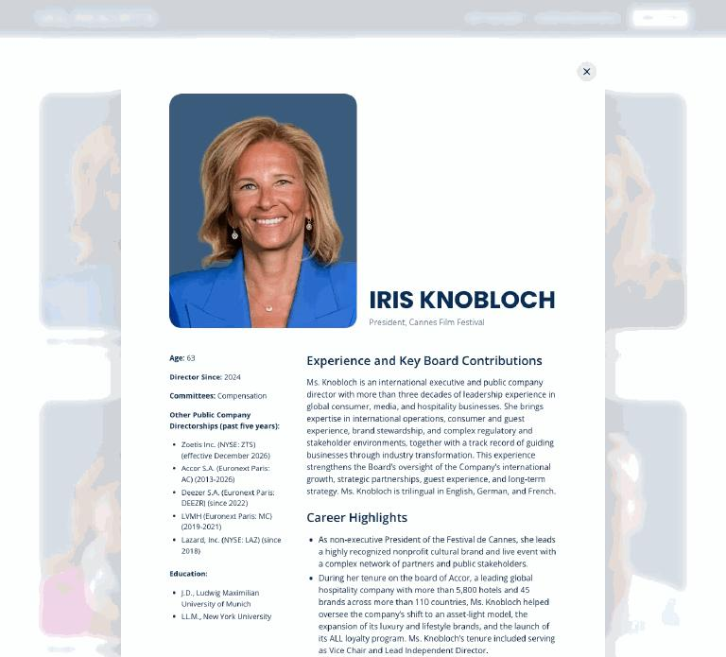

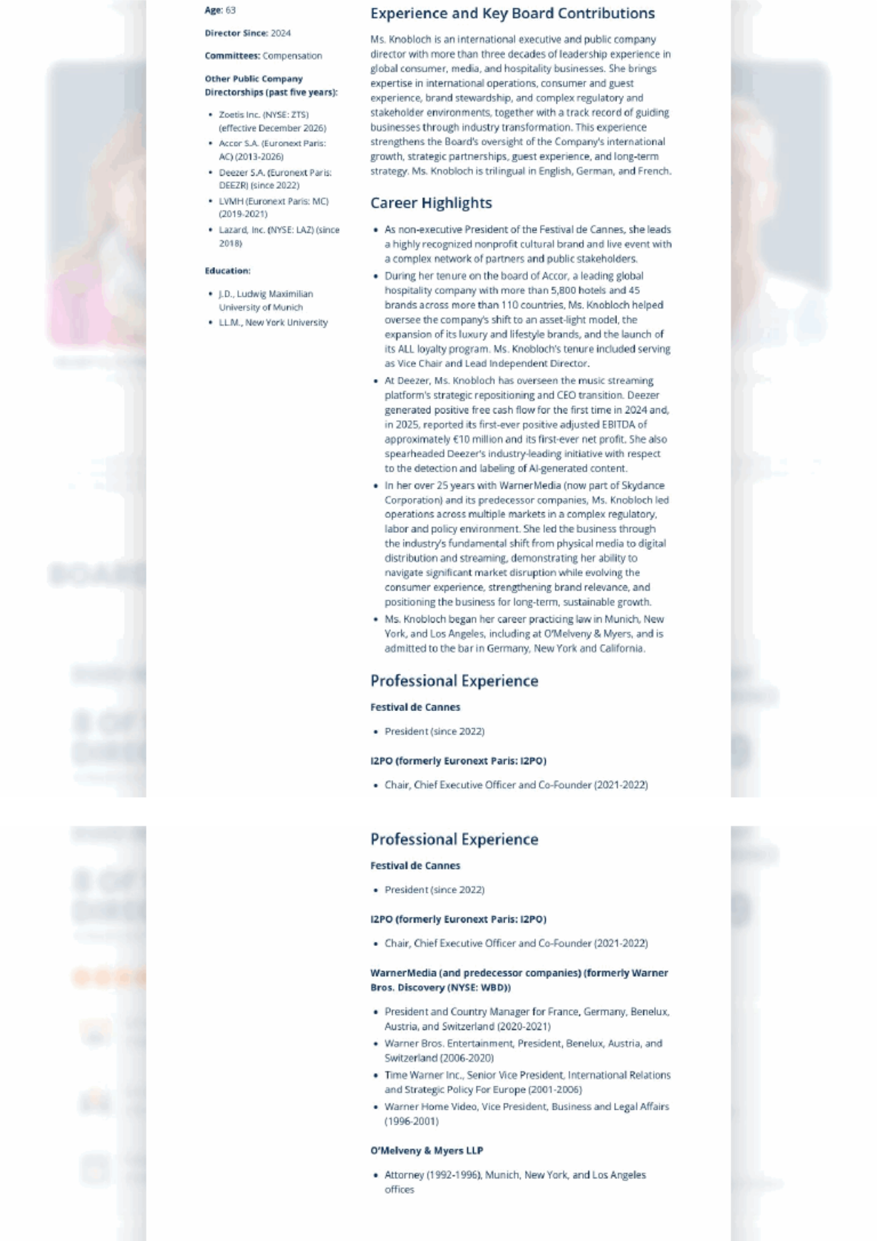

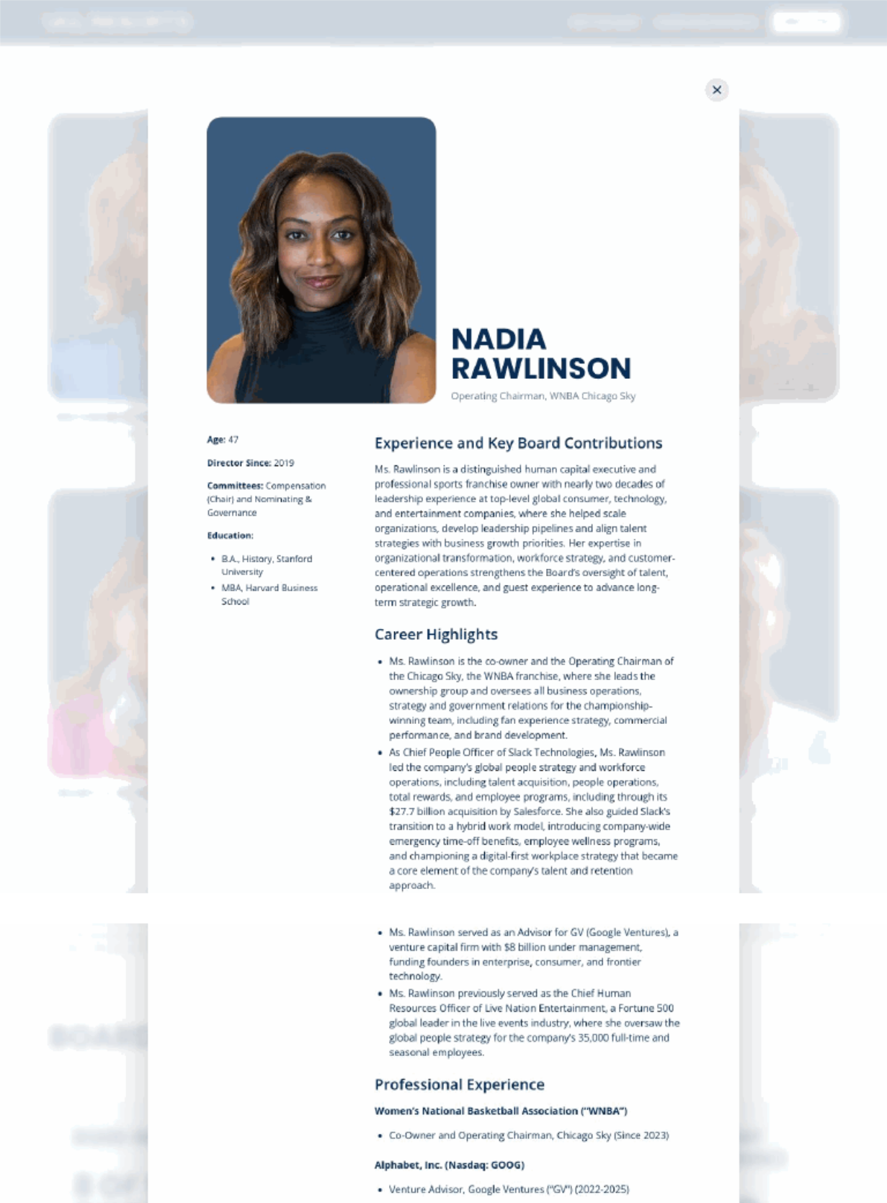

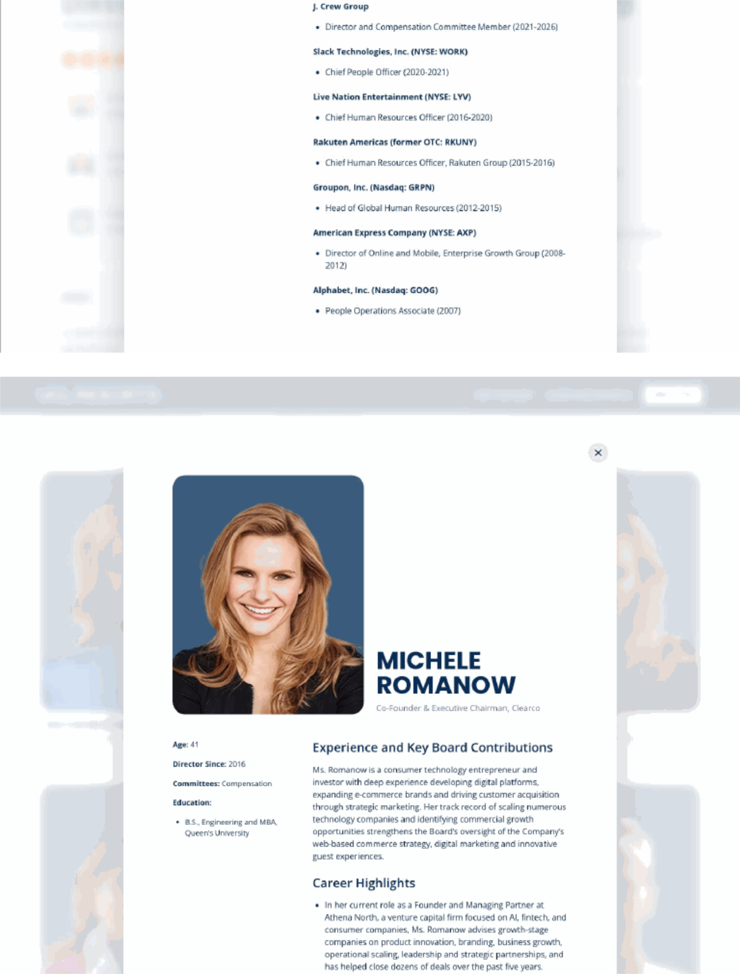

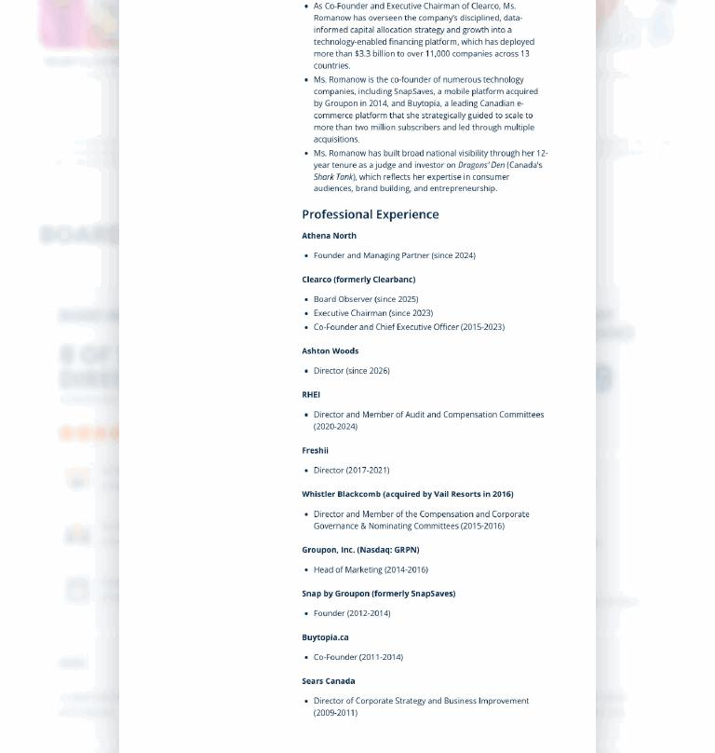

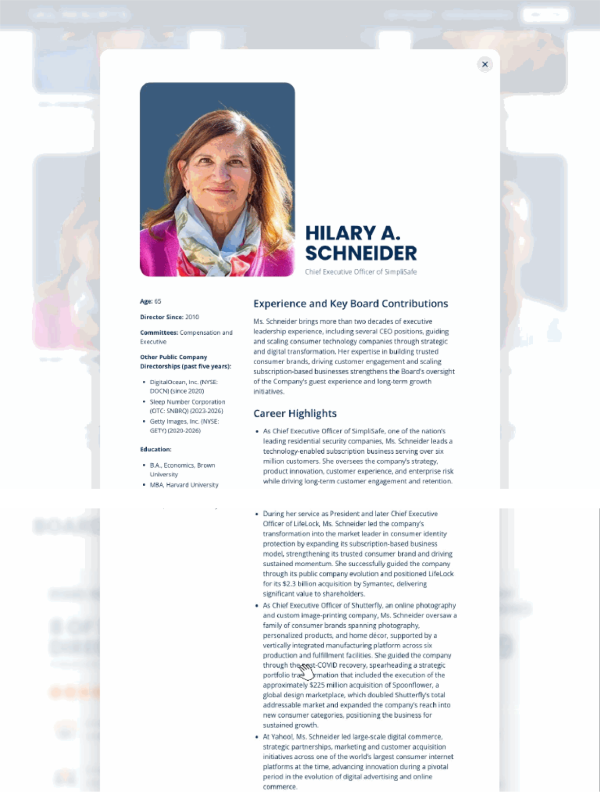

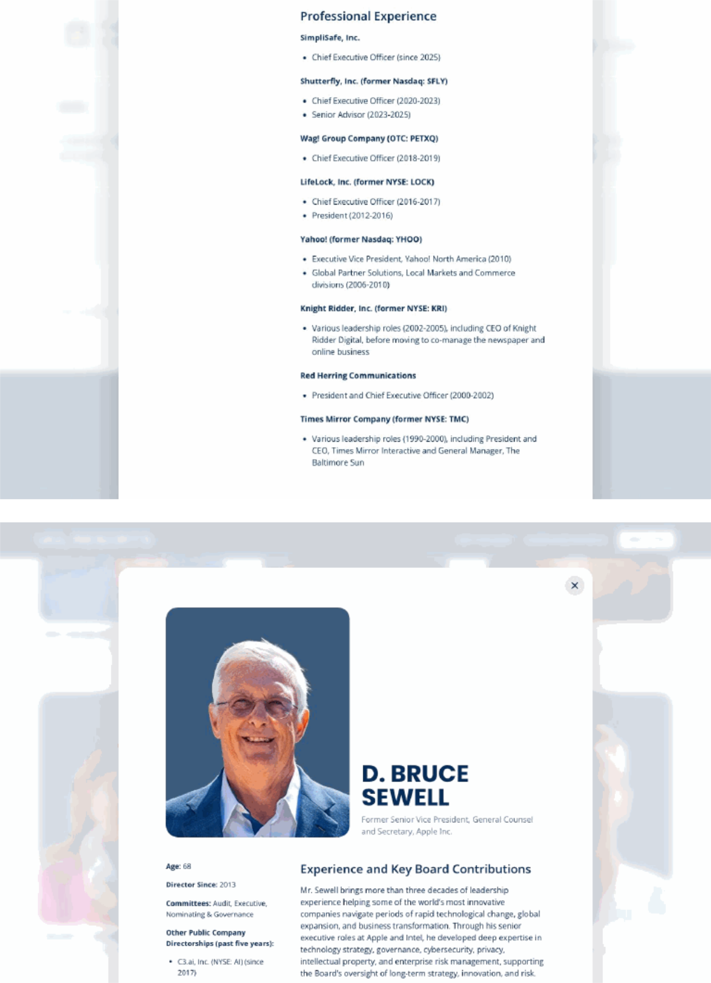

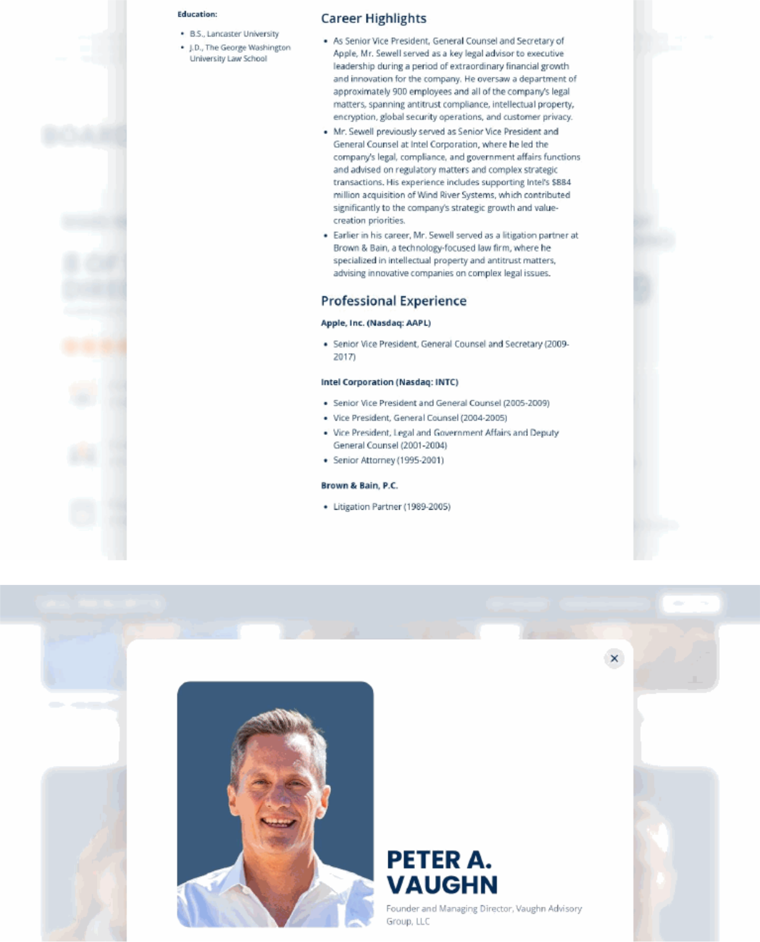

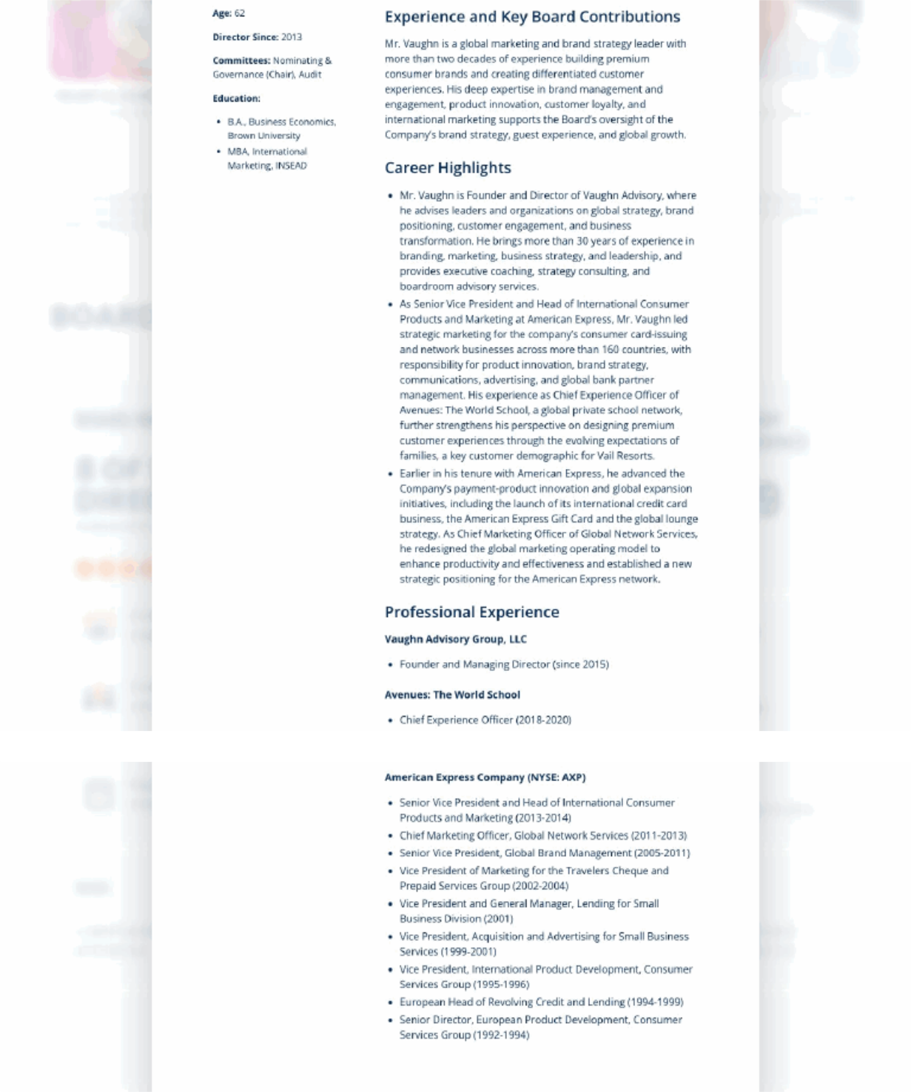

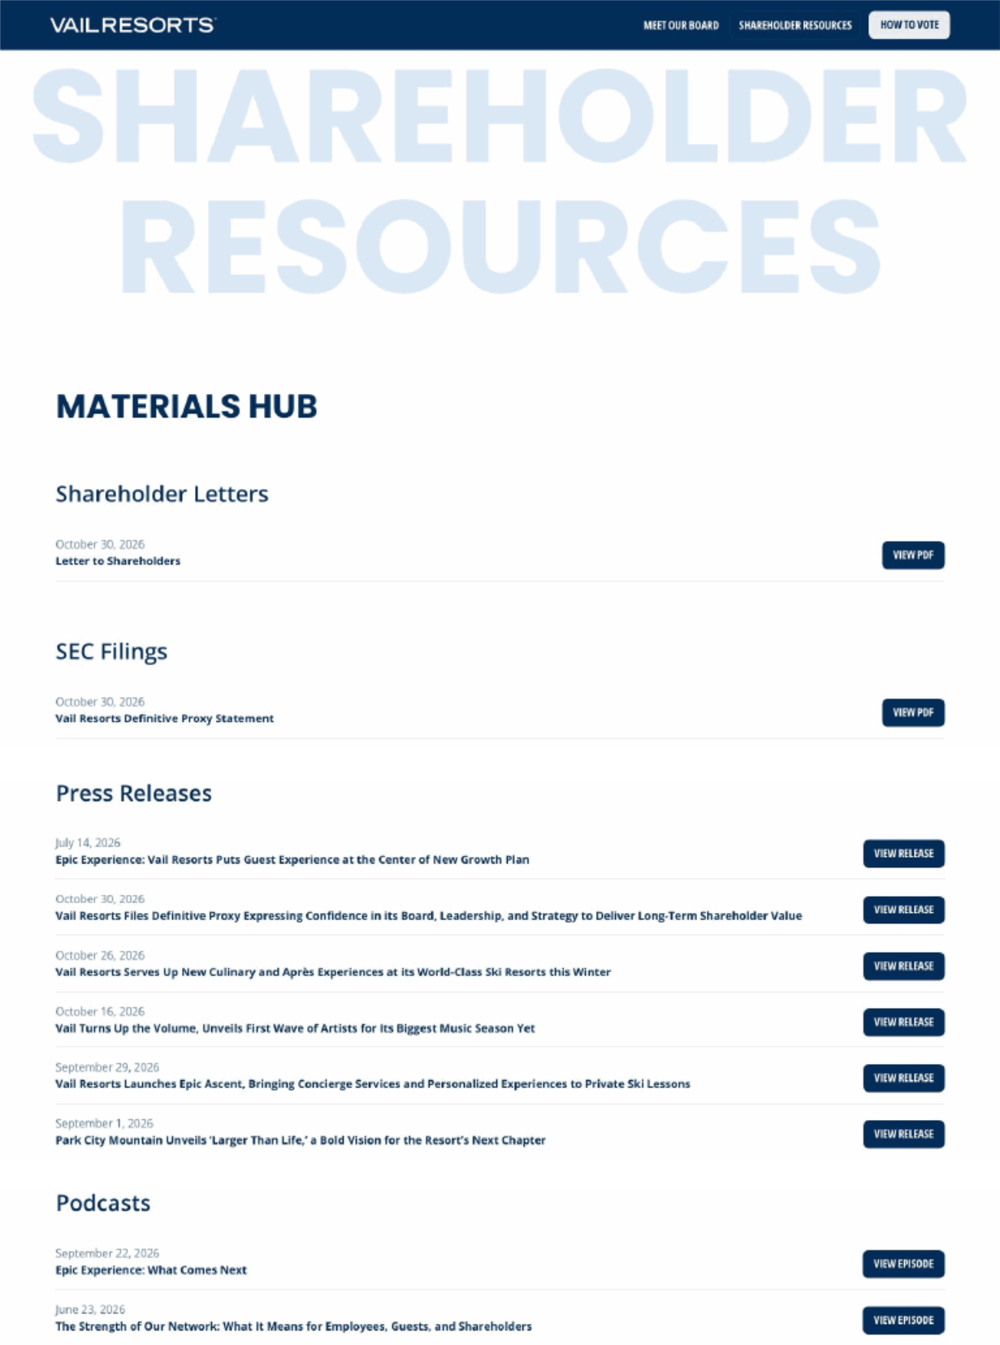

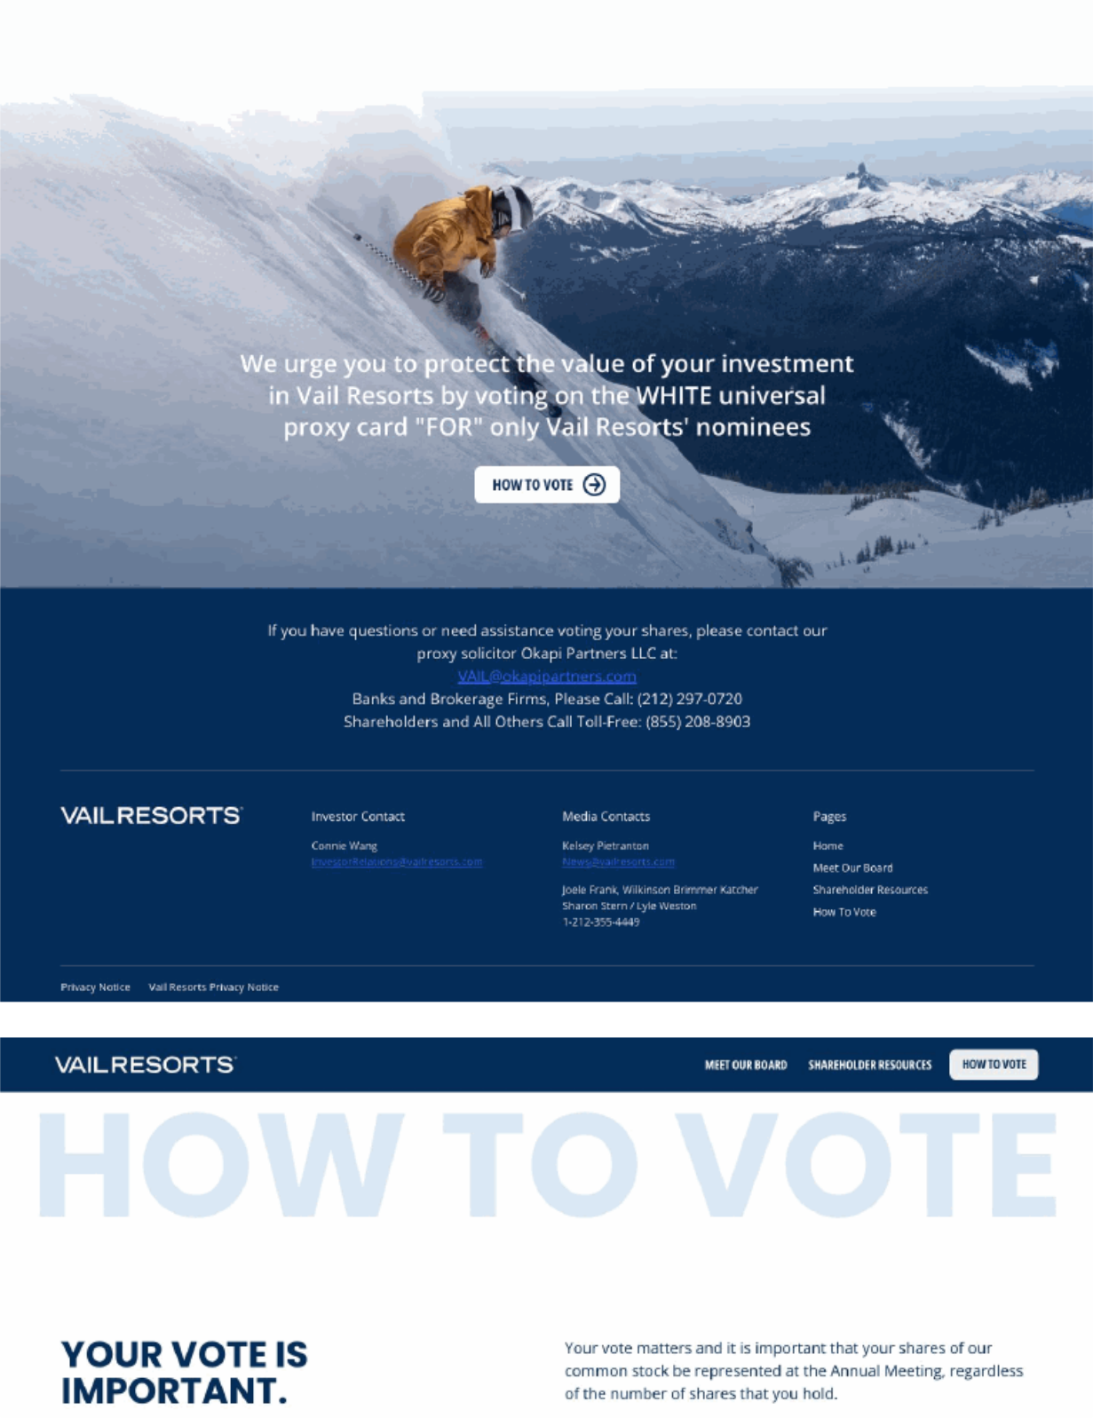

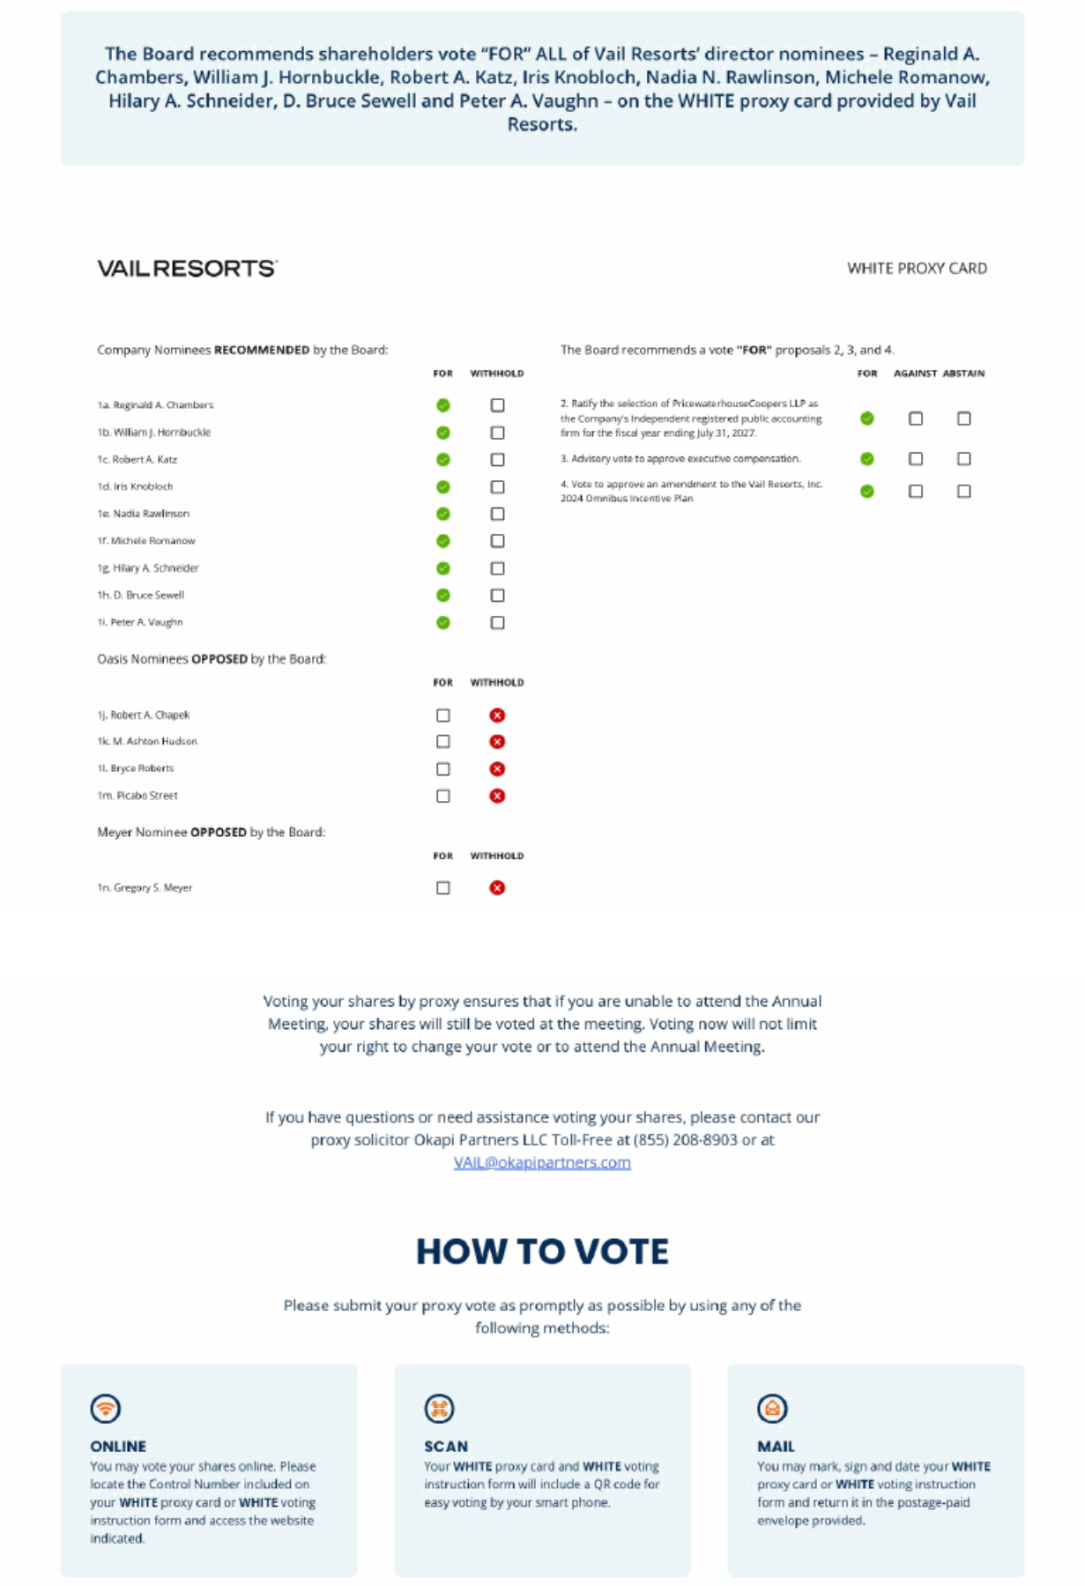

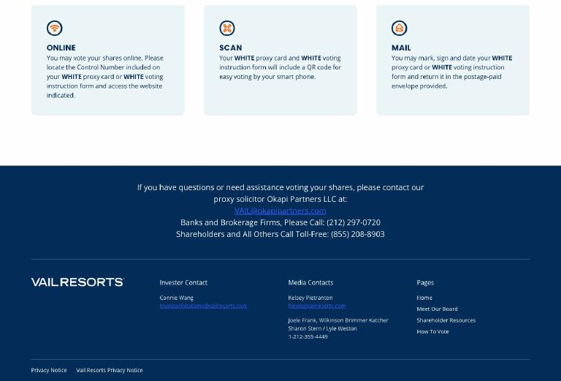

Vail Resorts Serves Up New Culinary and Après Experiences at its World-Class Ski Resorts this Winter

- The company’s largest investment in food to date will enhance the most popular menu items across 15 resorts

- New experiences include the Vail Ice Bar, Park City Mountain’s S’mores Sleigh, Whistler Blackcomb’s Caviar and Champagne service and Breckenridge’s Climb and Dine series

- Elevating mountain food is central to Vail Resorts’ Epic Experience commitment to deliver the best and most differentiated guest experience in skiing and riding

- Epic Pass Holders save 20% on dining all season; Pass prices increase after November 15

IMAGES are available for media use here.

BROOMFIELD, Colo., Oct. 26, 2026 /PRNewswire/ -- As first flakes fall across the mountains and excitement builds for what many hope will be an exceptional Super El Niño snow season, Vail Resorts is giving guests more reason to savor their time on the slopes with new culinary and après experiences.

This winter, the world’s best ski resorts like Whistler Blackcomb, Vail Mountain, Park City Mountain and Breckenridge will introduce new, unique dining and après experiences that reflect the energy, culture and character of each resort. Complementing these offerings, Vail Resorts is making its largest investment in food to date by elevating its most popular quick-service menu items – chili, burgers, pizza, fries, hot dogs, chicken strips, and mac and cheese – with higher-quality ingredients and refined presentation across 15 resorts. These collective dining enhancements are part of Vail Resorts’ Epic Experience commitment to deliver the industry’s best and most differentiated guest experience in skiing and riding. Skiers and riders craving winter in the mountains should lock in an Epic Pass before prices increase after November 15.

“An exceptional guest experience isn’t about a single standout moment, it’s high-standard service delivered at every turn that makes the whole ski trip unforgettable,” said Greg Sullivan, Vail Resorts’

Executive Vice President of Retail-Rental, Hospitality and Food & Beverage. “Great food is a critical part of a memorable day on mountain with some of the best ski day moments happening around the table. We want our guests to know that when they choose to visit our resorts, they aren’t only getting world-class skiing, they are also gaining access to high-quality food, differentiated dining experiences and incredible après scenes to enjoy with friends and family.”

New Food Upgrades to Popular Menu Items Across 15 Ski Resorts

Vail Resorts is making its largest investment in food to date, enhancing the menu items that account for the majority of dining purchases across 15 regional and destination resorts. The ski-day classics guests order most often at iconic mountain lodges – chili, burgers, pizza, fries, hot dogs, chicken strips, and mac and cheese – will be prepared with higher-quality ingredients and enhanced recipes.

For instance, guests can enjoy the new Steakhouse Burger, a butcher’s blend burger with melted New School American Cheese, shredded lettuce and Summit Sauce on a butter toasted brioche bun, served with seasoned waffle fries and the option to add pecan-smoked bacon.

The food improvements this season will not come with higher prices beyond normal inflation, plus Epic Pass Holders receive 20% off dining. In addition to upgraded food offerings, the company is implementing new technology and operational enhancements designed to reduce wait times and increase seating capacity, helping guests spend less time in line and more time enjoying the mountain.

New Dining and Après Experiences Across the Mountains

This winter, guests will discover new ways to dine, gather and celebrate across the mountains. Here’s what’s new to eat and drink across Vail Resorts’ destinations this season:

- At Whistler Blackcomb (BC), guests can experience several new offerings inspired by the region’s renowned food and beverage culture. Guests can enjoy a new Caviar and Champagne service on the patio at Steeps, or sample flavors of the Sea-to-Sky region from its new menu rooted in Pacific Northwest cuisine. At Christine’s on Blackcomb, guests will find an iconic alpine destination with the launch of On The Rocks, an Ice bar complete with cozy outdoor seating where guests can gather for handcrafted cocktails and bubbles.

- At Park City Mountain (UT), guests may be unexpectedly greeted by a traveling S’mores Sleigh bringing fireside treats to surprise locations throughout the resort. The mountain is also expanding its popular Peak to Plate Dining and Skiing Experience, taking guests on a guided journey to ski and dine their way across the mountain, with distinctive dishes inspired by the unique character of each on-mountain lodge. And for a sweet snack, the new Kodiak Cakes Waffle Shack in the Mountain Village base area offers a great spot to stop and refuel.

- At Vail Mountain (CO), après is part of the resort’s DNA, with a rich history of iconic traditions and gathering spots. The mountain is building on that legacy with the new Vail Ice Bar, a lively outdoor destination adjacent to the iconic Legendary Back Bowls Gate. Guests will also find new ways to toast the day, from Bistro 14’s retro-inspired redesign and specialty Spritz menu to the return of the beloved Two Martini Lunch at The 10th, serving martinis, a Caesar salad and fries. Frisco-based Outer Range Brewing Co. will also sponsor the season-long après series at Vail Express Lift Bar and host special events featuring its locally crafted brews across Vail Mountain, as well as Breckenridge, Beaver Creek, Keystone and Crested Butte.

- At Breckenridge (CO), guests will find everything from culinary adventures to over-the-top mountain indulgence. The new Climb and Dine series pairs a self-powered ascent with a curated dinner experience, while the returning Instagrammable Hot Dog Tower serves up a playful, shareable mountain dining moment. Après enthusiasts can raise a glass to the resort’s unique origin story with the new Kingdom of Breck bourbon cocktail or join friends for the Ullr Time Mega Shotski at T-Bar. The resort is also adding a new Sweets Station at TenMile Station complete with cobbler, brownies and large cookies. Nearby, Keystone is also sweetening the ski day with the debut of the Sweet Shack at Summit House, serving loose candy, waffles on a stick and hot chocolate.

- At Beaver Creek (CO), the new Spruce Saddle Cabin Corner brings cabin-inspired dishes to Spruce Saddle offering a casual meal in a convenient on-mountain setting on select dates throughout the season. For a more intimate dining experience, the resort’s renowned Alpine Table Series returns with chef-curated menus and sommelier-selected wine pairings served in an intimate alpine setting.

Guests will also discover new food and après offerings across many of Vail Resorts’ regional mountains. From locally inspired flavors and signature celebrations to upgraded classics and vibrant gathering spaces, this winter’s enhancements are designed to make every ski trip more memorable, and include:

- Crested Butte (CO) will celebrate its 65th anniversary season with the return of its popular Uley’s Cabin sleigh ride dinners, where guests travel by snowcat and sleigh for an intimate on-mountain dining experience.

- Stevens Pass (WA) will celebrate its 90th anniversary season through a collaboration with a local brewery to introduce The 90th, a custom, locally brewed beer crafted exclusively for the occasion.

- Hunter Mountain (NY) will transform its iconic Base Lodge bar into Corduroy’s, a new, expanded indoor-outdoor après destination with more seating and enhanced food and beverage offerings.

- Mount Snow (VT) will introduce a new Maple Syrup Flight that celebrates Vermont’s iconic maple heritage through locally sourced syrup tastings paired with sweet and savory bites.

Resorts To Open Soon and Epic Passes are on Sale Now with Prices Increasing After Nov. 15

As winter nears, and Keystone Resort hopes to open in October, resorts across the east coast are now announcing target opening dates.

Vermont’s premier mountain resorts are gearing up for an exciting 2026/27 season with Stowe Mountain Resort, Okemo Mountain Resort, and Mount Snow targeting Saturday, November 21 for opening day, conditions permitting. This winter is especially notable as Stowe celebrates its 90th anniversary, Okemo unveils major snowmaking enhancements and Mount Snow introduces new mountain experiences, setting the stage for another memorable season across the Green Mountains. Opening dates for resorts in the Rockies and West are available here.

Guests eager to ski and ride this winter can still lock in access and savings with an Epic Pass. Pass prices increase after November 15. With new savings for young adults, skiers and riders ages 13-30 can save 20% on an Epic Pass or Epic Local Pass. Plus, guests who purchase an Epic Pass or Epic Local Pass now will receive five Epic Friend Tickets offering 50% off adult lift tickets, making it easier to bring the crew along and save. Epic Friend Tickets can also be used for 25% off child lift tickets.

In addition to access to world-class mountain destinations, Epic Pass Holders receive exclusive savings including 20% off dining, lodging, group ski and ride school lessons, equipment rentals, and other eligible mountain experiences with Epic Mountain Rewards.

About Vail Resorts, Inc. (NYSE: MTN)

Vail Resorts is a network of the best destination and close-to-home ski resorts in the world including Vail
Mountain, Breckenridge, Park City Mountain, Whistler Blackcomb, Stowe, and 32 additional resorts across North America; Andermatt-Sedrun and Crans-Montana Mountain Resort in Switzerland; and Perisher, Hotham, and Falls Creek in Australia – all available on the company’s industry-changing Epic Pass. We are passionate about providing an Experience of a Lifetime to our team members and guests, and our EpicPromise is to reach a zero net operating footprint by 2030, support our employees and communities, and broaden engagement in our sport. Our company owns and/or manages a collection of elegant hotels under the RockResorts brand, a portfolio of vacation rentals, condominiums and branded hotels located in close proximity to our mountain destinations, as well as the Grand Teton Lodge Company in Jackson Hole, Wyo. Vail Resorts Retail operates more than 250 retail and rental locations across North America. Learn more about our company at www.VailResorts.com, or discover our resorts and Pass options at www.EpicPass.com.

Forward-Looking Statements

Certain statements discussed in this press release, other than statements of historical information, are forward-looking statements within the meaning of the federal securities laws, including statements regarding the Company’s expectations and assumptions related to future performance; guest experience; investments in and enhancements to food, lessons, gear, guest engagement, people, products, services, and other offerings; opportunities; key initiatives; and strategies. Readers are cautioned not to place undue reliance on these forward-looking statements, which speak only as of the date hereof. All forward-looking statements are subject to certain risks and uncertainties that could cause actual results to differ materially from those projected. Such risks and uncertainties include, but are not limited to, risks related to our ability to execute on our key initiatives and strategies; risks related to a prolonged weakness in general economic conditions, including adverse effects on the overall travel and leisure related industries and our business and results of operations; the willingness or ability of our guests to travel due to terrorism, the uncertainty of military conflicts or public health emergencies, and the cost and availability of travel options and changing consumer preferences, discretionary spending habits; risks related to travel and airline disruptions, and other adverse impacts on the ability of our guests to travel; our ability to acquire, develop and implement relevant technology offerings for customers and partners; the seasonality of our business combined with adverse events that may occur during our peak operating periods; competition in our mountain and lodging businesses or with other recreational and leisure activities; risks related to resource efficiency transformation initiatives; risks related to changes in security and privacy laws and regulations which could increase our operating costs and adversely affect our ability to market our products, properties and services effectively; potential failure to adapt to technological developments or industry trends regarding information technology; our ability to successfully launch and promote adoption of new products, technology, services and programs; risks related to our workforce, including increased labor costs, loss of key personnel and our ability to maintain adequate staffing, including hiring and retaining a sufficient seasonal workforce; and the risks detailed in the Company’s filings with the Securities and Exchange Commission, including the “Risk Factors” section of the Company’s most recently filed Annual Report on Form 10-K and quarterly reports on Form 10-Q. All forward-looking statements are expressly qualified in their entirety by these cautionary statements. All forward-looking statements in this press release are made as of the date hereof, and the Company does not undertake any obligation to update any forward-looking statements whether as a result of new information, future events, or otherwise, except as may be required by law.

SOURCE Vail Resorts

For further information: Vail Resorts Communications at news@vailresorts.com

Vail Turns Up the Volume, Unveils First Wave of Artists for Its Biggest Music Season Yet

ILLENIUM and Ian Asher kick off Vail’s biggest music season yet, alongside seven on-mountain performances and two brand-new venues

VAIL, Colo., Oct. 16, 2026 /PRNewswire/ -- With the first snowfall on Vail Mountain’s peaks this week and snowmaking kicked off last night, anticipation for winter is building fast. This season, Vail is raising the bar with its most ambitious music lineup yet, bringing more live music, more venues and more unforgettable performances to the mountain and village than ever before.

Headliners and New Venues

Kicking off the season on December 11, GRAMMY®-nominated, multi-platinum artist ILLENIUM will headline a marquee performance at the new Dobson Arena, ushering in a winter packed with music experiences designed for the mountains. With the potential for surprise performances throughout the weekend, fans will want to keep a close eye on social media at @VailMtn for artist announcements and unexpected moments.

On January 16, Southern California DJ, producer and remix sensation Ian Asher takes over Dobson Arena. Best known for his viral electronic and house remixes, including the billion-stream “Makeba” remix that earned Remix of the Year honors, Asher represents the next generation of dance music talent and expands Vail’s growing lineup of nationally recognized artists.

Freshly transformed into a premier entertainment venue, Dobson Arena combines more than 56,000 square feet of state-of-the-art production capabilities with unmistakable alpine character, creating a concert experience unlike any other in the Rockies.

“There’s nothing quite like live music in the mountains, and we’re excited to bring even more of it to Vail this winter,” said Shaydar Edelmann, vice president and chief operating officer of Vail Mountain. “Working alongside the Town of Vail and our community partners, we’re creating more opportunities for guests to come together and enjoy incredible music in a legendary setting.”

This winter builds on a breakout 2025/26 season, when Vail hosted on-mountain performances from globally recognized artists including SOFI TUKKER, Dillon Francis, Chris Lorenzo and John Summit. Always dreaming bigger, Vail is expanding its music footprint even further with seven on-mountain performances, three more than last season, plus two brand-new music venues.

Following the success of last season’s first-ever sunrise concert beneath the Legendary Back Bowls sign, Vail is once again pushing the boundaries of what an alpine music experience can be. Additional artists, venues and mountain activations will be unveiled throughout the season, giving fans new reasons to visit and new ways to experience music at elevation. Announcements will be released throughout the winter on @VailMtn.

Vail Après Scene

As Vail’s live music lineup grows, so does the experience surrounding it. This winter, the destination will pair headline performances and on-mountain sets with a robust lineup of après events, culinary offerings and nightlife experiences throughout the village.

- NEW! The Vail Ice Bar: A beloved Vail tradition returns. Located next to the Legendary Back Bowls Gate, the reimagined Vail Ice Bar blends alpine nostalgia with a lively outdoor gathering space for drinks, music and après in the heart of Vail Mountain. See images of the historic Vail Ice Bar HERE.

- Après All Day at Express Lift (base of Gondola One, starting opening day): More than 50 performing artists, nearly double last season, with live DJs every Friday, Saturday and Sunday, 2:30–5:30 p.m., in collaboration with Vail Mountain partner Outer Range Brewing. See full schedule HERE.

- Chasing Rabbits: When the lifts stop spinning, the night is just getting started. The Rabbit Hole returns with high-energy DJ sets and unforgettable winter nights, following performances by Loud Luxury, Dombresky and Chris Lorenzo. This winter’s lineup, coming soon, already includes a Coachella headliner, a Billboard Music Awards nominee and internationally recognized DJs.

- Stoke Sessions: Live music every Friday for the first month of the ski season in Vail. Bundle up, sip something warm, and celebrate the season with the Vail community. Lineup announcement coming soon! Follow @discovervailcolorado to be the first to know.

Epic Passes on Sale for the 2026/27 Winter Season

Epic Passes are on sale now and with new savings for young adults, skiers and riders ages 13-30 can save 20% on an Epic
Pass or Epic Local Pass. Plus, guests who purchase an Epic Pass or Epic Local Pass now will receive five Epic Friend

Tickets offering 50% off adult lift tickets, making it easier to bring the crew along and save. Epic Friend Tickets can also be used

for 25% off child lift ticket prices.

About Vail Mountain

Vail Mountain spans more than 5,300 acres of terrain, including the Legendary Back Bowls and Blue Sky Basin. Founded in 1962, Vail is one of the world’s premier mountain destinations and a part of the Vail Resorts network connected by the Epic Pass. For more information, visit Vail.com.

SOURCE Vail Resorts, Inc.

For further information: Lee Nielsen, lee.v.nielsen@vailresorts.com

Vail Resorts Launches Epic Ascent, Bringing Concierge Services and Personalized Experiences to Private Ski Lessons

- Epic Ascent offers concierge services, white-glove gear rental, high-touch customer support and skip-the-lift-line access at Vail Mountain and Beaver Creek this winter

- Bookings accommodate individuals or groups of up to six participants at the same price
- Plus, Company to expand connected Ski & Ride School in the My Epic app to 14 resorts
- Epic Pass Holders can save 20% on group lessons, equipment rentals and more; Pass prices go up after October 7

BROOMFIELD, Colo., Sept. 29, 2026 /PRNewswire/ -- Vail Resorts today announced that Epic Ascent private lessons are now available to reserve at Vail Mountain and Beaver Creek for personalized mountain experiences, expert ski and snowboard instruction, and skip-the-lift-line access this winter. The new Epic Ascent program automatically upgrades all private lessons into guided experiences for up to six guests with exclusive perks and a dedicated concierge to coordinate every detail of the overall trip, including dining reservations, white-glove gear rental, customized ski day itineraries and transportation coordination. Vail Resorts is also expanding connected Ski & Ride School in the My Epic app from four to 14 resorts, further supporting guests’ pathway to skills progression.

“Traditionally, a private lesson began when an instructor met a guest on the mountain,” said Bill Rock, President of Vail Resorts’ Mountain Division. “With Epic Ascent, the private lesson experience now begins well before arrival and extends far beyond instruction, because guests aren’t just booking a lesson – they are booking a mountain guide for a curated vacation experience. Whether you’ve got a group of friends planning a girls’ trip, a family ready to explore the slopes together, or individuals looking for personalized coaching on expert terrain, Epic Ascent brings together expert instruction, concierge planning and insider knowledge to create ski days that feel personal, effortless and unforgettable.”

Epic Ascent is now available to reserve online at Vail Mountain and Beaver Creek. Guests are encouraged to reserve early to secure preferred dates during the 2026/27 season. Group ski and ride lessons are also available to book across Vail Resorts’ North American resorts, with Epic Pass Holders receiving 20% off group lessons. Lock in an Epic Pass or Epic Day Pass before prices increase after October 7.

Epic Ascent Redefines the Private Lesson Experience

Beginning this winter, all private lessons at Vail Mountain and Beaver Creek will be automatically upgraded to Epic Ascent to transform a traditional lesson into a curated mountain experience with vacation-planning concierge support. Epic Ascent will not result in increased private lesson prices beyond normal inflation. Each booking accommodates individuals or groups of up to six participants at the same price and features:

- Expert Instruction: World-class instructors serve as mountain insiders, tailoring the day to meet guests’ goals with personalized coaching and terrain recommendations.

- Concierge Services: Dedicated concierge support helps guests create their ideal mountain experience, including white-glove rental gear arrangements, mountain transportation and dining reservations. An Epic Ascent concierge can coordinate high-quality rental equipment along with exclusive access to a private gear fitting lounge for customized service from expert technicians. Prefer to stay in? Gear can be delivered directly to lodging locations at no additional cost.

- Exclusive Perks: Guests can maximize their time on the mountain with skip-the-lift-line access and the flexibility to choose when and where a lesson begins.

Epic Ascent’s concierge team can also share insider recommendations to curate customized ski day itineraries that adapt to the unique goals and interests of each guest. Itinerary examples include a girls’ trip with morning ski exploration and an afternoon après scene; a family vacation looking to cruise the best blue groomers for shared mountain time; individuals who want personalized coaching on expert terrain before they ski their way to a great meal on mountain; and much more.

Epic Ascent launches at Vail Mountain and Beaver Creek for the 2026/27 winter season, with expansion planned to additional mountain resorts in 2027/28.

Ski & Ride School in the My Epic App Expands to 14 Resorts

Vail Resorts is significantly expanding Ski & Ride School in the My Epic app to offer guests in group lessons digital check-in for seamless arrivals, real-time lesson and photo updates, and the ability to track and build skills progression over time. Originally launched at four resorts in Colorado, the experience will be available at 14 resorts across the country this winter.

Designed for guests participating in group ski and snowboard lessons, connected Ski & Ride School in the My Epic app creates a personalized digital record of each guest’s learning journey, capturing photos, lesson history, skill achievements, terrain milestones and instructor feedback in one place. Key features include digital check-in, real-time updates and photos shared throughout the day, achievement and terrain-based badges, and lesson summaries that help track progress over time and across various resorts. The experience gives parents visibility into their child’s day on the mountain, while providing guests of all ages with a lasting record of their progression wherever they choose to ski and ride.

“Over the past year, we’ve received feedback from guests who greatly appreciated the app’s ability to help parents stay connected during their kids’ lessons and track skills achieved,” said Rock. “Learning to ski and snowboard is a journey, and every lesson should build on the one before it. By expanding access to Ski & Ride School in the My Epic app, we’re offering more guests a connected, personalized way to see that journey come to life.”

Connected Ski & Ride School in the My Epic app is available this winter at Vail Mountain, Beaver Creek, Breckenridge, Keystone, Park City, Crested Butte, Heavenly, Hunter Mountain, Kirkwood, Mount Snow, Northstar, Okemo, Stevens Pass and Stowe.

Epic Passes on Sale for the 2026/27 Winter Season

Guests interested in Epic Ascent and Ski & Ride School this winter should purchase an Epic Pass before prices increase after October 7. With new savings for young adults, skiers and riders ages 13-30 can save 20% on an Epic Pass or Epic Local Pass. Plus, guests who purchase an Epic Pass or Epic Local Pass now will receive five Epic Friend Tickets offering 50% off adult lift tickets, making it easier to bring the crew along and save. Epic Friend Tickets can also be used for 25% off child lift ticket prices.

For those who prefer to customize their access, Epic Day Pass allows guests to choose the number of days they want to ski or ride. An Epic 4-Day Pass offers up to 65% savings compared to lift ticket prices, with prices starting at $223 for adults (ages 13+) and $116 for children (ages 5-12).

In addition to access to world-class mountain destinations, Epic Pass Holders receive exclusive savings including 20% off group lessons, equipment rentals, dining, lodging and other eligible mountain experiences with Epic Mountain Rewards.

IMAGES are available for media use here.

About Vail Resorts, Inc. (NYSE: MTN)

Vail Resorts is a network of the best destination and close-to-home ski resorts in the world including Vail Mountain, Breckenridge, Park City Mountain, Whistler Blackcomb, Stowe, and 32 additional resorts across North America; Andermatt-Sedrun and Crans-Montana Mountain Resort in Switzerland; and Perisher, Hotham, and Falls Creek in Australia – all available on the company’s industry-changing Epic Pass. We are passionate about providing an Experience of a Lifetime to our team members and guests, and our EpicPromise is to reach a zero net operating footprint by 2030, support our employees and communities, and broaden engagement in our sport. Our company owns and/or manages a collection of elegant hotels under the RockResorts brand, a portfolio of vacation rentals, condominiums and branded hotels located in close proximity to our mountain destinations, as well as the Grand Teton Lodge Company in Jackson Hole, Wyo. Vail Resorts Retail operates more than 250 retail and rental locations across North America. Learn more about our company at www.VailResorts.com, or discover our resorts and Pass options at www.EpicPass.com.

Forward-Looking Statements

Certain statements discussed in this press release, other than statements of historical information, are forward-looking statements within the meaning of the federal securities laws, including statements

regarding the Company’s expectations and assumptions related to future performance; guest experience; investments in and enhancements to food, lessons, gear, guest engagement, people, products, services, and other offerings; opportunities; key initiatives; and strategies. Readers are cautioned not to place undue reliance on these forward-looking statements, which speak only as of the date hereof. All forward-looking statements are subject to certain risks and uncertainties that could cause actual results to differ materially from those projected. Such risks and uncertainties include, but are not limited to, risks related to our ability to execute on our key initiatives and strategies; risks related to a prolonged weakness in general economic conditions, including adverse effects on the overall travel and leisure related industries and our business and results of operations; the willingness or ability of our guests to travel due to terrorism, the uncertainty of military conflicts or public health emergencies, and the cost and availability of travel options and changing consumer preferences, discretionary spending habits; risks related to travel and airline disruptions, and other adverse impacts on the ability of our guests to travel; our ability to acquire, develop and implement relevant technology offerings for customers and partners; the seasonality of our business combined with adverse events that may occur during our peak operating periods; competition in our mountain and lodging businesses or with other recreational and leisure activities; risks related to resource efficiency transformation initiatives; risks related to changes in security and privacy laws and regulations which could increase our operating costs and adversely affect our ability to market our products, properties and services effectively; potential failure to adapt to technological developments or industry trends regarding information technology; our ability to successfully launch and promote adoption of new products, technology, services and programs; risks related to our workforce, including increased labor costs, loss of key personnel and our ability to maintain adequate staffing, including hiring and retaining a sufficient seasonal workforce; and the risks detailed in the Company’s filings with the Securities and Exchange Commission, including the “Risk Factors” section of the Company’s most recently filed Annual Report on Form 10-K and quarterly reports on Form 10-Q. All forward-looking statements are expressly qualified in their entirety by these cautionary statements. All forward-looking statements in this press release are made as of the date hereof, and the Company does not undertake any obligation to update any forward-looking statements whether as a result of new information, future events, or otherwise, except as may be required by law.

SOURCE Vail Resorts

For further information: Vail Resorts Communications, news@vailresorts.com

Latest Episode of Epic By Nature: “Epic Experience: What Comes Next”

BROOMFIELD, Colo., Sep. 22, 2026 — What brings guests back to a mountain year after year?

For decades, the ski industry competed on access: bigger terrain, faster lifts, and more places to ski. Today, guest expectations are evolving. Increasingly, success is determined not only by where guests ski, but by how they experience a mountain once they get there.

In the latest episode of Epic By Nature, CEO Rob Katz sits down with his chief of staff to share why Vail Resorts is investing in the guest experience as the next frontier of growth in the ski industry. Together, they discuss rising guest expectations, the importance of loyalty, and how Epic Experience is designed to create more seamless, personalized, and memorable experiences across the guest journey.

The conversation also examines the critical role employees play in bringing Epic Experience to life. From creating moments of genuine hospitality to helping reduce friction throughout the guest journey, our teams help build the lasting connections that keep guests coming back year after year.

Listen to the full episode on Apple Podcasts, Spotify, or SoundCloud, or read the full transcript below.

Full Episode Transcript

Rob: Welcome to Epic by Nature. I’m Rob Katz, CEO of Vail Resorts. For decades, the ski industry competed over access, more mountains, bigger terrain, and faster lifts. Those things still matter, and they always will. But today, guest expectations are evolving, and increasingly we believe the future of growth will be shaped not only by where guests can ski, but how they personally experience our mountains once

they get there. That’s what today’s conversation is about. Over the past several months, we’ve talked about Epic Experience, our company-wide commitment to delivering the most exceptional and differentiated experience in skiing and riding. But today, I want to focus less on what we’re doing and more on why we’re doing it. Why do we believe guest experience has become a critical source of growth and differentiation? Why is loyalty so important to the future of our business? What does all of this mean for our guests, employees, and investors?

To help explore those questions, I’m joined by someone making his first appearance on the podcast, my new chief of staff, David Ganick. Many of you may remember Sarah Schwandt, my previous chief of staff, and I was sorry to see her go, but she has moved on to an incredible role overseeing our Vail Resorts retail organization and overseeing the development and transformation of our My Epic Gear opportunity. I can’t wait to see what she does in that role. But I’m also thrilled to have David in this role. David and I have known each other going back over a decade. David has had so many different incredible roles in our company, and I am lucky to have him now in this chief of staff role. David, welcome to Epic by Nature.

David: Thanks, Rob. Thanks for having me. I’m definitely excited to be here, and I’m excited to talk about Epic Experience. I’m also excited today to maybe ask you some tough questions and see if we can get some candid answers from you and learn a little bit more about how you’re thinking about this next chapter.

Rob: Awesome. I can’t wait to go at it with you over this podcast and the podcasts to come. Let’s start.

David: All right, so let’s start with something you said at the very top. For much of the ski industry’s history, companies competed on terrain, lifts, snowmaking, and destination appeal. Why do you believe that’s no longer enough?

Rob: Yeah, I think it’s a great question. And obviously I’ve been around the industry now, started this kind of business relationship with what was then called Vail Associates back in 1991, so 35 years. And I have watched an incredible progression in the industry. And I think it’s important to highlight that, of course, terrain, lifts, snowmaking, destination, these are all critical. It’s not like these are going away. These are still very important and our company, and I think everybody in the industry still needs to make sure we’re making progress on that. But when I look back, what I really see is this arc.

And that really was started, I think, with the season pass and the efforts by us and others to really ensure that both ski resorts and the communities could have greater stability by putting more of their lift access and their visitation onto a product that was committed before the season started. And I think that’s worked out well for everybody because it’s given more certainty to ski resort companies, us and others who have then used that certainty to invest more in lifts and snowmaking.

But that is the past. And I think as we look to the future, there’s more that we need to do. And the reason why I think it’s no longer enough is because of the state of travel. The good news is that people do want experiences and they’re continuing to travel. And we see that in almost every economic survey you can look at, but they want more. They want to see how you can use technology, how you can use new processes, how you can use people to elevate their experience and take the challenges out of any trip. And I think for skiing and riding, there are many challenges and logistical hurdles that you have to jump over. And I think guests today want to see ski resorts and everybody in travel, but ski resorts really make the investments, come up with the innovations so that they feel like they are getting the best of a ski vacation, that time on the mountain, that time with family and friends, but they’re not necessarily having to go through all the challenges that they may have faced over the last number of years.

David: Yeah, thanks. Makes a ton of sense. And I’ve heard you talk a lot in the past about the need to drive guest loyalty and the need to drive guest satisfaction. And I’m curious to hear you talk about the difference.

Rob: Yeah, I think there is a difference. I think guest satisfaction is obviously really important. We track it religiously. We track it not only in a broad basis like with a net promoter score, but we also track each and every aspect of our business. It’s one of the things that when I look back over the last number of years, I

think our company has really done some great work on. A lot of it’s starting with the investment we made in talent and better staffing.

But yeah, to see record guest satisfaction scores last year in a year that we had really tough weather and tough conditions was amazing, but I don’t even think that’s enough anymore. I think guest loyalty means that they feel not just that they had a good experience while they were on our mountains, but it means that they feel a loyalty to the overall network, the overall experience that kind of transcends one visit. And I think loyalty means we know who the guest is and we can treat that guest differently based on what they want, what they need, what they tell us about themselves. And I think for the ski industry, that’s something that we absolutely have to get better at. And I think we’re now at a point within our company where we have an incredible network, an incredible platform, and we can put the time, effort, and investment into elevating those components that really make guests feel like they are part of the company and our experience in the mountains, not just necessarily having a good time when they come, which of course is still critical.

One of the other things about guest loyalty that’s critical is how it’s important to our business. The ski business is not one that’s going to ever grow very fast. I think that the most important opportunity for us is just to keep maintaining growth. Our ability to drive our company and our share price goes right to that guest loyalty and guest experience point, which is to the extent that we can create better guest loyalty, we will pick up more visits and more trips from our guests. They will use more ski school. They’ll use our gear business more, more food and engage with other products. To the extent that we can do that, that allows us to really hit the kind of growth targets that we have as a company. And that’s why to me, Epic Experience is so important to who we are as a company because it speaks to the future of the experience that we can provide, what the ski industry needs to look like, and how we drive value for our shareholders as well.

David: Got it. So, what are some of the ways that you see the company being able to really drive that guest loyalty?

Rob: Yeah, I think obviously one of the early ways we did it was with season passes and bringing people into a program that meant more and delivered more to our guests than just a lift ticket. But now I think there’s a real opportunity to take that same approach to every other part of the ski business. So you think about what those core components are and it’s things like gear, first and foremost, ski school and lessons, food, guest engagement, how we communicate with our guests, how we deal with feedback, and then certainly lots of other areas around how to navigate the village or parking, the arrival, all of that. And so what I’d say is I think that there are pieces of each one of those that can really be transformed with better process, better technology, better investment. So with gear, this has been at the forefront for us because everyone who gets on one of our mountains needs gear, skis or snowboard.

And I think the way people use gear today hasn’t really changed in the last 50 years, which is there’s some people who want to know what gear they’re going to get when they’re on the mountain and they own gear. And for some people, sure, a small percentage, they’re skiing 50, 100 days a year and they make good use of that. But for a lot of people, they are skiing five days or 10 days a year, but they own gear. So that gear is just sitting in their garage, it’s not getting tuned, it’s not getting updated or waxed or anything like that. Then you have a bunch of people who may not care as much about the gear that they’re using on the mountain, so they’re renting, but historically the rental opportunity was much lower quality gear, wasn’t as comfortable. And I think it actually created a barrier to getting new people into the sport.

So the opportunity with gear in my mind is really to flip it on its head and say, well, wait a minute, we can get the right gear for people where they need it, when they need it for the kind of day that’s out there because we have that size and scale. And so it’s really a transformation of how people use and access gear that makes it easier for everybody. And it’s something that I think it is one of the biggest pain points for everyone about skiing and riding is gear, either going through the rental process or schlepping and carrying or traveling with your gear to a mountain. So if we can solve that, I think it’s a big opportunity. Lessons, really ski lessons are amazing, but we haven’t added anything to that lesson again in 50 years. And so over last year and now this year, basically digitizing group lessons so people can watch and follow their progress, either their own or their kids.

And then we’re also adding this concierge service, this kind of high touch service to private lessons for people who want that experience where every single aspect of their trip has somebody supporting them. And for that clientele, we feel like that’s an amazing opportunity. Food. Obviously we serve and deliver a lot of lunches primarily across our resorts, huge volume. But I think because of the network that we provide, we can actually elevate the quality and ingredients. And so this year we’re really trying to take the ingredients to the maximum they could be while still being able to serve the volume that we do. And then ultimately bringing technology into how people move around and find a seat or go through to get their food and check out. And so really to try and elevate that dramatically. And then last, it is really that guest communication piece where we need to be able to communicate with guests.

There’s a lot of information that’s important to guests throughout their trip, weather, grooming reports, lift line wait times, things like that. And so we need to provide all of that in a format to guests that they can easily use it, access it, and then leverage it for their trip where they’re not really having to put any effort into that because we’re serving it up to them in a way that can be used right off the bat. And I think we’ve seen lots of other people in travel and cruise and airline and hotels do great jobs with that, and I think we can do that as well.

David: Thanks, Rob. All that makes a ton of sense and certainly resonates with me in terms of the experiences. How do you see staffing and how do you see what’s the importance of talent in these strategies?

Rob: Yeah, I think it is the entry point. I think unless in the end, this is an experience, as much as technology and process and everything can make a difference to people’s day, it is the people who ultimately really provide the experience. And we’ve seen that across the board. I mentioned earlier that we had record guest satisfaction scores this year. That was because we had record staffing scores this year. We saw that was by far the biggest increase that we saw. So it’s very clear that if you want to deliver a great experience for guests, you have to be fully staffed and you have to have the right people. And I think one of the reasons why I feel like this is the right time for our company to now be launching Epic Experience is because of the investments that we’ve made over the last three to four years in staffing, starting in 2022 where we made $175 million investment in wages and staffing to make sure that we would be fully staffed, which we have been every year since.

We also have done some things to improve the return rate, like how many people who worked for us last season will come back this season. And so what’s happened is that we’ve taken those two things plus more efficient scheduling, meaning that what we’ve done is we’ve implemented technology and said, “Hey, we have somebody who’s working as a scanner in the morning. They might be able to also get another job or a few hours in the afternoon doing rental returns or they’re working on one of our restaurants at one point in the day and then they’re working as guest engagement during other parts of the day.” We couldn’t do that manually, but now that we have this broad-based system, we actually are using less employees, but giving those employees more hours. So they’re making more money during the season, but we’re hiring less employees, which means we’re putting less pressure on housing in our resorts.

And we’re also hiring less people every year because we’re retaining more each successive season. So then we have been able to be more selective with the employees that we’re hiring to really try and hire people who naturally have an affinity for guest service and guest engagement. And so in my mind, you have to do that well to even earn your ticket to the game, so to speak. You can’t really try and do all these other amazing innovations if you don’t have an incredible staff. And so that always has to stay front and center for us as we go forward. And actually, I think hopefully what we see over the next few years is this flywheel continues where last year we accepted only 11% of the number of people who applied for jobs for frontline staff, which is kind of funny. It almost sounds like an Ivy League school of sorts, but that’s the key to keep doing that every year to get better at that.

David: So Rob, how do you think about the tension between standardization, which is required for all of the experiences and to deliver those experiences that you just talked about with ensuring that we’re not homogenizing the mountain experience and ensuring that each resort feels different?

Rob: Yeah, it’s a great question. Certainly one that’s come up a lot over the years. And yeah, I think one, the success of our company depends on each resort being unique. And when you think about our season pass, one of the key reasons why we were acquiring resorts over the years was because we wanted to provide people more choice when they bought a pass. And so it was critical that people saw the mountains as different. One good thing is that each mountain is very different. The physical structure of the mountain is totally different. The other piece is that a big component of the experience is the local cities and towns and communities that our mountains are in, and they’re all very different. And so the feel and vibe of each one is very different. But what I would say is that as we go across our mountains to try and let’s say elevate staff, to bring people in that have a bigger passion for guest service, to ensure that we’re fully staffed and giving people the most hours, that’s all great, but that doesn’t take away from having people’s individual personality come out as they engage with people throughout their experience.

And over the years we’ve had a lot of different efforts around our service culture, but one of it has always been around personalizing it, making it something that’s personal because we know our mission is that we’re going to provide an Experience of a Lifetime to our employees so that they can provide an Experience of a Lifetime to our guests. And that Experience of a Lifetime is something that’s unique and personal. We want somebody’s passion to come out, so we have to always bring it out. I’d also say that eliminating the hassles of skiing, I don’t think homogenizes the experience. I think it makes it possible for people to really experience the uniqueness of each mountain better and more clearly and without hassles and more time on the mountain, less time in lines, less time going through a checkout line, less time going through a ticket line, less time going through a rental line.

And to the extent that we can eliminate all of that and get people up on the hill, that is what makes each of these mountains so unique is the skiing and the terrain. And so I think that’s, in my mind, at least a pretty easy win. Guest engagement, being able to communicate with our guests better, getting them information quicker, getting them better gear. These are all things that I think regardless of what mountain you’re skiing on or riding on, I think everybody will appreciate. And so although I understand people talking about that tension, I think as we actually move forward to execute this, I don’t actually think these two things will be in tension. I think they will actually be complementary.

David: Yeah, it sounds, I mean, what I hear you saying is that actually by removing some of those hassles and barriers, you actually elevate the unique aspects of each resort and really allow a guest to truly enjoy those components versus having lines or some of these other hassles. Why do you think it’s important to own and operate the resorts versus having partnerships like some of the other models within the industry?

Rob: Yeah, I think this was obviously something we’ve talked a lot about, and I think there’s a lot of hassle in owning a resort and running a resort. It takes a lot of work and investment, people. But when we were building the company way back when, I think we were thinking that this was more than just about selling passes. Selling passes was just one part of the ultimate goal for what we were trying to create. We were trying to create an Experience of a Lifetime.

We can make a difference in ski school and guest communication and guest support and service and guest feedback and recovery, all of those things. We clearly couldn’t do that if we were just doing pass partnerships. And there’s nothing wrong with a pass partnership. Even on getting people to the mountain, one of the things I think we’re seeing is that obviously the pass market is maturing and as we go forward, it’s going to be important that when we bring people to the mountain, we are driving both. We’re driving people who want to buy a pass before the season or people who want to buy lift tickets and we can seamlessly move back and forth on that.

It’s also critical obviously that we’re getting the data, so we get a chance to watch how people are using the products and what their feedback is. And again, that’s not something we could do if we were just about pass partnerships. So for us, it’s been a pretty critical component of how we built the company in the first place.

David: Okay. So three to four years down the road when Epic Experience is working like it’s supposed to, what does that look like?

Rob: It should be a real sea change. And obviously I think we’re definitely thinking big and we understand, look, this is an operational company. It takes time. We have 55,000 employees, most of whom are seasonal, so we only have them for four months of the year. And so getting people on board and trained, making the investments in the technology and all of that’s going to take time. But as we look out a few years, we’re really seeing a very different experience that we can provide, which is around one, an app and websites that give you an amazing opportunity supported by AI to browse and look for the resort that really meets your needs and getting you all the information across this whole network, not just, again, lift access, but every part of the resort, every part of the experience. So you can put together the information and make a decision as to where you want to take your trip, and then obviously start the booking process and do it simply and easily either on an app or web for any of the resorts or products, and that we would know who you are.

So when you come back every year and you’re trying to pick where you want to go skiing, we remember where you went before, we remember what you liked, and so we can make it easier for you to go through that process. And that hopefully takes the hassle, the worry down quite a bit. And in our mind, I think it not only makes the experience better for the current skiing and riding community, but actually creates a much better entry point for new people who want to try out the sport. Because one of the things we know in our sport is that we do have a lot of people that try it out and then don’t come back. And a lot of that is because of gear or their experience on the lesson or the hassle of it. And so to the extent we could do this, we think it’s actually a way to grow the sport.

David: So that’s a pretty exciting view of the future, exciting for me as a part of the team that gets to deliver on it and certainly as a skier and snowboarder. So why do you think we are uniquely positioned to deliver on this vision?

Rob: Yeah, I think because we’ve spent the time and effort to build the company to deliver on all aspects of the vision where we said, “Hey, we’re going to bring our resorts together under a common technology platform. We’re going to hire using best in class technology and systems. We’re going to have a gear business that is all integrated and allows us to leverage all of these pieces and obviously owning and operating the resorts as we talked about earlier, but it really is that it was not easy to bring everybody together under one roof, so to speak, under one culture, under one approach, but this is where we get to show what that can deliver for skiers and riders. And actually, I think, yes, it is more challenging for sure for other people who are built differently and take different approaches. But like with season passes, it took the industry maybe 10 years after we started to get going on season passes.

Yeah, my hope would be that the industry over time actually does follow us in their own way because I think this is better for the sport overall.

David: Thanks, Rob. All right, new ski season, a new chief of staff, and we’re going to mix up the routine a bit. So we’re going to try something new today and incorporate a special mailbag moment in our show. In this segment, I’ll have you answer questions from our listeners and employees. Sounds good. Okay, Rob, the first question in our mailbag moment comes on the heels of us spending time with our Epic Service winners, where obviously a key theme was around service. So what’s something a frontline employee once did for you that changed how you think about service?

Rob: Yeah, I mean, it’s a great question and it goes, I think, to the heart of who we are and what we stand for and what we talk about. And by the way, the experience with our Epic Service Award winners was amazing ambassadors. They were incredible. But to me, I think it was a moment where I had both of my kids, they were younger. We were trying to get to the lift. I was skiing with the two of them. They were maybe five and six or something like that. And I was not in uniform, so nobody knew who I was. And my younger son, I think, dropped his gloves as we were going through lift line, and I didn’t even realize it. And we were now, I don’t know, way back. Now we’re at the front. I’ve got these two kids that I’m with on my own.

And yeah, one of our scanners saw that and there was not a huge line, admittedly, at that time, but he ran back. I didn’t even ask. He just ran back, picked up the gloves and ran back and gave it to my kid. And yeah, I think as a parent, it goes back to this other thing. It’s hard. It’s a hard sport. It’s an even harder sport when you have little kids. And yeah, to have somebody do that without asking, while you feel like

you’ve got your hands full and you’re trying to get your family off on their day, it makes you feel like you’re being taken care of and people are really looking out for you. And to me, yeah, I think that’s always stuck with me and I’ve had a lot of moments like that on our mountains. And I think it’s one of the things that makes going skiing and feeling like you’re in part of a community when you’re at our resorts.

And it always keeps me focused on what’s most important, which is our people and the kind of impact that they can have on providing an amazing experience and bringing family and friends together on the mountain.

David: Thanks for that answer, Rob. To any of our listeners, if you have a question for a future podcast, you can submit your question to podcast@vailresorts.com.

Rob: David, thanks for the time today as always. If there’s one thing today’s conversation demonstrated to me, it’s that the future of our business will increasingly be shaped by the relationships guests build with our mountains. And those relationships are built on the exceptional experiences and service we need to provide as a company. Epic Experience is ultimately about strengthening those connections, reducing friction, and creating more reasons for guests to return year after year. It’s a pretty bold vision, but I think it’s the right vision for our company, ultimately for the industry and how we drive value for shareholders. David, thanks for joining me and thanks to all of you for listening. And I will see you all out on the hill this season.

Park City Mountain Unveils ‘Larger Than Life,’ a Bold Vision for the Resort’s Next Chapter

Larger Than Life is narrated by three-time Olympic gold medalist and Founder of The Snow League Shaun White, whose own career redefined what is possible on snow

Images Approved for Media Use Available HERE

PARK CITY, Utah — September 1, 2026 — Park City Mountain today introduced Larger Than Life™, a new brand platform rooted in a simple belief: this mountain changes you. Not in some small, forgettable way – it settles into your legs the next morning, replays in your mind all summer, and returns as the trip you’re already planning for next winter.

“This mountain is rooted in greatness – Olympians, record-breakers, pioneers – and that energy doesn’t leave. It lives in the snow, in the runs and in the air you breathe at elevation,” said Deirdra Walsh, Vice President and Chief Operating Officer of Park City Mountain. “Larger Than Life gives a name to what makes this mountain so special, while also challenging us to keep moving forward. We’re chasing one thing here – that every part of someone’s day should feel worthy of the mountain it happens on. This winter, that work will come to life in exciting new ways, with even more to come as we shape the future of the resort alongside our community.”

Inspired by the scale, history and energy of the largest ski resort in the United States, Larger Than Life draws on 7,300 acres of possibility and the thousands of perfect moments that live across them – clearing the snow from your face on a powder day in McConkey’s Bowl, chasing a friend into town on Quit n’ Time, taking in the view from the top of Jupiter Peak, trading stories over Orange Bubble Bites when the lifts stop spinning. More than a campaign, the platform brings together significant investments, new infrastructure, global competition, immersive on-mountain experiences and a renewed commitment to planning for the resort’s future. Park City Mountain has always had a personality all its own, and Larger Than Life is part of a wider effort across Vail Resorts to bring each mountain’s personality fully to life.

Helping to tell this new brand story is three-time Olympic gold medalist and Founder of The Snow League Shaun White. One of the most decorated athletes in snowsports history, White spent a career redefining what was possible on snow, and Larger Than Life is narrated in his voice – his own larger than life career running parallel to the mountain’s. Across television, digital, social media and out-of-home creative, White connects some of his biggest career-shaping moments to Park City Mountain as the place where greatness has long been made.

“There’s something special about Park City Mountain,” Shaun White said. “It’s an incredible place to ride, with so much terrain and so many different ways to experience the mountain. I’ve had some memorable times there over the years, and I’m excited to be part of this campaign to help showcase what makes the mountain so great.”

Larger Than Life is the clearest expression yet of a multi-year effort to elevate the guest experience. In the last decade, the resort has invested more than $144 million in lifts, terrain, snowmaking, restaurants and other improvements, including the Sunrise Gondola, major snowmaking upgrades in Canyons Village, redeveloped beginner ski and ride zones and terrain park enhancements. That transformation continues in the 2026/27 season with a reimagined arrival experience at Canyons Village, where the new 10-person Canyons Village Skyway will be the second new gondola to debut in as many winters. Together, the Skyway and the new Canyons Village Parking Structure will create a more comfortable and seamless journey from arrival to the slopes. The resort is also pleased with the recent approval by the Park City Planning Commission to upgrade Silverlode Express and Eagle Lift.

This summer also brought Park City Mountain’s first remote avalanche control system to Limelight Bowl, giving resort operations a safer, more efficient way to open an important stretch of terrain. The resort also used 3D modeling to reshape the superpipe’s foundation, creating a feature that will host the world’s best while training the next generation of skiers and riders headed into 2034.

Larger Than Life will come alive during the 2026/27 season through elite competition and unexpected moments across the resort.

Guests who visit Park City Mountain this winter can expect:
- Shaun White’s The Snow League, coming to Park City Mountain January 21 through 23, 2027, bringing the world’s top halfpipe snowboarders and freeskiers to the resort for three days of competition, live music and immersive fan experiences

- The return of a 22-foot superpipe, which will remain a premier terrain park feature following The Snow League as the resort builds toward the 2034 Olympic Winter Games

- A traveling S’mores Sleigh delivering fireside treats to surprising locations around the mountain
- The expansion of our Peak to Plate one-of-a-kind skiing and dining experience that allows guests to eat their way across the mountain

Park City Mountain’s winter will also reflect improvements underway across Vail Resorts through Epic Experience – including reimagined rentals with My Epic Gear, a more seamless and personalized ski and ride school experience in the My Epic app, and a significant investment in on-mountain dining with higher-quality ingredients and refined presentation for the resorts’ most popular menu items.

The work will not stop there. Park City Mountain will continue planning how the resort evolves in the years ahead – how lifts, dining, snowmaking, skier services and the arrival experience can better serve skiers, riders, employees and the surrounding community – with each step raising the bar on what Larger Than Life means here.

“There are thousands of ways to spend a day here, and no two guests spend it the same way,” said Walsh. “That’s the part I love – everyone leaves with a trip that belongs only to them, made of moments they found themselves. That’s what larger than life means to us.”

There is more in store. Additional events, experiences and offerings will be announced closer to the start of the winter season. Epic Passes are on sale for the 2026/27 season, and Young Adults ready to experience Park City Mountain get 20% off an Epic Pass.

###

Media Contacts:

John Kanaly, john.kanaly@vailresorts.com

Bailey Quinn, bailey.t.quinn@vailresorts.com

About Park City Mountain

Park City Mountain is the largest ski and snowboard resort in the United States, offering 7,300 acres of terrain, more than 330 trails and two distinct base villages in the heart of Park City, Utah. Located approximately 35 minutes from Salt Lake City International Airport, the resort combines expansive mountain terrain with direct access to one of the country’s most celebrated mountain towns. Park City Mountain is part of the Vail Resorts network connected by the Epic Pass and is a proud venue for the Olympic Winter Games Salt Lake City-Utah 2034. For more information, visit ParkCityMountain.com.

Epic Experience: Vail Resorts Puts Guest Experience at the Center of New Growth Plan

- Begins multi-year transformation of the end-to-end guest journey, setting a new standard for the modern ski experience across its network of premier mountain destinations

- Raises the bar on mountain food with significant investment to elevate its most popular dishes
- Launches Epic Ascent for an enhanced private lesson experience with concierge services, white-glove gear rental and high-touch customer support

BROOMFIELD, Colo., July 14, 2026 /PRNewswire/ -- Vail Resorts CEO Rob Katz today announced a new era for the company defined by delivering the best and most differentiated guest experience in skiing and riding. Anchored to the belief that future growth will come by offering an exceptional experience that drives loyalty and visitation, the Epic Experience vision spans a multi-year roadmap that comes with a series of immediate investments in food, lessons, gear, guest engagement and talent. Most notably, new next season, Vail Resorts will raise the bar on mountain food with a significant investment to elevate its most popular dishes, and introduce Epic Ascent to enhance private lessons with concierge services.

“For years, Vail Resorts focused on building the Epic Pass model and expanding its resort network,” said Katz. “That strategy helped establish the company’s position today, but the Pass and acquisitions were not the end goal. The next chapter of growth for Vail Resorts is about delivering a guest experience that undeniably leads the ski industry and is best in class in the travel sector. Epic Experience is about using the strength of our integrated model and leveraging our scale and technology to make every part of the mountain journey more seamless, personalized and memorable.”

As the world’s largest and only fully integrated ski resort company, Vail Resorts has consistently led the industry in innovation and is uniquely positioned to influence every part of the end-to-end guest journey across its network of premier mountain destinations.
“Exceptional experience is not one moment – it is the standard we want guests to feel across their entire journey. From the food, lessons and gear that shape a day on the mountain to how we communicate with and support our guests, we are focused on removing friction, elevating the experience and creating more moments that inspire guests to return.”

Throughout its transformation of the guest experience, Vail Resorts will continue to prioritize delivering an incredible experience on snow. The company will maintain its industry-leading investments in lift infrastructure to help guests get up and around the mountain faster, while taking an aggressive approach to snowmaking strategy and technology to create the best possible early-season and in-season conditions for guests.

Beyond the snow experience, Vail Resorts will focus on the five experience pillars outlined below to drive future growth.

Reimagining Rentals with My Epic Gear

Vail Resorts is continuing its previously announced plans to integrate the best features from My Epic Gear® into traditional gear rentals, as part of a multi-year effort to transform the gear experience for all skiers and riders.

Beginning this season, guests who book high-performance Demo rentals at the company’s rental outlets across 12 participating resorts will receive the curated My Epic Gear experience without the membership

fee. That includes the ability to select their preferred ski or snowboard model, and BOA® ski boots or Step On® bindings, online, ahead of their arrival.

Ahead of the 2027/28 winter season, Vail Resorts’ rental outlets will offer expanded and upgraded gear and service options, which will include the ability for anyone to choose a specific gear model – online or in app. Returning guests will have the ability to get their skis or snowboards fully teched, tuned and ready for pickup or delivery, without going through an in-store fitting process. Other future offerings include slopeside valet and digital enhancements for easier browsing and booking.

Elevating Lessons into Personalized Mountain Experiences

Vail Resorts is redesigning its private lesson experiences to be more personalized and seamless for every guest. This winter at Vail Mountain and Beaver Creek, the company will upgrade all private lessons to Epic Ascent, an elevated private lesson experience offering concierge services, white-glove gear rental and enhanced customer support.

Private-lesson guests will get high-touch customer support and a dedicated concierge to coordinate every detail of their overall trip, like dining reservations, transportation coordination and white-glove gear rental. Epic Ascent will expand across more Vail Resorts mountain destinations in the 2027/28 season. More information on Epic Ascent will be shared ahead of the upcoming season.

In parallel, Vail Resorts is further simplifying the pathway to progression with connected ski and ride school in the My Epic app by expanding from four to 14 resorts. A first-of-its-kind digitized offering, ski and ride school in the My Epic app offers guests in group lessons a seamless arrival with direct-to-lesson digital check-in. It helps parents stay connected with real-time updates and photos during child lessons, and monitor progression with skills tracking that includes badges for milestones achieved.

Setting a Higher Standard for Guest Engagement

Vail Resorts is committed to delivering a guest service experience that feels more thoughtful, responsive and connected at every step of the journey. The company’s ambition is to make every interaction and communication feel easier, more personal and more supportive – so guests feel confident, cared for and inspired to return. This commitment reflects the belief that an exceptional experience is not a single moment, but a consistent standard that shapes the entire trip.

Supporting this focus on guest engagement are continued investments in digital technology to remove the small hassles that get in the way of enjoying the magic of the mountains. Starting this fall, guests will be able to purchase Passes and lift tickets, as well as share Epic Friend Tickets with friends and family, directly in the My Epic app. Guests can also expect the introduction of Apple Pay and Google Pay, while continuing to enjoy favorite features like Mobile Pass, lift line wait times, Find My Friends and personalized stats.

Ahead of the 2027/28 season, guests will be able to purchase lessons and rentals directly in the My Epic app. Future app enhancements will leverage modern AI to support intuitive trip planning and surface intelligent personalized recommendations and itineraries – from parking and lessons to lunch, après and more.

Raising the Bar on Mountain Food

Skiing and snowboarding are about the full on-mountain experience, and food is a critical part of a memorable day on the slopes. As Vail Resorts embarks on a journey to elevate dining on the mountains, the company is making its most popular menu items better across 15 destination resorts. Ski-day classics like chili, burgers, pizza, fries, hot dogs, chicken fingers, and mac and cheese

– which make up the majority of resort food sales – are all getting elevated with a significant investment in higher-quality ingredients and refined presentation. For instance, guests across 15 destination resorts can enjoy a butcher’s blend burger with melted New School American Cheese and pecan-smoked bacon on a griddled brioche bun, served with crispy waffle fries and a signature comeback sauce.

Next season, skiers and riders will continue to see chef-driven dishes that bring fresh energy and flavor to each mountain experience. Resorts like Vail Mountain, Beaver Creek, Breckenridge and Whistler

Blackcomb will continue to focus on the development of unique signature dishes that reflect the energy, culture and character of each resort.

More information will be shared in the coming months. The food improvements next season will not come with higher prices beyond normal inflation. In addition to elevated food, the company will be looking to add new technology and processes to reduce wait times and increase seating capacity.

Investing in Top Talent to Drive Excellent Guest Service

Vail Resorts is committed to making every interaction easier and more personal by elevating its ability to anticipate and exceed guests’ expectations. Delivering an exceptional guest experience starts with excellent people, who will always be the foundation of the company.

Following a $175 million investment in wages and benefits, the company has continued to build a world-class frontline team through a disciplined, technology-enabled approach to recruiting, staffing and scheduling. These investments have helped the company remain fully staffed each season, become more selective in hiring for guest-service orientation, increase seasonal employee return rates and give employees more hours while reducing overall hiring and housing pressure. This is collectively translating to better service, with frontline teams serving as a key driver of record guest satisfaction scores last season.

IMAGES are available for media use here.

About Vail Resorts, Inc. (NYSE: MTN)

Vail Resorts is a network of the best destination and close-to-home ski resorts in the world including Vail Mountain, Breckenridge, Park City Mountain, Whistler Blackcomb, Stowe, and 32 additional resorts across North America; Andermatt-Sedrun and Crans-Montana Mountain Resort in Switzerland; and Perisher, Hotham, and Falls Creek in Australia – all available on the company’s industry-changing Epic Pass. We are passionate about providing an Experience of a Lifetime to our team members and guests, and our EpicPromise is to reach a zero net operating footprint by 2030, support our employees and communities, and broaden engagement in our sport. Our company owns and/or manages a collection of elegant hotels under the RockResorts brand, a portfolio of vacation rentals, condominiums and branded hotels located in close proximity to our mountain destinations, as well as the Grand Teton Lodge Company in Jackson Hole, Wyo. Vail Resorts Retail operates more than 250 retail and rental locations across North America. Learn more about our company at www.VailResorts.com, or discover our resorts and Pass options at www.EpicPass.com.

Forward-Looking Statements

Certain statements discussed in this press release, other than statements of historical information, are forward-looking statements within the meaning of the federal securities laws, including statements regarding the Company’s expectations and assumptions related to future performance; guest experience; investments in and enhancements to food, lessons, gear, guest engagement, people, products, services, and other offerings; opportunities; key initiatives; and strategies. Readers are cautioned not to place undue reliance on these forward-looking statements, which speak only as of the date hereof. All forward-looking statements are subject to certain risks and uncertainties that could cause actual results to differ materially from those projected. Such risks and uncertainties include, but are not limited to, risks related to our ability to execute on our key initiatives and strategies; risks related to a prolonged weakness in general economic conditions, including adverse effects on the overall travel and leisure related industries and our business and results of operations; the willingness or ability of our guests to travel due to terrorism, the uncertainty of military conflicts or public health emergencies, and the cost and availability of travel options and changing consumer preferences, discretionary spending habits; risks related to travel and airline disruptions, and other adverse impacts on the ability of our guests to travel; our ability to acquire, develop and implement relevant technology offerings for customers and partners; the seasonality of our business combined with adverse events that may occur during our peak operating periods; competition in our mountain and lodging businesses or with other recreational and leisure activities; risks related to resource efficiency transformation initiatives; risks related to changes in security and privacy laws and regulations which could increase our operating costs and adversely affect our ability to market our products, properties and services effectively; potential failure to adapt to technological developments or industry trends regarding information technology; our ability to successfully launch and promote adoption

of new products, technology, services and programs; risks related to our workforce, including increased labor costs, loss of key personnel and our ability to maintain adequate staffing, including hiring and retaining a sufficient seasonal workforce; and the risks detailed in the Company’s filings with the Securities and Exchange Commission, including the “Risk Factors” section of the Company’s most recently filed Annual Report on Form 10-K and quarterly reports on Form 10-Q. All forward-looking statements are expressly qualified in their entirety by these cautionary statements. All forward-looking statements in this press release are made as of the date hereof, and the Company does not undertake any obligation to update any forward-looking statements whether as a result of new information, future events, or otherwise, except as may be required by law.

SOURCE The Vail Corporation

For further information: Vail Resorts Communications at news@vailresorts.com

Epic By Nature Episode 29: The Strength of Our Network: What It Means for Employees, Guests, and Shareholders

BROOMFIELD, Colo., June 23, 2026 — For nearly two decades, Vail Resorts’ integrated network of world-class resorts has been at the heart of the company’s success. But as the ski industry evolves, that owned-and-operated model is becoming even more important to the future of growth.

In the latest episode of Epic By Nature, CEO Rob Katz sits down with his chief of staff to discuss why Vail Resorts believes its integrated network of resorts remains one of its greatest competitive advantages. Together, they explore how the company’s scale, shared technology platforms, and unified culture help create opportunities for employees, enhance the guest experience, and drive long-term value for shareholders.

Listen to the full episode on Apple Podcasts, Spotify, or SoundCloud, or read the full transcript below.

Full Episode Transcript

Rob: Welcome back to Epic By Nature. I’m Rob Katz, CEO of Vail Resorts. On today’s episode, I want to dive into something that seems to be coming up a lot recently, especially from some rather loud voices. It’s about one of our biggest strengths as a company, a strength that many seem to misunderstand, the power of our owned-and-operated integrated network of 42 world-class resorts that is at the heart of our business model.

That network is what has enabled our success over the past nearly 20 years. It’s what made the Epic Pass possible, that reshaped the global ski industry. But more importantly, it’s what will allow us to innovate across our resorts in a way that uniquely elevates the guest experience and allows us to better market to our guests, whether for lift tickets or passes and better communicate and engage with our guests. This is how we will drive value in the future.

As I said when I first came back to the CEO role one year ago, passes, both Epic and Ikon, as important as they are, will not be the defining story of the ski industry going forward. It will be about the guest experience. Just as this industry shift is happening, we have seen some folks question why it makes sense for our company to own and operate our resorts and suggesting maybe we sell some of our biggest and most iconic resorts, that somehow it would be better for the company and our communities, that we are worth more broken apart than we are being together, and that if we don’t do this, some shareholders may try to force us to do it.

I understand that some Wall Street folks will always think that a company is better broken up than together. I spent 14 years on Wall Street and absolutely understand that world and what some shareholders may think they want. I also understand why this does not make any sense for us or for our shareholders.
But I get questions about it from many of our team members. So today, my Chief of Staff, Sara, is going to help me unpack all of this. Everything from why and how our network gets its strength, to

understanding why these questions are being raised now, to how we approach aligning with our investors. If nothing else, to try and break apart for our employees, fact from fiction.

Sara: Okay, Rob, so let’s start at the beginning. What is it about our network of resorts that is so foundational to our business model and success as a company?

Rob: Yeah. The network of resorts was critical as we were building a season pass program. So way back when, more than almost... It’s now almost 20 years ago, when we came up with the idea to create the Epic Pass and to make season passes a defining feature of the company, something that would provide tremendous stability, not only for the company, but for our communities.

We realized that it would be important that when we were offering a season pass that we offered more resorts to people, that people had choice because it’s one of the great things about the ski industry is that no two ski areas are alike. And skiers and riders all over the world like that diversity and choice. And so if we were going to offer people a product that they had to buy before the season, we knew that the more resorts we could put on the pass, the better.

We also knew that it would be important to have resorts in a number of locations around North America and ultimately around the world so that people could participate and benefit from the different weather patterns that occur during a season. And I think this past season is a great example because while Colorado and Utah and Tahoe had really challenging weather, the Northeast had an amazing ski season. And so a lot of our passholders in the Northeast got a chance to use their passes in our Northeast resorts. So having that network was critical as we built a season pass that would be transformative.

Now we also thought that it would be critical for us to own and operate our resorts within that network to make the season pass successful. It was critical that our resorts would really get behind it 100%, and I think that’s how we got our company to the point where 75% of our visits are coming on a pass. When you look at this past season, again, that was an incredibly important step in terms of allowing us to weather, no pun intended, this past season.

Now it’s also important to understand that while we were acquiring resorts over the last 15 years to make our pass better, we also took the step to integrate those resorts, to bring all of these ski mountains together under one platform, under one culture, under one technology system, to try and use best practices across all of our resorts to try and have everyone actually get better.

The first was that we thought there was tremendous power in creating a career path for the people who worked at our resorts. We thought that there was a unique opportunity for our company to actually allow people to join the ski industry and have a more rapid progression in their career. Historically, because each resort was kind of on its own, somebody would join and they’d have to wait for their boss to retire or leave, and very often you didn’t see that kind of career progression that you see in many other industries. For our company, because we now had a lot of resorts, we were able to give people this opportunity. They could join as a lift operator in one resort, they could move up to a lift supervisor in another resort, they could move up to management in another resort.

But to do that, we needed a unified culture and a unified way of doing things. And I think you look back over the last 15 years and while there’s no doubt that our season pass has been incredibly successful, I actually think the career progression that we’ve created within the company where you see every time we are looking to promote a new GM or COO of one of our resorts, we, 95% of the time, are promoting from within because we’ve created this incredible progression for people. So this career piece and talent piece was really important.

The second piece was that our ultimate goal in bringing the resorts together was not just about a season pass, it was about creating a way to elevate the guest experience across all of our resorts.

Sara: Yeah, Rob, I think those are all really good points, but I am really curious to hear a little bit more around how this model really can benefit our guests from a guest experience standpoint when they’re in resort, or maybe even when they’re thinking about booking their trip to one of our locations.

Rob: Yeah, that is a valid question because while we were building this network, again, over 15 years we went from five resorts to 42 resorts, and we built this season pass program from a couple of hundred thousand units to almost 2.5 million units at one point. I think we didn’t actually have the bandwidth to also elevate the guest experience in some of these other ways. I think we really clearly made some huge improvements on selling season passes and we also did some great innovations around introducing RFID and making it easier for people with the mobile pass where you can use your phone to get on the mountain. So like lift access, we really did a lot with.

But in so many other areas, we didn’t actually showcase what we could do as a company. And I do think, yeah, there are critical ways that we can make a difference. And that is all the things that we’re talking about as we go forward, things like gear, ski school, food and talent, people who are at our resorts, which in the end are the most foundational critical piece to delivering guest experience.

But when you think about all these areas, these are all places where season passes and how you get on the mountain has had a lot of innovation. All of these other parts of the ski and snowboard experience have not really seen any innovation over the last 30 to 40 years. And so I think our company, because of our size and scale, has a unique opportunity to truly transform these other areas. In gear, we’ve talked about My Epic Gear quite a lot and it’s an opportunity to get people the gear that they want, when they want it, without having to actually bring it or carry it to the slopes.

I think the same is true for a ski school. Also, an amazing experience, critical, and one that hasn’t changed much.

This past year we introduced kind of this digitization of the ski school experience where when you go and take a group lesson at one of our resorts, we are tracking how you’re doing. We’re taking photos of you. We’re literally having the instructor put down almost like in a report card format, how you’re doing, what you’re working on. And so you have it in your app when you leave and the next time you come to one of our resorts to take another lesson, it’s right there. And so the next instructor, the next person you’re taking a lesson from, no matter what resort it’s at, ultimately we’ll be able to track you. And that’s an amazing thing to do for you and an even better thing to do for your kids.

You’re going to hear us talk more later this summer about some opportunities in private ski school where candidly, again, an amazing experience, but one that really could use a little bit of a refresh in terms of what private ski instruction is all about because it’s not just about the instruction.

Food. Another area where we think we can elevate by using our size and scale, the quality of the food, and ultimately bring technology and best-in-class approaches to how people get their food to make that experience better.

And then maybe most importantly, it’s about people. And I think our company back in 2021, 2022, had some very public issues with not having enough staffing in our resorts. We made a critical decision that year to invest $175 million into our seasonal frontline staff. Every year since then we have been fully staffed and have been in this terrific position. Part of that is that investment.

But another part is that we are using technology to recruit in best in class ways to bring people into our resorts to work. We’re doing a better job selecting people to come to the resorts by giving people screenings so we know we’re bringing in people who are oriented towards guest service. Our return rates year after year are, actually continue to go up and are at record levels.

And then finally, I think just we introduced workforce planning, which is a technology that allows all of our staffing and scheduling decisions to be done in a more unified way. It’s actually allowed us to get more hours to each employee and hire less employees, which means less people need housing. We don’t need as many people in the resort, which reduces the impact there, but we’re actually getting just as many hours as we need. And when you look back at this last season, we’ve been really candid about this. We saw huge increases, record levels of guest satisfaction scores. And one of the primary drivers of that was our staffing scores.

And all of these areas are things that, if you’re a standalone resort on your own, it’s hard to innovate around this. It’s hard to put the capital around this. We think some of these solutions can only be delivered if you do have a network of resorts and the support that goes with that.

Sara: Okay. So I guess I have to ask the question then. What about other models that are out there, specifically ones that don’t anchor towards this owned-and-operated concept but are more focused on that partnership model? What about those and how they approach the business?

Rob: Yeah. And I think a lot of those models have been successful in selling passes and in converting people who want to go to a lot of these other resorts, including a lot of so-called independent resorts.

And I actually think that’s been a great thing for the ski industry. I don’t think it’s been a bad thing. And I said when a lot of these models started coming onto the scene that I really welcomed them because I think it has helped provide stability to the whole industry. But I do think there are a number of drawbacks in this and certainly when you look at our biggest competitor, our biggest competitor, although they’ve relied on partners, has also been quite acquisitive where they could buy resorts. And so it kind of highlights that I think it’s not just us, but others that see that there are some challenges in just having a partnership model.

And I can go through a handful of them and why we have really avoided it because I do get this question from a lot of people. When you have a partnership model, you’re only getting a very small percentage of the revenue that comes from season passes. So it makes it hard to do things like lower the price of a season pass, like we just did for the young adult pass that we just launched. It’s not impossible but harder to do if you’re primarily relying on a partnership model. It’s harder to change the benefits that you get from a pass to the extent that you’re requiring your partners to chip in to do that. You also have a little bit of diffusion, right, where you have the central pass partner marketing their pass, but then you also have each individual resort marketing their own pass.

But maybe most importantly, you don’t actually control the lift ticket pricing of each individual resort or the marketing of those

lift tickets, which means that you’re not collecting the data, you don’t know who’s skiing at the resort. It’s hard to know how or

where or who to market to. So from a marketing efficiency perspective, I think there’s real challenge in having a model like that.

And then more importantly, I think we are at a point in time, and I think we need to admit this and the industry needs to admit this, where passes are reaching kind of a maturity point. We had a lot of years with explosive growth. We had 50% growth over a five-year period, but we’ve reached kind of a maturity. And I think when you look at a lot of our bigger competitors, they’ve reached kind of a maturity point in that. And you look at the industry overall for the US and pass visits actually have gone down for a couple of years for the first time in 15 years where lift ticket visits started to come up.

And so as a business, yeah, actually going forward, it’s not really about passes alone, it’s about how you market lift tickets and passes. And actually one of the big growth areas for us is lift tickets and we need to get better at it. It’s one thing I’ve highlighted. So becoming a pass partner model actually goes against that.

And then most importantly, if over the next five to ten years, the value in the ski industry is going to be created by elevating the guest experience, then just being a pass partner model where you don’t actually own and operate your resorts actually will mean you won’t be participating in that entire opportunity for those independent resorts.

Sara: Well, I guess obviously both of these components in the industry, they’ve been around for quite a while. So why are we taking the time right now to unpack these and really talk to people about what this means, and in particular the position that we’ve taken around owned-and-operated?

Rob: Yeah. Well, as I said in the intro, I think we’ve got some folks out there right now calling the premise that I’ve just outlined over the last few minutes into question. And I think there’s been a really strong suggestion that actually our company would be better off if we sold off our resorts and just ran a kind of franchise model where we were just providing season passes.

And I guess maybe I’ll say like, why is that coming up now? I do think that the industry over the last couple of years has been going through a change. A lot of the chatter in the industry has been... Over the last 15 years has been about consolidation and buying new resorts, and it’s been about the growth of season pass and it’s been about Epic versus Ikon and things like that. And I think as the industry is kind of now headed towards a new spot, I’m not sure everybody is picking up on this. And by the way, I’d say I was right there, right? I would be the first to admit that I don’t think I quite was in front of this transition enough. And it’s why I think in 2025 we didn’t perform as well as a company as we could have because I think I was actually kind of behind the curve there a little bit.

But I think the good news is that we kind of made this pivot and we realize now that, wait a minute, we got to be in a different place. The market is shifting. And I do think some people are stuck in this kind of old way of thinking because of what might have looked like it was successful for the three to four years before. So I think that’s a piece.

I think there’s another piece, which is just we have in a lot of our communities, some very wealthy folks and very passionate folks and a lot of them have an interest in buying a ski resort, no different than you see wealthy folks who want to buy a sports team. It’s like there’s a passion to it and a pride to it, and I get it. I think actually that some of that emotion and energy is good, because we like to see it, but it doesn’t mean it’s necessarily the right thing for us to do.

And last, I think you’re always going to get some shareholders who kind of say to themselves, “Hey, wait a minute, if you sold off each of these resorts, maybe you could get more for them than the way you’re valued today as a company.” This kind of, “Hey, let’s break everything up.” And it’s an old Wall Street thing. It’s been around for a really long time. And I’d be the first one to say, “I’m not sure it’s always wrong. Sometimes it might be right.” I understand it, but I also think folks who are thinking that way are kind of missing what’s important about our model and why it’s critical for the ski industry where we are.

Sara: So then why is this so important for the ski industry right now that we’re talking about this?

Rob: First of all, the ski industry’s got some challenges. It is not an easy business. No one should pretend that it is. We have huge weather variability. I mean, just look at this last year. I think we have to engage Gen Z in this experience. We need to make sure that happens. We also need to make sure that we’re diversifying the sport and bringing in communities of color if we want to see real growth overall.

These are real challenges that we face and I think it is from the resorts banding together that they get the power to both withstand some of the ups and downs that we’re dealing with and really innovate and put money behind the future. And the truth is, if you look back over the last 15 years where I think we have seen some really strong times, really good times for a lot of the ski industry, it has come from banding together.

Obviously in our minds from creating an owned-and-operated network, but even the pass partnerships, right, there is that... That you see that by banding together in some ways actually there’s more strength, more stability, more innovation. To me, I don’t think it’s the time to go backwards on that.

Sara: Well, what would you say to some of the main stakeholders, one of those being communities or representatives of communities around some of these challenges or some of the complexities that we do face in the industry today?

Rob: From the very beginning when we started this, we had a vision that bringing resorts together was important to deal with the ups and downs of weather and was important to really create motion and progress and investment in the industry.

And I also understand that every resort is different, and that every community is different and has a different personality. And a lot of the communities do feel like, well, wait a minute, if the resorts are part of some larger company, does that mean that we’re not really getting the focus that we need, or they’re not thinking about each of our communities? And that is a fair question and a fair critique sometimes. And I do think in my mind, I think that we’ve created a lot more benefit, more stability, more investment for these communities in the approach that we’ve taken.

I also think it’s not just stability from the ups and downs of weather, but I think it’s also true that, yes, I think you can have individual resort owners that could be wealthy individuals and yeah, sometimes they can be incredible owners of resorts. Sometimes they can actually present unique challenges to a lot of these resort communities. It’s not always just a positive to have a wealthy individual own a resort. I think with our company, I think people have a sense that, yes, of course we’re about making money as we need to be as a public company, but we’re about the long term. We’re not about any one person’s particular view or emotion or approach. It’s about, “Hey, how do we create something that has true longevity?”

And I think that it also allows these resorts to get access to a huge array of talent, that if you’re just a standalone resort, you’re not going to get. I don’t think that communities are better off necessarily by being owned by one person, but I think it’s incumbent upon our company to constantly be improving our relationship, and our engagement with our communities to make that happen. I think you’ve seen areas where we have absolutely slipped back. Park City is a great example where I think absolutely had some challenges there.

And I think you’re also seeing, yeah, that we’ve pivoted, we’ve realized where we made some missteps and we had to change. And I think getting the two new lifts in Park City approved by the planning commission unanimously recently is like a small first step I think towards a new partnership as we go forward, that’s going to require us engaging day in and day out to make that happen.

Sara: Rob, you just mentioned Park City and it has actually been something that has come up quite, I would say recently and frequently, and I’ve heard you kind of dismiss this concept of Park City being for sale and I think a lot of people are curious around the why.

Rob: Yeah. So one is for all the reasons that I’ve been sharing, we just don’t see how it makes any sense for us whatsoever to sell our resorts, let alone one of our most iconic and the biggest resort in the United States.

And so because obviously while maybe we could still sell some passes there, yeah, every other benefit that I’ve outlined would go away and to a certain extent, if it made sense to sell something like Park City, then of course you might as well just sell all your resorts because if you’re selling Park City, then yeah, really the whole point of it really goes away.

I think separately, Park City actually is a resort that we can’t sell. As many people know, we operate Park City, but we actually are a tenant on the land in Park City. It’s a lease. Now it’s a lease that goes on for 300 years, so we’re not really in any risk of the lease going away, but yeah, we have no right to sell Park City. So it’s always been kind of a silly conversation on every front. It doesn’t make sense strategically and it’s just not feasible for a company like ours to just start selling off resorts one by one just given all the challenges you would encounter around finding individual buyers, regulatory approvals, all the tax issues that go along with it, and then trying to undo all the common systems and platforms and the cost structure that we’ve already put in place.

And so going down a path like that, it really puts the company in serious limbo. And again, I get why it’s the kind of idea that might make for a good soundbite, but it’s not one that remotely works in the real world. I understand people’s enthusiasms and I understand the media chatter about it, but I think for us internally it’s a distraction and we can’t let it take our eye off the ball of actually delivering a great guest experience for people.

Sara: Yeah. And Park City is really just one example of a case where there are other circumstances where there may be external shareholders or stakeholders, whether or not it’s in the community or potential investors, that do give feedback around the business model that you’ve just kind of walked everyone through. I’m curious around what guides you and how you think about... Or how you do respond to some of that feedback?

Rob: First of all, we’ve got a lot of stakeholders in our company and a lot of very passionate stakeholders. We’ve got guests and shareholders and team members and community members and local regulators and national regulators and the rest. And so I think we run and operate in a complex system.

And because people care so much about these mountains and about the experience, we do get a lot of feedback, some of it very intense, and we take it in, we listen. But in the end, we have to figure out what we think is best to do with both our team members and our management team and our board. We can’t just listen to any one voice and run with that.

And so one of those stakeholders, our shareholders, a little unique in that they own the company collectively. And so ultimately it is very important for us to listen to their views, but it is their collective views. And I meet with shareholders very often and a lot of them have different views, different ideas, different thoughts about how we should be running the company or what would make it more successful. And I think all of those are actually very genuinely helpful, right, to take in and to listen to because they get a chance to see not just our company, but they’re looking at tons of companies around travel and leisure and around the entire corporate ecosphere. But it is just one piece of feedback. And so ultimately we need to be aware of it, we need to take it in, but we need to make our decision.

And so yeah, to the extent that there are shareholders who might say to me, “Well, hey Rob, might it not make sense to sell off Park City or sell this or that?” And then yeah, I spend the time just like I’m doing here walking through why it is that we don’t think that’s the right approach. As you go forward, shareholders come and go and their ideas and their views change too. So you never know what’s going to happen in the future.

But so far to date, no one’s proposing to us that the company should be broken up or we should sell off our resorts, but still conversations that we’re always having with people about their ideas.

Sara: What would you say to employees who may be seeing some of these stories about bringing in bankers to provide support or assistance?

Rob: Yeah, I think every public company, right, of course is going to avail itself of outside advisors. And as a public company, I think it is really important, right, for our employees to understand that it’s always possible that somebody could come forward and say they want to buy the company. And despite what I may think, our board will ultimately decide what’s best in those situations. That’s our collective fiduciary duty as a public company.

But that said, yeah, nobody’s done that and the company’s not hired anybody, bankers or otherwise, to try and defend ourselves from that, not something we’re spending any time on. Because where we’re focused is on running the business. We are focused on operational excellence. We’re focused on having the best people here and what’s critical is not getting distracted on all of that.

And I would say that when we talked about potentially doing this podcast, I debated whether it was a good idea because my concern on it was that if I did the podcast, it would, I don’t know, have maybe a lot of our team members feel like, “Oh, well, it must be a big deal if Rob’s doing a podcast.” But I don’t know, my two cents is I think it’s better to share with people more background on this.

And I think that’s what we said we would do with the podcast. We said we would handle and talk about the tough stuff and the stuff that people are thinking maybe in the company or reading about at the company, but maybe afraid to ask or don’t know what it really all means. And so in my mind, I think this really aligns with what we said about this podcast and not shying away from tough topics, but important for people to understand that, no, this is not where I’m spending my time.

As always, very much appreciate everyone taking the time to listen to the podcast today. It’s, I think, an important topic because it really goes to stakeholder management and it goes to the fact that as we try and align all of our stakeholders, and I think this is true for me and it’s true for everyone at the company, not all of your stakeholders are always going to agree.

Our job is to try and take all that in and chart the best course that we see for the long-term future of our company. And that’s what we’re trying to do every day. And so to me, this is a podcast to really bring everybody up to speed, provide a little bit of background, share a little bit what’s going on, but also an

important moment that all of us get back to and keep our focus on what is going to drive value going forward, and that’s the guest experience and the employee experience.

With that, thanks so much and look forward to seeing everyone up on the hill.

PRIVACY POLICY

Updated: June 22, 2026

VAIL RESORTS PRIVACY NOTICE

Vail Resorts Inc., through its subsidiaries, provides a variety of resort services around the world (together, “Vail Resorts”). We value you as a guest and know that you care how information about you is collected and used. This Privacy Notice (the “Privacy Notice” or “Notice”) informs you about what information we collect and how we use it. This Notice is part of the Terms of Use published on our Sites. Click here to review the Terms of Use.

This Notice applies to the Personal Information we collect when you visit any Vail Resorts website or use an online or mobile application, such as EpicMix®, Emma™, the Perisher Dashboard, or other Vail Resorts application – where the Notice is referenced (our “Sites”). The Notice also applies to the Personal Information we collect when you visit any of our resorts, retail locations, rental locations, lodging, events sponsored in whole or in part by Vail Resorts, or other service providers worldwide (our “Locations”). By interacting with Vail Resorts through our Sites or providing specific information at any of our Locations, you consent to the use of Personal Information that is collected or submitted as described in this Privacy Notice.

Personal Information We Collect

When we use the term “Personal Information” we mean information that identifies, relates to, describes, is capable of being associated with, or could reasonably be linked, directly or indirectly, with a natural person or household, such as a real name, postal address, e-mail address, telephone number, payment information, pass or lift ticket ID number or identities, profile photographs and location information. When other information (such as consumer preferences, demographic information, or opinions about an identified individual or reasonably identifiable individual) is directly associated with Personal Information, we treat this other information as Personal Information. Information that is de-identified, aggregated, or anonymized will not be considered Personal Information. Publicly available information (made available from federal, state, or local government records) may be considered Personal Information, and may only be processed for the purpose for which it was published.

When visiting our Sites, interacting with us (e.g., over the phone, by email) or providing information at any of our Locations, we collect the following types of Personal Information:

- identification data (e.g., first name, last name, postal address, phone number, email address);

- payment details or methods and transaction information (e.g., when you purchase lift tickets, event tickets, or goods, or book accommodations online);

- location data (e.g., the location where you stay or ski, the location of an event at one of our Locations that you attend, location data sent by your device, the runs that you ski or ride, the ski lifts that you ride, a top level domain name such as .com, .gov,

.au, .ca);
- connection data (e.g., IP address, connection speed, type of browser used and information communicated by your browser, mobile network information, data automatically communicated by your device);

- device information (e.g., device type, screen size, operating system);
- data regarding your use of our Sites (e.g., date and time of visits, viewing information, pages viewed, keystroke activity, time spent on pages, scroll activity, click/touch information, content you provide, such as through email or messages, and mouse movements);

- information relating to your preferences and activities (e.g., vertical distance by day; calories burned; time spent skiing or riding; individuals with whom you form groups for skiing or riding, as reflected in your use of our applications; frequency with which you use or visit various facilities, services, programs, or Locations; events attended);

- details of ski-related accidents and other incidents;

- an assessment of your skiing/riding ability; and
- photographs and video of you at our Locations or that you otherwise submit; and
- demographic information (e.g., household information, number of children, age ranges, gender).

In addition to the above, we may combine information you have provided to us on our Sites with information you have provided to us offline, including information you have provided to us at one of our Locations, and we may store this information together in your customer profile. For example, we may combine data automatically collected when you use your season ski pass, attend an event, rent equipment at one of our Locations, or otherwise visit one of our Locations, or data you provide to us when you stay at one of our hotels or resorts, with your customer profile. In addition, we may use your devices’ connection to WiFi, Bluetooth, or GPS in order to provide services specific to your use of our Sites or other accounts as described in this Privacy Notice. This enables us to provide the best experience possible when you visit our Locations.

If you provide us with Personal Information of other persons, for example information about the receiver of a gift, gift card, gift certificate or a referral, please provide their Personal Information to us only if you are allowed to do so pursuant to applicable data protection laws and only if the other person would agree to you providing Personal Information to us for the purposes the information is collected and processed according to our Privacy Notice.

Some personal information included in this section is considered “Sensitive Personal Information” or “Sensitive Data” under certain data privacy regulations. Where required by law, your explicit consent to collection, processing, or transferring of such Sensitive Personal Information will be obtained. Appropriate security and protection measures will be deployed that will be congruent with the nature and risks associated with the data and processing activities.

Sources of Personal Information

When providing Personal Information as described in this Notice, that Personal Information is primarily collected directly from you (e.g., when you fill out a form at one of our Locations or on one of our Sites) and you will know the precise information being collected by us. In certain circumstances, however, the information may be collected indirectly or from other sources, for example:

- when a third party provides information about you (e.g., if someone orders a gift, gift card, or gift certificate online and wants to send it directly to you, he/she must provide us with your name and address; if third parties, including travel agents or business partners with whom we have joint marketing or service providing arrangements, provide information about you);

- when your electronic communications devices, such as smartphones, tablets, or computers, automatically submit information;

- when technology implemented at our Locations provides us with information (e.g., when your ski pass is scanned at a chairlift);

- when we are provided information from other business partners;
- when you are at one of our Locations, and we take photographs or video of you; and
- when such information is available from public sources.

In certain limited circumstances, third-party service providers may collect information on our behalf, though such collection will always be within the context of the service provided. We may also automatically collect certain information as described in our Cookie Notice, but this is limited to the degree to which that information is considered Personal Information. In particular, we may collect personal and non-personal information through the following additional channels:

- our own cookies on our Sites;

- 3rd party cookies on our Sites;
- social media networks; and
- 3rd party software applications.

How We Use Your Personal Information

We use your Personal Information for the following purposes, all of which relate to the relationship between you and us, and the services we provide:

- to provide you or the person of your choice with the services and/or products you requested (e.g., passes—including use of your phone as your pass/ticket via Bluetooth—, reservations, services offered by our Sites—such as the summary of your ski day, and ability to share), to perform transactions, in particular to check your identity or the identity of the person you designated, as well as for billing and shipping purposes;
- providing you with souvenir, photography and video services; and
- to provide you and/or the person you designated with after-sale support in case you encounter any difficulties following your transaction with us.

We also may process your Personal Information for the purposes listed below, which are necessary for us to pursue our legitimate interest and provide you with quality services and products:

- for security and fraud prevention purposes as well as for protecting our rights, pursuing available remedies and enforcing our Terms of Use;

- to administer our systems, debug, and improve the performance and accessibility of our Sites and Locations;
- to monitor and optimize the use of our facilities (e.g., when you scan your pass and ride one of our chairlifts, we use such information for monitoring the use of our chairlifts; improvement of facilities based on number of attendees at events);

- to better understand your use of our products, services, programs, and events; and
- to improve our Sites, Locations and, more generally, our products, services, programs, and events.

In addition, with your consent, we may also process your Personal Information:

- to provide you with marketing communications, recommendations and special offers regarding our products and services, as well as products and services of third parties which might be of interest to you, and to give you the opportunity to enroll in our loyalty program; and
- to combine your data and implement profiling activities in order to better understand your needs, expectations and preferences and provide you with personalized content and targeted advertising accordingly.

By providing your residential or wireless phone number(s) to us, you expressly consent to receive certain non-marketing calls and text messages from or on behalf of Vail Resorts, where permitted by law. Your consent to receive calls or texts is not a condition of any purchase. Consent to receive calls or text messages can be revoked at any time; please follow the unsubscribe link in the relevant communications or contact us using the link at the bottom of the Notice. Even after you opt-out or update your marketing preferences, however, we may still contact you for transactional or informational purposes. These include, for example, customer service issues, returns or product-related inquiries, surveys or recalls, or any questions regarding a specific interaction.

Please refer to the Your Choices and Rights and State Privacy Rights sections below for information regarding how you can manage your options and exercise your rights with respect to your Personal Information.

Cookie Notice and Third-Party Advertisers

This Cookie Notice applies to any Sites operated by or on behalf of Vail Resorts, which may include other interactive properties linked through this and other Sites. We use technology such as “cookies” to help us provide customized services and as a means to collect dependable and consistent traffic data. A “cookie” is a small piece of data that is sent to a user’s browser from a web server and stored on a user’s hard drive.

These cookies, along with other technologies, such as web beacons, may also be used by Vail Resorts corporate partners and on co-branded websites to help us understand how you use our products and Sites and better provide advertising to you.

We may use third-party advertising companies to customize the advertisements you see on our Sites, on other websites, or on your mobile or other devices. These companies may use cookies, web beacons, or other technologies to collect information about your use of our Sites and other websites and applications, including in particular your IP address, web browser, mobile network information, pages viewed, time spent on pages or in applications, and links clicked. We may use this information to analyze data, determine the popularity of certain content, deliver advertising and content targeted to your interests, and better understand your online activity. Our service providers are bound by contract to keep your Personal Information confidential and use it only for the purposes laid out in the contract on our behalf. For more information about online behavioral advertising, or to learn about your choices related to such practices, please

visit http://www.aboutads.info/choices or http://www.networkadvertising.org/choices.

By clicking to accept cookies, you are consenting to our use of cookies and similar technologies in accordance with this Cookie Notice. If you do not agree to our use of cookies and similar technologies, and are in a region with laws that may require additional choices, you can modify your cookie and similar technology settings for certain optional functional and advertising analytics and opt out of “sharing” for targeted advertising (defined as cross-context behavioral advertising by California and similar terms under other states’ laws) for our Sites via the banner that appears at the bottom of the Site during your first visit, or by selecting “Your Privacy Choices” link in the footer of that Site. Please be aware that restricting cookies may impact how our Sites operate for you, and you may be unable to use all of the functionality of our Sites.

Cookies are not intended to harm your PC and do not contain any viruses. Please note that most browsers allow you to manage your cookies preferences by changing your settings. You may have the possibility to set your browser to: (i) automatically accept or refuse all cookies; (ii) automatically accept or refuse first party cookies and/or third parties cookies; (iii) notify you before any cookies are placed, so that you get the opportunity to decide whether you are willing to accept it or not.

Consequently, if you accept cookies in the first place but later change your mind and want to opt out, you may use your browser settings for deleting cookies already placed on your electronic devices and/or change your browser settings to refuse any further cookies or particular further cookies.

In addition, you may wish to visit www.aboutcookies.org, which contains comprehensive information on how to do this on a wide variety of browsers, or http://www.youronlinechoices.com/, which enables you to manage the advertisement cookies placed on your devices.

Some of our Sites utilize third-party analytics tools, to track page content and viewing information, pages viewed, keystroke activity, time spent on pages, scroll activity, click/touch information, and mouse movements. One tool our sites utilize is Mouseflow. To learn more about Mouseflow’s privacy practices, please consult https://mouseflow.com/legal/company/privacy-policy/. You can also opt-out at http://mouseflow.com/opt-out.

Disclosure of Your Personal Information

Under limited circumstances we may disclose the Personal Information we collect to third parties for all or part of the above-mentioned purposes and to provide certain, specific services or opportunities offered by the below third parties. Examples of those circumstances are described below, along with some of the steps we take to limit the manner in which your Personal Information is used.

- Service Providers: We may share your information with companies that provide support services to us (such as credit card and payment processors, printers, mailing houses, analytics providers, claims adjusters, call center/chat providers, web hosts, application developers, event co-sponsors, concessionaires, resort management boards responsible for management and planning for the development, promotion and use of our Locations, or providers of online reservation services) or that help us market our products and services (such as email or text messaging vendors).
- Ski Pass Partners: Vail Resorts sometimes enters into contractual relationships with other resorts that we do not own so that our customers can access skiing or other resort services at those resorts.

- With Other Vail Resorts Entities: Personal Information we collect may be shared, consistent with this Notice, with other Vail Resorts entities, including current or future parents, affiliates, subsidiaries, and

entities sharing common ownership with Vail Resorts. All of the Vail Resorts entities are bound to this Privacy Notice.

- Partner Promotions and Events: We may occasionally co-sponsor events with business partners or provide you opportunities to register for special promotions or services provided in conjunction with our business partners. We may share your information with those business partners to help us market or improve our products and services, and we will give you a clear notice if you are providing information to such third party. In addition, we may also arrange to send you marketing and promotional information of other companies that we think might be of interest to you, only if you tell us that you want to receive these sorts of materials.

- In Connection with Corporate Events: In the event of a merger, reorganization, acquisition, joint venture, assignment, spin-off, transfer, or sale or disposition of all or any portion of our business, including in connection with any bankruptcy or similar proceedings, we may transfer any and all Personal Information to the relevant third party. Your Personal Information would remain subject to this Notice, unless notified otherwise.

- Credit Card Token Data: If you make a transaction using your credit card, we use third-party service providers to securely anonymize your payment card information and replace it with a unique, random identifier called a “token.” This token information is used to process your transaction while protecting your actual card information from exposure or breaches. Additionally, we may receive this token information from our third-party service providers and associate it with other Personal Information about you to: provide you with marketing for our goods and services via email, SMS message, and the My Epic app; and to conduct research and analytics to improve our services, marketing, and product offerings.

In all the above circumstances, any third-parties or partners are only authorized to use the Personal Information we share with them for the particular purpose of delivering the service, opportunity, or access we are working with them to provide. In addition, we only disclose the information they need to provide the specific service, function, or opportunity, including providing aggregated or de-identified data when possible. All Personal Information is shared pursuant to written contracts with the third party in line with applicable laws.

In addition, we may release Personal Information: (i) to the extent we have a good-faith belief that such action is necessary to comply with any applicable law; (ii) to enforce any provision of our contracts/agreement with you, protect ourselves against any liability, defend ourselves against any claims, protect the rights, property and personal safety of any user, or protect the public welfare; (iii) when disclosure is required to maintain the security and integrity of the service, or to protect any user’s security or the security of other persons, consistent with applicable laws; (iv) to respond to a court order, subpoena, search warrant, or other legal process, to the extent permitted and as restricted by law; (v) in the event that we go through a business transition, such as a merger, divestiture, acquisition, liquidation or sale of all or a portion of our assets; or (vi) for an additional purpose that is directly related to and compatible with the original purpose for which the Personal Information was collected.

Links to Third-Party Websites

Our Sites contain direct links to sites offered by third parties (e.g., our strategic alliance partners’ sites, co-branded event sites, or websites belonging to community partners). Those third-party sites are not covered by this Privacy Notice.

Some of the sites may give you the option of sharing your thoughts, Personal Information, or skiing and snowboarding experiences automatically on their platforms. If you choose to share information with a third-party site such as Twitter or Facebook, or a third-party service such as Apple Health, the information you choose to share is not subject to this Privacy Notice. You should review the privacy policies of those sites or services to make an informed decision about whether to share your information. Further, you should review your account settings on those sites to ensure that you are comfortable sharing your information with the audience chosen in that account.

Vail Resorts Accounts

In addition to other purposes outlined in this Notice, Vail Resorts will use information collected through your My Epic and/or other Vail Resorts accounts, such as the Perisher Dashboard, to establish, maintain and manage your account. Vail Resorts may combine this information with your location information collected via Bluetooth or GPS, in order to provide some of the services via our Sites. Depending on the notification options you choose, we may also send you emails, push notifications, or text messages related to your account, such as a summary of your day when you ski or snowboard, or awards or special offers when certain milestones have been achieved. You may unsubscribe from receiving such messages by managing your account settings.

Your Vail Resorts accounts allow you to share certain information within the application or on social media or other third-party sites. In particular you can view or share:

- your name (or display name if preferred);

- your statistics on certain applications;
- badges earned, date of becoming a Vail Resorts skier/rider, date last active at Vail Resorts, goals and progress towards goals;

- your position on leaderboards;
- the number of days, streak (number of days you have skied/ridden in a row), lift rides (which may include each scan of your ski pass: location, date and time), and vertical distance you have skied or ridden; and

- photos, social media accounts connected to the application.

You can manage the content and information you share when using your account through the privacy settings you select. The settings allow three basic types of information sharing:

- Private: Your information is not visible to other application members or to the public. You will not be visible on leaderboards and your name/email address will not be searchable on these applications.

- Share within application: Other application members who have been accepted as friends will be able to see the above details about you that you have chosen to share with them.

- Share Socially: The above details will be shared via any social media accounts connected to the application. If you choose to link your application account to third party sites, such as Facebook, you can manage what information you want to share with each of these sites automatically, or you can choose what content to share manually. As described in this Notice, if you choose to share information with a third-party site, the information you share on that site is not subject to this Privacy Notice. You should review the privacy policies of those sites to make an informed decision about whether to share your information.

Use of Bluetooth and GPS

To provide digital lift ticket service allowing utilization of your phone as a lift ticket or Epic Pass, and/or to allow use of maps in MyEpic, we use information from devices that broadcast Wi-Fi, Bluetooth, and Global Positioning System (“GPS”) signals broadcast from your mobile device. For example:

- if you use your phone as your lift ticket or Epic Pass, the application will use Bluetooth to enable such functionality;

- MyEpic Time uses Wi-Fi and Bluetooth signals anonymously to calculate the line times at participating chair lifts; or
- if you use the MyEpic Maps functionality, your phone’s GPS signal will be used to display your location on a map in order to provide you with the customized map functionality.

Unless necessary as a part of the services (e.g., using your phone as your lift ticket) we do not connect information broadcast from your device to link to or collect Personal Information about you. If you do not wish for your information to be included in things like the wait time calculation, you can turn off your device’s Wi-Fi and Bluetooth services, though be aware that may reduce the availability of other services. With regard to GPS, your current location is only used to update your location

on MyEpic Maps and is not stored by MyEpic. If you do not wish to see your personal location on the map, you can turn off GPS location services on your device at any time.

For more information about MyEpic accounts, visit these FAQs.

Children’s Privacy

We do not knowingly collect Personal Information on our Sites from children under the age of 13 without the prior consent of the child’s parent or guardian.

Children and Vail Resorts Applications

Children under age 13 may only open a Vail Resorts application account (such as a MyEpic or Perisher Dashboard account) with parental consent. After parental approval is received and verified, the child’s account will be created. Parents who approve the creation of a child account understand that we will collect the following information about the child: an email account, name, date of birth, gender, state, zip or postal code, country. We will maintain that information in the application account and combine it with information collected offline, such as the child’s chair lift rides at our resorts, attendance at events sponsored in whole or in part by Vail Resorts, information about the child’s ski school experience, pictures taken by Vail Resorts photographers, and race times. We will only collect information about your child for the purpose of providing the account services you have enabled and for providing account features and notifying you and your child of information related to the account. We will not use the information to market other products or services to your child and will not sell or share the information with others for those purposes.

Application profiles created for children under 13 have restricted privacy features and are only viewable by you, your child, and other family members linked to your account. The child’s information is not visible to other application members or to the general public, and is not visible on leaderboards or searchable on Vail Resorts applications such as MyEpic. In addition, children under age 13 are not able to link to third party sites, such as Facebook.

If you believe that a child under age 13 (or other age applicable in a different jurisdiction) has provided Personal Information to us without the consent of a parent or guardian, has created an account of any kind without the consent of a parent or guardian, or if you wish to delete your child’s Vail Resorts application account or revoke consent, please notify us
at DataPrivacy@vailresorts.com (or in Australia, by emailing privacy@perisher.com.au) as soon as possible so their data may be deleted.

Your Choices and Rights

If you agreed to receive communications from us, our Sites give you the option of not receiving future communications by sending an email to DataPrivacy@vailresorts.com (or if you are in Australia, by sending an email

to response@mail.perisher.com.au) or by clicking on the link enabling you to unsubscribe displayed at the bottom of each of our communications. You can also exercise the above-mentioned option by visiting our Consumer Communication Preference Center.

If you have a snow.com or epicpass.com account, you can manage your information and privacy preferences by logging into your account at www.snow.com or www.epicpass.com.

If you have a MyEpic account, you can manage your information and privacy preferences by logging into your account at www.MyEpic.com (or in Australia, by logging into your account at www.epicaustraliapass.com.au).

Your Privacy Rights and Additional Disclosures

Depending on the state in which you reside, you may have certain privacy rights regarding your personal data. If you are a California resident, please see our “Notice to California Residents” section below. For other state residents, your privacy rights may include (if applicable):

- the right to confirm whether or not we are processing your personal data and to access such personal data;

- the right to obtain a copy of your personal data that we collected from and/or about you in a portable and, to the extent technically feasible, readily usable format that allows you to transmit the information to another controller without hindrance, where the processing is carried out by automated means;
- the right to delete personal data that we collected from and/or about you, subject to certain exceptions;
- the right to correct inaccurate personal data that we maintain about you, subject to certain exceptions;
- the right, if applicable, to opt out of the processing of your personal data for purposes of (1) targeted advertising; (2) the “sale” of your personal data (as that term is defined by applicable law); and (3) profiling in furtherance of decisions that produce legal or similarly significant effects concerning you;

- if we are required by applicable law to obtain your consent to process sensitive personal data, the right to withdraw your consent; and

- the right not to receive discriminatory treatment by us for the exercise of your privacy rights.

You can exercise the above-mentioned rights by visiting our Consumer Privacy Rights Request Form, emailing DataPrivacy@vailresorts.com or calling us by telephone at 1-866-684-5604 (in Australia, by

emailing privacy@perisher.com.au). If you submit a request to delete online, you may be asked to confirm separately that you want your Personal Information deleted.

Depending on how the applicable privacy law defines a “sale,” we may sell personal data to third parties in certain, limited circumstances. For instance, if you are a resident of Colorado or Connecticut, our use of cookies and tracking

technologies constitutes a sale of personal data to third-party advertisers. We also use cookies and other tracking technologies to display advertisements about our products to you on nonaffiliated websites, applications, and online services. This is “targeted advertising” under applicable privacy laws. We do not use personal data for profiling in furtherance of decisions that produce legal or similarly significant effects concerning individuals. For more information about our use of cookies and similar technology, please review our Cookie Notice.

Notice to California Residents

The California Consumer Privacy Act, as amended by the California Privacy Rights Act of 2020 (“CCPA”), requires that we provide California residents with a privacy policy that contains a comprehensive description of our online and offline practices regarding the collection, use, disclosure, sale, sharing, and retention of personal information and of the rights of California residents regarding their personal information. This section of the Privacy Notice is intended solely for, and is applicable only as to, California residents. If you are not a California resident, this section does not apply to you and you should not rely on it.

The CCPA defines “personal information” to mean information that identifies, relates to, describes, is reasonably capable of being associated with, or could reasonably be linked, directly or indirectly, with a particular California resident or household. Personal information does not include publicly available, deidentified or aggregated information or lawfully obtained, truthful information that is a matter of public concern. For purposes of this “Notice to California Residents” section we will continue to refer to this information as “Personal Information,” as previously defined.

If you are a California resident and a current or former employee, job applicant, or independent contractor of ours, please see the applicable privacy notice for more information on our collection and use of your Personal Information in that capacity.

We currently collect and, in the 12 months prior to the effective date of this Privacy Notice, have collected the categories of Personal Information described above in this Notice. We collect Personal Information directly from California residents and, in the case of website users, from advertising networks and internet service providers. We do not collect all categories of Personal Information from each source.

In addition to the purposes stated above in the section “How We Use Your Personal Data” we currently collect and have collected the above categories of Personal Information for the following business or commercial purposes:

- auditing related to counting ad impressions to unique visitors, verifying positioning and quality of ad impressions, and auditing compliance with this specification and other standards;

- helping to ensure security and integrity to the extent the use of your Personal Information is reasonably necessary and proportionate for these purposes;

- debugging to identify and repair errors that impair existing intended functionality;
- short-term, transient use, including, but not limited to, non-personalized advertising shown as part of your current interaction with us, provided that your Personal Information is not disclosed to another third party and is not used to build a profile about you or otherwise alter your experience outside the current interaction with us;

- performing services, including maintaining or servicing accounts, providing customer service, processing or fulfilling orders and transactions, verifying customer information, processing payments, providing financing, providing analytic services, providing storage, or providing similar services;

- providing advertising and marketing services, except for targeted advertising, to you provided that, for the purpose of advertising and marketing, our service providers and/or contractors shall not combine the Personal Information of opted-out consumers that the service provider or contractor receives from us, or on our behalf with Personal Information that the service provider or contractor receives from, or on behalf of, another person or persons or collects from its own interaction with you;

- undertaking internal research for technological development and demonstration;
- undertaking activities to verify or maintain the quality or safety of a service or device that is owned, manufactured, manufactured for, or controlled by us, and to improve, upgrade, or enhance the service or device that is owned, manufactured, manufactured for, or controlled by us; and

- advancing our commercial or economic interests, such as by inducing another person to buy, rent, lease, join, subscribe to, provide, or exchange products, goods, property, information, or services, or enabling or effecting, directly or indirectly, a commercial transaction.

Sale, Sharing, and Disclosure of Personal Information

The CCPA defines “sale” as the transfer of Personal Information for monetary or other valuable consideration. However, Vail Resorts does not knowingly sell and will not sell the Personal Information of any guest. However, we do engage in online activities that may constitute a share of Personal Information under California law. This may include showing you advertisements on other websites.

The following table identifies the categories of Personal Information that we shared to third parties in the 12 months preceding the last update of this Privacy Notice and, for each category, the category of third parties to whom we sold or shared Personal Information. For more detailed information about this type of sharing please review the above sections “Third-Party Advertisers” for details about the specific entities that we may share your data with.

Categories of Personal Information | Categories of
 | Third Parties
Unique personal identifiers (device identifier; cookies, beacons, pixel tags, mobile ad identifiers, or other | Advertising
similar technology; customer number, unique pseudonym or user alias; or other forms of persistent or | network; data
probabilistic identifiers that can be used to identify a particular consumer or device) | analytics
 | provider.

We shared Personal Information to third parties for the following business or commercial purposes:

- to better understand how you use our Sites across the various devices you use, and to deliver tailored promotions to our guests;

- to track page content and viewing information, pages viewed, keystroke activity, time spent on pages, scroll activity, click/touch information, and mouse movements; and

- to better understand your specific preferences and track your activity across our web-based offerings and advertisements.

The following table identifies the categories of Personal Information that we disclosed for a business purpose in the 12 months preceding the last update of this Notice:

Categories of Personal Information (more detail for each in the |  | Categories of Third Parties
above sections)
● | identification data; | ● | Service providers;
● | payment details or methods and transaction information; | ● | Ski Pass Partners;
● | location data; | ● | Other Vail Resorts Entities;
● | information relating to your preferences and activities; | ● | Partners in Promotions and Events (to be shared
● | photographs and video of you at our Locations or that you |  | based on a specific event or promotion)
 | otherwise submit; and
- demographic information (e.g., household information, number of children, age ranges, gender)

● | connection data; | ● | Service providers;
● | device information; | ● | Ski Pass Partners;
● | data regarding your use of our Sites; | ● | Other Vail Resorts Entities
- details of ski-related accidents and other incidents;
- an assessment of your skiing/riding ability;

We disclosed Personal Information for the business or commercial purposes described in detail in the “Disclosure of Your Personal Information” section above.

Retention of Personal Information

We retain your Personal Information for as long as necessary to fulfill the purposes for which we collect it, such as to provide you with the service you have requested, and for the purpose of satisfying any legal, accounting, contractual, or reporting requirements that apply to us.

Your Rights

If you are a California resident, you have the following rights with respect to your Personal Information:

- the right to know what Personal Information we have collected about you, including the categories of Personal Information, the categories of sources from which we collected personal Information, the business or commercial purpose for collecting, selling or sharing Personal Information (if applicable), the categories of third parties to whom we disclose Personal Information (if applicable), and the specific pieces of Personal Information we collected about you;
- the right to delete Personal Information that we collected from you, subject to certain exceptions;
- the right to correct inaccurate Personal Information that we maintain about you;
- if we sell or share Personal Information, the right to opt out of the sale or sharing;
- if we use or disclose sensitive Personal Information for purposes other than those allowed by the CCPA and its regulations, the right to limit our use or disclosure; and

- the right not to receive discriminatory treatment by us for the exercise of privacy rights the CCPA confers.

How to Submit a Request to Know, Delete, and/or Correct

You can exercise the above-mentioned rights by visiting our Employee/Applicant Privacy Rights Request Form, emailing DataPrivacy@vailresorts.com or calling us by telephone at 1-866-684-5604 (in Australia, by

emailing privacy@perisher.com.au). If you submit a request to delete online, you may be asked to confirm separately that you want your Personal Information deleted.

If you are submitting a request on behalf of a California resident, please submit the request through one of the designated methods discussed above. After submitting the request, we will require additional information to verify your authority to act on behalf of the California resident.

Our Process for Verifying a Request to Know, Delete, and/or Correct

We will comply with your request upon verification of your identity and, to the extent applicable, the identity of the California resident on whose behalf you are making such request.

If you maintain a password-protected account, we may verify your identity through existing authentication practices available through your account. Prior to disclosing or deleting the Personal Information, we will ask you to re-authenticate yourself with respect to that account.

If you do not maintain a password-protected account, or if you are an account-holder but we suspect fraudulent or malicious activity with your account, we will verify your identity either to a “reasonable degree of certainty” or a “reasonably high degree of certainty” depending on the sensitivity of the Personal Information and the risk of harm to you by unauthorized disclosure, deletion, or correction as applicable. To do so, we will ask you to verify data points based on information we have in our records concerning you.

Right to Opt Out of Sale or Sharing of Personal Information

If you are a California resident, you have the right to direct us to stop selling or sharing your Personal Information. However, Vail Resorts does not and will not sell the Personal Information of any guest, but we may share your Personal information in accordance with this Notice. You may submit a request to opt out of sharing by visiting Your Privacy Choices and/or via the opt-out mechanisms, the degree to which such sharing is performed via cookies and similar technologies managed by that cookie opt-out.

Right to Limit Use of Sensitive Personal Information

California residents have the right to limit our use or disclosure of sensitive Personal Information if we use it for purposes other than those allowed by the CCPA and its regulations. You may submit a request to limit our use of your sensitive Personal Information through our interactive webform available by clicking on this link: “Limit the Use of My Sensitive Personal Information.”

Notice of Financial Incentive

From time to time, you may have the opportunity to provide Personal Information in exchange for discounts and price differences. For example, we may provide discounts and price differences in exchange for you subscribing to a mailing list.

Signing up for discounts and price differences is optional. By providing your Personal Information during the discount sign-up process, you affirmatively opt in to receiving the financial incentive and to have your personal information processed as described. You have the right to withdraw from the financial incentive at any time. If you opt out of receiving a financial incentive, we will not reduce the value of any financial incentives you previously received from us. If you wish to withdraw from receiving the financial incentive, you may submit such a request at any time by emailing us at dataprivacy@vailresorts.com.

Erasure Law

If you are a California resident under the age of 18 and a registered user of the services, California Business & Professions Code

- 22581 permits you to request and obtain removal of content or information posted on the services by you. If you wish to make a request, please contact us at dataprivacy@vailresorts.com. Please be aware that removal does not ensure complete or comprehensive removal of the content or information posted on the services by you and there may be legal reasons for denying your request.

Browser Settings and Universal Opt-Out

At this time, Vail Resorts’ websites are not able to recognize and/or respond to certain browser preference signals or opt-out settings such as Global Privacy Control (“GPC”) or Do Not Track. GPC and “Do Not Track” are browser settings that notify websites of an individual’s privacy preferences. For example, “Do Not Track” is a preference you can set in your web browser to inform websites you visit that you do not wish to be tracked via certain technology like cookies and pixels. Such browser settings must be supported by the website you are visiting to be effective. Vail Resorts is not currently able to support such browser codes, so Vail Resorts will not automatically acknowledge and/or respond to your particular settings when you access our websites. However, you may make a request to opt-out of or limit any processing activities as described herein or through the links available on our websites.

International Data Transfers

Vail Resorts’ headquarters are located in the United States. Through our affiliates, we operate Locations in the U.S.,

Canada, Australia and Switzerland. Your Personal Information may be transferred, stored or processed by Vail Resorts entities or third parties located in the United States or other locations around the world, in particular where our partner resorts

are located, i.e. additional countries in Europe as well as Japan, as described in this Notice. Data protection standards in those countries may differ from the country where you reside.

For individuals in Australia, please note that your Personal Information may be transferred to our affiliates in the United States or Canada for the purposes described in this Notice. Vail Resorts affiliates will handle your Personal Information in a manner consistent with the Privacy Act 1988 (Cth) and Australian Privacy Principles (APPs), and may also be subject to other countries’ privacy and data protection laws that impose requirements similar to the APPs.

Notice Regarding European Law

Under certain European law, companies are required to have a legal basis for processing personal data. We process personal data as necessary to perform our contracts with you, including based on our Terms of Use, and the disclosures above. We further process personal data based on our legitimate interests or the interests of a third party, for compliance with a legal obligation, and to protect your interests or those of another person. While we make efforts to respond to all privacy inquiries from individuals, Vail Resorts does not actively solicit business from the European Economic Area; therefore, you may not have the opportunity to avail yourself of the rights provided under the EU’s General Data Protection Regulation (“GDPR”) or the laws of your particular country of residence. By providing your information, you unambiguously consent to transfer of your Personal Information and other information to the US and elsewhere for the purposes and uses described in this Notice. Further, you acknowledge that Vail Resorts may not be subject to the GDPR, and, therefore, you may be unable to claim the privacy rights provided in those laws. We also process personal data based on your consent in certain instances. Where personal data is processed based on consent, you may have the right to withdraw such consent at any time. Exemplary instances are detailed further in the disclosures above, including the disclosures regarding “How We Use Your Personal Information.” For processing based on public interest, you have a right to object to such processing, which we will assess. For additional information or to make a request, please contact dataprivacy@vailresorts.com or call 1-866-684-5604.

Data Security and Retention

Vail Resorts has implemented physical, technological, and organizational safeguards and security measures designed to protect against the loss, misuse, or unauthorized access or disclosure of your Personal Information under our control. We also take measures to protect the Personal Information we disclose to third parties, for example by entering into contractual agreements stipulating the confidentiality of the information and the purposes for which it is to be used. Please be aware though that, despite our efforts, no security measures are perfect or impenetrable. You can help us by protecting and keeping your passwords safe at all times, and not using the same password for different applications or sites. You also can protect yourself and help us reduce the risk of fraud by promptly notifying us if you suspect that your credit card, pass product with resort charge, other resort-specific payment product, user name, or password is lost, stolen or used without permission.

We will retain your Personal Information for the length of time needed to fulfill the purposes outlined in this Notice and for the purposes of satisfying any legal, accounting, contractual, or reporting requirements that apply to us. Personal Information that is no longer required for those purposes will be destroyed or made irreversibly anonymous.

Changes to the Notice

We may change this Notice from time to time, and will post the revised Notice on our Sites. The changes will only apply to

Personal Information we collect after we have posted the revised Notice. If we make material changes to the way we
collect, use or disclose Personal Information, we will notify you by means that are appropriate, including potentially posting a
clear and prominent announcement on our Sites or alerting you through a direct communication. To the extent allowed by
applicable law, your continued access to or use of Vail Resorts Sites or Locations following notice of material changes to this

Notice shall constitute consent to any amendments and/or modifications. Where required by law we will provide separate notice

or seek separate consent for changes to our Privacy Notice or practices.

Contact Us

If you have questions about this Privacy Notice or our data security practices, or need to access this Privacy Notice in an alternative format due to a disability, please contact:

For residents of the United States of America, or of regions not otherwise specified below:

The Vail Corporation dba Vail Resorts Management Company

Attn: Privacy
390 Interlocken Crescent, Suite 1000
Broomfield, CO 80026
1-866-684-5604

DataPrivacy@vailresorts.com

For Canadian Residents:

Whistler and Blackcomb Mountains

Attn: Privacy
4545 Blackcomb Way,
Whistler, B.C. V8E 0X9
Canada

DataPrivacy@vailresorts.com

For Australian Residents:

Perisher Blue Pty Limited

Attn: Privacy
PO Box 42,
Perisher Valley,
NSW 2624 Australia

privacy@perisher.com.au

WEBSITE TERMS AND CONDITIONS

Welcome to the websites of Vail Resorts. The Vail Corporation and its affiliates (“Vail Resorts”, “we”, “us”, or “our”) provide these websites to you, subject to the following Terms of Use (“Terms of Use”), which govern your use of any of our websites containing a link to these Terms of Use (collectively, the “Sites”). Please read these Terms of Use carefully before using our Sites. By using any of our Sites, you agree to these Terms of Use. If you do not agree to these Terms of Use, you should not use our Sites or the services we provide on them.

Privacy

By agreeing to the Terms of Use, you agree to the terms of our Online Privacy Policy, which is expressly incorporated into these Terms of Use. All personal data provided to us as a result of your use of these Sites will be handled in accordance with our Privacy Policy.

Additional Terms and Agreements

We may also require you to follow additional rules or guidelines in order to sign up to use various special features or password-protected areas of our Sites, to make purchases or reservations on our Sites, to participate in certain promotions available through our Sites, or for other reasons. In such cases, you may be asked to expressly consent to additional terms, for example, by checking a box or clicking on a button marked “I agree.” This type of agreement is known as a “click-through” agreement. If any of the terms of a click-through agreement are different than the terms of these Terms of Use, the terms of the click-through agreement will supplement or amend these Terms of Use, but only with respect to the matters governed by the click-through agreement. In addition, certain policies or terms of sale may apply to online purchases or reservations made on our Sites, which may be deemed accepted when you complete or confirm your purchase or reservation. All additional terms and click-through agreements as described in this paragraph are referred to as “Additional Terms.”

Vail Resorts Content

Our Sites contain text, graphics, video, audio, or other content provided by Vail Resorts or its partners (collectively, “Vail Resorts Content”) and such content is protected under applicable intellectual property laws. All Vail Resorts Content and related intellectual property rights are the property of Vail Resorts or the material is included with the permission of the rights holders. Vail Resorts grants you permission and license to lawfully access and use these Sites and to display, print, or download one copy of the Vail Resorts Content on any single computer for your personal, noncommercial use only, provided that you (a) do not modify the Vail Resorts Content; (b) you retain any and all copyright and other proprietary notices contained in the Vail Resorts Content; and (c) you do not copy, post, distribute or transmit the Vail Resorts Content on any other website, via any network computer or broadcast the Vail Resorts Content in any media.

You expressly recognize and agree that Vail Resorts’ trademarks, including our resort and hotel names and logos (the “Vail Resorts Marks”) are the sole property of Vail Resorts. You are not authorized to display or use the Vail Resorts Marks or the trademarks, product names, company names, logos, service marks and/or trade dress of any other owners featured on our Sites without the prior written permission of the owner.

Any applicable software you may download from or access on our Sites, including any files, images, or data accompanying the software (collectively, the “Software”) are licensed to you by Vail Resorts for the limited use described in the preceding paragraph. Vail Resorts transfers no right, title or interest in the Software to you. Vail Resorts retains full and complete title to the Software, and all intellectual property rights therein. You may not redistribute, sell, decode, reverse engineer, disassemble, or otherwise reduce the Software to a human-perceivable form.

Content You Submit to the Sites

Some of our Sites may provide you with the ability to add, create, upload, submit, distribute, post, or share on or through the Site, content, including without limitation information, website links, opinions, photos, profiles, graphics, videos, and audio clips (“User Content”). For example, the Epic Mix service allows you to upload your photographs to the Epic Mix Site for posting and sharing through your Epic Mix account.

By posting any User Content on the Site, you expressly grant, and represent and warrant that you have the right to grant, to Vail Resorts a non-exclusive, irrevocable, worldwide, transferable, royalty-free, perpetual license to publicly display, publicly perform, reproduce, distribute, create derivative works, and sublicense your User Content in any manner or through any media now known or later developed without any

payment to you.

Vail Resorts may choose, in its sole discretion, to pre-screen, edit, refuse, move or remove any User Content posted to the sites.

You agree that exercise of that discretion by Vail Resorts does not convert the User Content into Vail Resorts Content.

Conduct

You agree to not use the Sites to:

- upload, post, e-mail or otherwise transmit any User Content that is unlawful, harmful, threatening, abusive, harassing, tortious, defamatory, vulgar, obscene, offensive, libelous, invasive of another’s privacy, hateful, or racially, ethnically or otherwise objectionable;

- engage in or facilitate harassing conduct aimed at any other person or entity;

- harm minors in any way;

- impersonate any person or entity or falsely state or otherwise misrepresent your affiliation with a person or entity;

- forge headers or otherwise manipulate identifiers in order to disguise the origin of any content transmitted through the Sites;

- upload, post, e-mail or otherwise transmit any User Content that you do not have a right to transmit under any law or under

contractual or fiduciary relationships (such as inside information, proprietary and confidential information learned or disclosed as part of employment relationships or under nondisclosure agreements);

- upload, post, e-mail or otherwise transmit any User Content that infringes any patent, trademark, trade secret, copyright or other proprietary rights of any party;

- upload, post, e-mail or otherwise transmit any unsolicited or unauthorized advertising, promotional materials, “junk mail,” “spam,” “chain letters,” “pyramid schemes,” or any other form of solicitation;

- upload, post, e-mail or otherwise transmit any material that contains software viruses or any other computer code, files or programs designed to interrupt, destroy or limit the functionality of any computer software or hardware or telecommunications equipment;

- interfere with or disrupt the Sites or servers or networks connected to the Sites, or disobey any requirements, procedures, policies or regulations of networks connected to the Sites;

- violate any applicable local, state, national or international law, and any regulations having the force of law.

Special Considerations Related to Epic Mix™

Vail Resorts provides the option for you to share your experiences at our resorts with others through your Epic Mix account and the Epic Mix mobile applications. If you open an Epic Mix account, you understand that Vail Resorts will collect and maintain information related to your use of your ski pass at our resorts. Vail Resorts publishes that information to your Epic Mix account in order to provide the Epic Mix service to you. If you agree to have your picture taken by one of our professional photographers, we will upload the photographs to your Epic Mix account in order to provide you with the Epic Mix photography services. We will also collect and publish the User Content, such as your personal photographs, that you submit in connection with your Epic Mix account.

The Epic Mix service allows you to share content through various platforms, websites, and mobile applications, including Facebook and Twitter. You understand that Vail Resorts does not control what

information gets published to those sites or who has access to that information. Those sites are managed by third parties and governed by the terms of use and privacy policies published on those sites.

Epic Mix allows you to upload and share photographs and tag or identify other Epic Mix users in a photograph. You agree not to tag users without their consent. You agree not to post a photograph of a minor child or tag a minor child in a photograph without the consent of that child’s parent or guardian. If a user requests that you remove a photo containing their image or delete a tag, you will do so immediately. Vail Resorts reserves the right to remove photographs or tags at its discretion.

You understand that when you publish User Content to Epic Mix using the “public” setting (including posting photographs), it means you are allowing anyone to access and use that User Content.

You understand that Epic Mix allows you to manage who can see User Content and other information in your Epic Mix account.

To learn more about managing your Epic Mix account settings, visit our Epic Mix Privacy FAQ.

Copyright Infringement Complaints

Vail Resorts respects the intellectual property of others, and we ask our users to do the same. If you believe that content on the Sites infringes your work, or the work of a third party for whom you are authorized to act, please send a notice of the alleged infringement to Vail Resorts’ copyright agent including all of the following information, pursuant to the Digital Millennium Copyright Act of 1998 (“DMCA”):

- An electronic or physical signature of the intellectual property owner, or an agent authorized to act on behalf of the owner;

- A description of the work that you claim has been infringed, including the URL, website location, or other identifying characteristics;

- Your name, company name, address, telephone number, fax number, and e-mail address (and, if you are not the owner of the intellectual property, the name of the owner);

- A statement by you that you have a good-faith belief that the described use of the work is not authorized by the intellectual property owner, its agent, or the law;

- A statement by you, made under penalty of perjury, that the information in your notice is accurate and that you are either the intellectual property owner or an agent authorized to act on behalf of the intellectual property owner.

Please send the notice of alleged infringement by any of the following:

Attn: Copyright Agent

U.S. Mail: The Vail Corporation
390 Interlocken Crescent
Broomfield, Colorado 80021
E-mail: comments@vailresorts.com (please include “attn: Copyright Agent” in the subject line)

Fax: (303) 404-6422

VAIL RESORTS TERMS OF USE FOR USER GENERATED CONTENT

Vail Resorts, Inc. and its subsidiaries and affiliates (together, “Vail Resorts”) reaches out to social media users to seek their permission to feature our favorite content on our various websites, social channels, and other Vail Resorts’ marketing and advertising media (collectively, the “Sites”), and other advertising outlets including paid advertising. You are reading this because Vail Resorts has requested your permission to use your social media content in this way.

If you choose to allow us to use your social media content (such as photos, text, graphics, audio, or video), including your name, profile information and location information associated with such content (collectively, “User Content”) by replying to Vail Resorts’ request with the hashtag #MyEpicPic, you agree to these Terms of Use and to Vail Resorts’ Online Privacy Policy located at snow.com/footer/privacy.aspx.

In addition, to the extent your User Content is displayed on the Sites you will also be subject to the Terms of Use for the Sites located at snow.com/footer/terms-and-conditions.aspx. If you do not agree to all of the terms of these Terms of Use, please do not submit User Content in response to a Request. Vail Resorts reserves the right to alter these Terms of Use without advance notice by posting a revised Terms of Use. Accordingly, you should review the Terms of Use each time you grant permission to Vail Resorts to feature your User Content.

Prohibited Content

Vail Resorts’ policy is that it does not accept any User Content that is libelous, defamatory, harassing, threatening, bigoted, racist, hateful, violent, vulgar, obscene, pornographic, or otherwise offensive or that harms or can reasonably be expected to harm any person or entity, whether or not such material is protected by law. You agree and represent and warrant that the User Content complies with this policy.

Age of Majority

By submitting your User Content, you confirm that you are at least the age of your majority in your state of residence. Ownership

You agree and represent and warrant that you own or have the necessary rights and permissions including, without limitation, all copyrights, music rights, and publicity rights (with respect to any person) contained in the User Content, without the need for payment to any other person or entity, to use and exploit, and to authorize Vail Resorts to use and exploit your User Content in all manners contemplated by these Terms of Use. You further agree to indemnify and hold Vail Resorts harmless from any claims or expenses (including attorneys’ fees) by any third party arising out of or in connection with our use and exploitation of your User Content resulting from a breach of these Terms of Use.

License

You retain ownership of any User Content you submit to Vail Resorts in response to a Request and grant to Vail Resorts and its respective agents, licensees, sublicensees, contractors, successors, and third-party service providers, and their respective retail partners, marketing or public relations agencies, and other affiliates (the “Licensed Parties”) a worldwide, perpetual, irrevocable, royalty-free, fully-paid, non-exclusive, transferable, sublicensable right to use, reproduce, transmit, print, publish, publicly display, exhibit, distribute, redistribute, copy, index, comment on, modify, transform, adapt, translate, create derivative works based upon, publicly perform, publicly communicate, make available, and otherwise exploit any User Content, in whole or in part, in all media formats and channels now known or hereafter devised (including in connection with Vail Resorts services or goods and on the Sites, any Vail Resorts Properties, third-party websites, social media pages, paid advertising in any medium (including broadcast), services, applications, and/or platforms), in any number of copies and without limit as to time, manner, and frequency of use, without further notice to you, without attribution (to the extent this is not contrary to mandatory provisions of applicable law), and without the requirement of permission from or payment to you or any other person or entity.

Unsolicited Ideas Policy

Vail Resorts does not accept or consider unsolicited creative ideas, suggestions or materials. In connection with any User Content you submit to Vail Resorts – whether or not solicited by Vail Resorts -- you agree that any creative ideas, suggestions or other materials you submit are not being made in confidence or trust and that no confidential or fiduciary relationship is intended or created between you and Vail Resorts in any way, and that you have no expectation of review, compensation or consideration of any type. This policy applies without limitation to any User Content you submit in response to a Request.

Miscellaneous

These Terms of Use are personal to you and may not be assigned or transferred by you for any reason without the prior written consent of Vail Resorts. These Terms of Use are governed by and interpreted in

accordance with the laws of the State of Colorado. Exclusive jurisdiction and venue for any legal proceedings related to these Terms of Use shall be in the state and federal courts located in Denver, Colorado. If we fail to enforce any provision of these Terms of Use, it will not be considered a waiver of our rights. If any portion of these Terms of Use is found to be unenforceable, then the remaining clauses and provisions will remain in full force and effect. These Terms of Use, including Vail Resorts’ Online Privacy Policy and the Terms of Use for the Sites constitute the entire agreement between you and Vail Resorts regarding your submission of User Content, superseding any prior agreements between you and Vail Resorts with regard to your submission of User Content. All of Vail Resorts’ rights and obligations under these Terms of Use are freely assignable by Vail Resorts in connection with a merger, acquisition, or sale of assets.

VAIL RESORTS 2026 ANNUAL MEETING WEBSITE PRIVACY NOTICE

Supplement to the Vail Resorts Privacy Notice and Notice at Collection

Last Updated: October 29, 2026

1. ABOUT THIS NOTICE

Vail Resorts, Inc. (together with its subsidiaries, “Vail Resorts,” the “Company,” “we,” “us” or “our”) operates the website located at vote.vailresorts.com, which may also be reached through VoteForVailResorts.com (together, the “Site”). We provide the Site to communicate with the Company’s shareholders and other interested persons about the Company’s 2026 Annual Meeting of Stockholders, including any adjournment or postponement (the “Annual Meeting”), the Company’s director nominees and related matters. This Privacy Notice (this “Notice”) explains how we collect, use, disclose and retain personal information through the Site and in related communications, and the privacy rights you may have. Vail Resorts, Inc. is responsible for personal information collected through the Site (and, where European data protection laws apply, is the “controller” of that information).

This Notice supplements the Vail Resorts Privacy Notice available at https://www.snow.com/policies?tc_1=3 (the “Vail Resorts Privacy Notice”). For personal information collected through the Site, this Notice controls wherever it differs from the Vail Resorts Privacy Notice. In particular, for the Site:

- Sections 6 and 10 of this Notice replace the sections of the Vail Resorts Privacy Notice titled “Browser Settings and Universal Opt-Out” and “Notice Regarding European Law”;

- the descriptions in the Vail Resorts Privacy Notice of resort visits, passes, bookings, guest accounts, marketing and other guest services do not describe the Site’s practices, and Sections 4 through 6 of this Notice describe the advertising technologies the Site may use; and

- statements in the Vail Resorts Privacy Notice that using our websites, providing information or continuing to use our websites after a change constitutes consent do not apply. By clicking “Accept” on the Site’s cookie banner, you agree to the use of the cookies, pixels and similar technologies described in Section 6. You can change your choice at any time through the Site’s cookie preferences.

The Vail Resorts Privacy Notice continues to apply to your separate interactions with our resorts and other websites, applications and services.

If you are a California resident, Section 7 is our notice at collection.

2. PERSONAL INFORMATION WE COLLECT

Information you provide to us. When you email us or our proxy solicitor, Okapi Partners LLC, or make a privacy request, we collect:

- your name and email address;

- the content of any message you send us, including any information you choose to include such as whether you are a shareholder, your holdings or the institution you represent, and our response; and

- if you make a privacy request, the request, our response and any information needed to verify your identity or your authorized agent’s authority.

Other than information collected automatically, providing information is voluntary. If you choose not to, you can still view the Site.

Information collected automatically. When you visit the Site, our web servers and the cookies, pixels and similar technologies described in Section 6 automatically collect technical information. This includes your IP address, cookie identifiers and, if we use advertising technologies on the Site, advertising identifiers, browser and device type, operating system, referring web page, the advertisement or link that brought you to the Site, pages and files you request, how you interact with the Site, the date and time of your visit, security-event information, and approximate location derived from your IP address.

Information from other sources. We may receive information about your use of the Site from the service providers that operate it on our behalf, and information about how our advertisements perform, such as which advertisements led visitors to the Site, from Google and our other advertising partners and social media platforms.

3. HOW WE USE PERSONAL INFORMATION We use personal information collected through the Site to:

- respond to your questions and requests, including by connecting you with Okapi Partners LLC, our proxy solicitor, which may share your message with us and our advisors, and keep an appropriate record of our correspondence;

- deliver, operate, maintain and secure the Site, diagnose errors and understand how visitors use the Site;

- if we use advertising technologies on the Site, show you advertisements about the Annual Meeting, the Company’s director nominees and related matters on other websites, apps and social media platforms, including advertisements based on your visit to the Site, and measure how well those advertisements work;

- detect, prevent, investigate and respond to security incidents, fraud and misuse of the Site;

- receive, verify, fulfill and document privacy requests, and honor your privacy preferences;

- comply with our legal obligations, including under the federal securities laws and the rules of the U.S. Securities and Exchange Commission (the “SEC”), keep records, and respond to lawful requests and legal process; and

- establish, exercise or defend legal claims, including in connection with the Annual Meeting.

4. HOW WE DISCLOSE PERSONAL INFORMATION

We disclose personal information collected through the Site to the following categories of recipients:

- Service providers and contractors. We disclose personal information to companies that perform services for us, including Site hosting and administration, shareholder communications and voting assistance, website analytics (Google LLC, through Google Analytics), and information technology, hosting and security services.

- Advertising partners and social media platforms. We may allow advertising companies and social media platforms to collect information through cookies, pixels and similar technologies on the Site. This information would include your IP address, cookie and advertising identifiers, the pages you visit, how you interact with the Site and your approximate location. These companies would use it to show you our advertisements on other websites, apps and platforms and to measure those advertisements. They may also combine it with other information they hold about you and use it for their own purposes, as described in their own privacy policies. You can opt out as described in Section 5.

- Professional advisors. We disclose personal information to our legal counsel, financial advisors and auditors in connection with the Annual Meeting and our legal and regulatory obligations.

- Legal and regulatory disclosures. We disclose personal information when we believe this is required by law, regulation or legal process (such as a subpoena or court order), when requested by the SEC or another governmental authority, or when necessary to protect the security of the Site or the rights, property or safety of the Company, our shareholders or others.

- Corporate transactions. Personal information may be disclosed or transferred in connection with a merger, acquisition, reorganization or sale of all or part of our business or assets.

- At your direction. We disclose personal information when you ask us to or consent to it.

  - SALE, SHARING AND TARGETED ADVERTISING

We may allow advertising partners and social media platforms to collect identifiers (such as your IP address and cookie and advertising identifiers), internet or other electronic network activity information and approximate geolocation through cookies, pixels and similar technologies, as described in Sections 4 and 6. They would use this information to show you our advertisements on other websites, apps and platforms and to measure those advertisements. Under California law, this may be a “sale” of personal information or “sharing” of personal information for cross-context behavioral advertising. Under other state privacy laws, it may be a “sale” or “targeted advertising.” As of the Last Updated date of this Notice, we have not sold or shared personal information collected through the Site. We have no actual knowledge of selling or sharing personal information of consumers under 16 years of age.

Your right to opt out. You can opt out of the sale and sharing of your personal information and of targeted advertising through the Site’s cookie preferences, where available, by turning on Global Privacy Control in your browser as described in Section 6, or by contacting us using the methods in Section 9.

We do not use or disclose sensitive personal information for any purpose that would give rise to a right to limit its use or disclosure under California law.

6. COOKIES, ANALYTICS, ADVERTISING, GLOBAL PRIVACY CONTROL AND “DO NOT TRACK”

Cookies and similar technologies. The Site uses, or may use, three types of cookies, pixels and similar technologies: (i) technologies that are strictly necessary to deliver and secure the Site and to remember your cookie and privacy choices; (ii) analytics cookies set by Google Analytics, as described below; and (iii) if we use them, advertising cookies, pixels and similar technologies set by advertising partners and social media platforms, which let us show you our advertisements on other websites, apps and platforms after you visit the Site and measure those advertisements. These advertising partners and social media platforms may collect personal information about your online activities over time and across different websites and apps. Depending on where you are, when you first visit the Site, a cookie banner may let you choose whether to allow analytics and advertising technologies. Where required by law, these technologies are off unless you agree to them. Where the Site offers cookie preferences, you can change your choice at any time through them.

Analytics. The Site uses Google Analytics, a web analytics service provided by Google LLC. For information about how Google uses data from sites that use its services, see https://policies.google.com/technologies/partner-sites. You can opt out of Google Analytics by installing the Google Analytics Opt-out Browser Add-on at https://tools.google.com/dlpage/gaoptout.

Global Privacy Control. We treat a Global Privacy Control (GPC) signal as a valid request to opt out of the sale and sharing of personal information, and of targeted advertising, for that browser or device and any profile associated with it.

“Do Not Track.” The Site does not respond to “Do Not Track” browser signals. We honor GPC signals as described

above.

7. CALIFORNIA NOTICE AT COLLECTION AND ADDITIONAL STATE DISCLOSURES

This section is our notice at collection for California residents. It also provides disclosures required by other U.S. state privacy laws. The table below describes, for each category of personal information we collect through the Site, where we get it, the categories of recipients to whom we disclose it for a business purpose, the categories of third parties to whom we may sell or share it if we use advertising technologies on the Site, and how long we keep it. Since the Site launched, we have collected and disclosed personal information as described in the table, and we have not sold or shared it. We use each category for the purposes described in Section 3. You can opt out of the sale and sharing of your personal information as described in Section 5.

Category and examples | Sources | Recipients for a business | Retention
 |  | purpose; third parties to
 |  | whom we may sell or share
Identifiers, such as name, | You; your device | Disclosed to: service | Name and email: for as
email address, IP address and | (automatically); our service | providers and contractors; | long as needed to respond
cookie and advertising | providers; advertising partners | professional advisors; | to you and for the Annual
identifiers | and social media platforms | governmental authorities | Meeting and any related
 |  | when required by law. May | proceedings, and then for
 |  | be sold or shared to (IP | any longer period required
 |  | address and cookie and | by law or needed to
 |  | advertising identifiers only): | establish or defend legal
 |  | advertising partners and | claims. IP address and
 |  | social media platforms | cookie and advertising
 |  |  | identifiers: for as long as
 |  |  | needed for the purposes
 |  |  | described in Section 3,
 |  |  | based on the


Category and examples | Sources | Recipients for a business | Retention
 |  | purpose; third parties to
 |  | whom we may sell or share
 |  |  | retention settings of the
 |  |  | analytics and advertising
 |  |  | tools we use.
Professional information | You | Disclosed to: service | For as long as needed to
and other information you |  | providers and contractors; | respond to you and for the
choose to provide, such as |  | professional advisors; | Annual Meeting and any
your institution and title, |  | governmental authorities | related proceedings, and
whether you are a |  | when required by law. Not | then for any longer period
stockholder and your |  | sold or shared | required by law or needed
holdings, and the content of |  |  | to establish or defend legal
your messages and our |  |  | claims
responses
Internet or other electronic Your device (automatically); our |  | Disclosed to: service | For as long as needed for
network activity | service providers; advertising | providers and contractors; | the purposes described in
information, such as pages | partners and social media | professional advisors. May | Section 3, based on the
and files requested, referring | platforms | be sold or shared to: | retention settings of the
page, the advertisement or |  | advertising partners and | analytics and advertising
link that brought you to the |  | social media platforms | tools we use, or longer in
Site, browser and device |  |  | aggregated form that does
information, interactions |  |  | not identify you. Security
with the Site and security- |  |  | logs relating to an incident:
event information |  |  | for as long as needed to
 |  |  | investigate and respond.
Geolocation data | Your device (automatically) | Disclosed to: service | For as long as needed for
(approximate, derived from |  | providers and contractors. | the purposes described in
IP address) |  | May be sold or shared to: | Section 3, based on the
 |  | advertising partners and | retention settings of the
 |  | social media platforms | analytics and advertising
 |  |  | tools we use, or longer in
 |  |  | aggregated form that does
 |  |  | not identify you
Privacy request records, | You; your authorized agent | Disclosed to: service | 24 months after the request
such as your contact details, |  | providers and contractors; | is resolved.
your request, our response |  | professional advisors;
and verification information |  | governmental authorities
 |  | when required by law. Not
 |  | sold or shared
We may keep personal information longer than stated above where we need it to comply with a legal obligation (including record-keeping obligations under the securities laws), to preserve it for actual or anticipated litigation or a governmental inquiry, or to establish, exercise or defend legal claims.

8. NOTICE OF YOUR PRIVACY RIGHTS

Depending on where you live, including if you live in California, Colorado or another U.S. state with a comprehensive consumer privacy law, you may have the right to:

- know what personal information we have collected about you, including the categories of information, its sources, our purposes for collecting it, the categories of third parties to whom we disclose it, and the specific pieces of personal information we hold about you, and to obtain a copy of it in a portable format;

- ask us to delete personal information we collected from you, subject to certain exceptions;

- ask us to correct inaccurate personal information we hold about you;

- opt out of the sale or sharing of your personal information and of targeted advertising, as described in Section 5, and of certain profiling;

- limit our use and disclosure of sensitive personal information; and

- not receive discriminatory treatment, and not be retaliated against, for exercising your privacy rights.

Nothing in this Notice limits any right you have under applicable law. If you live outside the United States, see Section 10 for the rights you may have.

9. HOW TO EXERCISE YOUR RIGHTS

To make a request about personal information collected through the Site, please mention “Annual Meeting website” in your request and use any of these methods:

- submit our Consumer Privacy Rights Request Form;

- email DataPrivacy@vailresorts.com; or

- call us toll-free at 1-866-684-5604.

To opt out of the sale and sharing of your personal information and of targeted advertising, you can also use the Site’s cookie preferences, where available, or enable browser GPC, as described in Sections 5 and 6.

Verification. Whether you make a request online or by phone, we will send a message to the email address you provided, and you must confirm your request within seven days as instructed in that email. If you do not confirm your request or provide any additional information we request within that time, we will close the request.

Authorized agents. You may use an authorized agent to make a request on your behalf, using the methods above. We may ask the agent for proof that you gave them signed permission to act for you, and, for requests to know, delete or correct, we may ask you to verify your identity directly with us.

Appeals. If you wish to appeal a decision we made about your request, email DataPrivacy@vailresorts.com within 14 days of receiving our final response. Include “Data Subject Rights Appeal” in the subject line, and provide your name, the original request case number, the email address associated with your request and any relevant information for us to review your appeal. We will respond within a reasonable time and in accordance with applicable law.

10. VISITORS OUTSIDE THE UNITED STATES

Personal information collected through the Site is processed in the United States and may be processed in other countries where our service providers and any advertising partners operate.

European Economic Area, United Kingdom and Switzerland. The information under this heading applies if European or Swiss data protection law applies to you. Controller. Vail Resorts, Inc. is the controller of personal information collected through the Site. Its contact details are in Section 12.

Legal bases. We rely on the following legal bases:

- Consent, for analytics and advertising cookies, pixels and similar technologies, and for using the information they collect to show you our advertisements and measure them. You can withdraw your consent at any time through the Site’s cookie preferences. Withdrawing does not affect processing that took place before you withdrew;

- Legitimate interests, for communicating with the Company’s shareholders and other interested persons about the Annual Meeting, responding to your messages, operating and securing the Site, and establishing, exercising or defending legal claims; and

- Legal obligation, for complying with securities and other laws, keeping required records and responding to privacy requests.

Social media platforms. When a social media platform, such as Meta, collects information through a pixel on the Site, we and that platform may be joint controllers for the collection and transmission of that information. The platform is responsible for how it uses the information after it receives it, as described in its own privacy policy.

Your rights. You have the right to access, correct and delete your personal information; to restrict or object to our processing of it, including at any time to processing for advertising; to receive it in a portable format; and to withdraw consent. To exercise these rights, use the methods in Section 9. You also have the right to complain to a data protection authority.

Canada. If Canadian privacy law applies, we rely on your consent to use analytics and advertising technologies, and you can withdraw your consent at any time through the Site’s cookie preferences. Your personal information will be processed outside Canada, including in the United States. You may ask to access or correct your personal information. Our person in charge of the protection of personal information is the Privacy Officer, whose contact details are in Section 12.

Australia. If the Australian Privacy Act applies, we are likely to disclose personal information collected through the Site to recipients in the United States and in other countries where our service providers operate. You may ask to access or correct your personal information, or complain about how we handled it, by contacting privacy@perisher.com.au. We will review your complaint and respond to you.

11. CHANGES TO THIS NOTICE

When we update this Notice, we will post the revised Notice on the Site and update the “Last Updated” date at the top.

12. CONTACT US

If you have questions about this Notice or our privacy practices, or if you need this Notice in an alternative format because of a disability, please contact:

For residents of the United States, or of regions not otherwise specified below:

The Vail Corporation dba Vail Resorts Management Company

Attn: Privacy Officer

390 Interlocken Crescent, Suite 1000

Broomfield, CO 80026
1-866-684-5604

DataPrivacy@vailresorts.com

For residents of Canada:

Whistler and Blackcomb Mountains

Attn: Privacy Officer
4545 Blackcomb Way
Whistler, B.C. V8E 0X9
Canada

DataPrivacy@vailresorts.com

For residents of Australia:

Perisher Blue Pty Limited

Attn: Privacy
PO Box 42
Perisher Valley
NSW 2624 Australia

privacy@perisher.com.au

